**Microsoft Power BI Data Analyst Professional Certificate**

**Course 2: Harnessing the Power of Data with Power BI**

**Module 1:**

**Course syllabus**

**Introduction**

Welcome to the *Harnessing the Power of Data with Power BI* course.

By now, you should have some foundational knowledge of Excel. The prior knowledge you gained in [*Preparing Data for Analysis with Microsoft Excel*](https://www.coursera.org/learn/preparing-data-for-analysis-with-microsoft-excel/home/week/1) provides a great foundation for your exploration in this course.

**In this course, you’ll learn about the role of a data analyst and explore the basic terminology and key concepts involved in the data analysis process with a focus on Microsoft Power BI**. **You will have the opportunity to apply and practice the conceptual knowledge gained in this course in the upcoming courses of this certificate, including**:

* Course 3: Extract Transform and Load Data in Power BI
* Course 4: Data Modeling in Power BI
* Course 5: Data analysis and visualization with Power BI

This course serves as a foundation for the Microsoft Power BI Analyst Professional Certificate, which offers a good starting point for a career in data analytics in Power BI. The Microsoft Power BI Analyst Professional Certificate program also helps you to prepare for the Microsoft PL-300 exam. By passing the PL-300 exam, you’ll earn the Microsoft Power BI Data Analyst certification, which serves as a pivotal milestone on your path to professional growth.

By the end of this course, you will be able to apply the skills you have learned and showcase your abilities in the final course project.

After completing this course, you’ll be able to:

* Describe how data is produced and gathered in businesses and organizations.
* Outline the role of data in creating data-driven decisions and successful business outcomes.
* Classify key stages in the data analysis process.
* Recognize the skills needed by a Power BI analyst and the tools they use.
* List the tasks performed by a Power BI Data analyst.
* Recognize the components of Power BI.

**Prerequisites**

Whether you’re new to data analytics or hoping to move into the data analytics field, this learning journey may be just what you need to achieve your goals. Previous experience in data analysis or IT-related areas is not necessary to pursue this certification. All you need is familiarity with using computers. It’ll also help if you enjoy questioning information and using the answers to inform others or plan actions!

Note that you will need to install Power BI Desktop and Power BI service, both available for free online. This course will guide you through setting up your Power BI online account and environment in preparation for the hands-on exercises. Familiarity with Microsoft apps is not a requirement but would be beneficial.

**Power BI Desktop user interface**

Power BI Desktop is updated and released on a monthly basis, incorporating customer feedback and new features. You might experience changes in the Power BI Desktop user Interface (UI) that have taken place after the development of this training content. As a result, the screenshots in the videos, readings, or exercises might not align exactly with how you experience the UI. However, please note that these changes do not impact the functionalities of the UI. Hence, you will still be able to perform all the steps shown in that video, reading, or exercise.

Let’s take a moment to outline what you’ll cover as you progress through this course.

**Week 1: Data analysis in business**

Following your welcome to the course, you’ll begin with an introduction to the role of a Microsoft Power BI Data Analyst. You’ll explore how data is used to solve business problems and the tasks and skills involved in data analysis.

You’ll then unpack the stages of the data analysis process, from gathering data to processing and analyzing that data and sharing analysis insights with stakeholders, covering key concepts in data analysis along the way.

You’ll also be introduced to using Power BI as a tool for data analysis. You’ll have the opportunity to set up your Power BI environment. You'll briefly explore the kind of report you can produce when using Power BI to analyze data, including user-friendly graphical representations of that data.

After completing the lessons in week 1, you'll be able to:

* Recall the skills needed and tasks performed by a Power BI analyst, and the tools they use.
* Outline the different stages in the data analysis process.
* Recognize the components of Power BI and the key elements of its user interface.

**Week 2: The right tools for the job**

Next, you’ll explore data collection in greater detail. You’ll gain insight into the process involved in identifying data sources and evaluating data to ensure it suits a business’s analytical needs and goals. You’ll also be introduced to a simple workflow in Power BI, learning more about how data flows through different Power BI components.

After that, you’ll discover more about the Extract, Transform, Load (ETL) process and how Power BI tools may be used to perform this process. In relation to the ETL process, you will explore key concepts concerning data ingestion and gathering, as well as data storage and management.

Lastly, you’ll learn about data transformation and cleaning, including when to perform these processes and their impact on data analysis. You’ll be introduced to the data transformation tool, Microsoft Power Query Editor, and discover the importance of evaluating data for analysis.

After completing the lessons in week 2, you’ll be able to:

* Describe the basic concepts of how data is produced and gathered in businesses and organizations.
* Explain the ETL process.
* Explain why data cleaning and transformation are needed.

**Week 3: Graded assessment and course wrap-up**

To summarize your learning in this course, you’ll start by recapping what you’ve learned and then integrate the knowledge and skills you've gained by completing a graded assessment. You’ll engage in some of the processes involved in analyzing sales results in an exercise based on a business problem for a fictional company called Adventure Works. You’ll also complete a graded assignment comprised of 30 questions that cover the course content.

You’ll then have the opportunity to reflect on the course content and explore the path ahead in your data analysis learning journey. This will prepare you for what's to follow before attempting the PL-300 exam at the end of the program.

**Excel User Interface**

In this course, we use the Microsoft 365 Desktop version of Excel. Microsoft 365 releases updates on a monthly basis, incorporating new features. You might experience changes in the Excel Desktop User Interface (UI) that have taken place after the development of this training content. As a result, the screenshots in the videos, readings, or exercises might not align exactly with how you experience the UI. However, please note that these changes do not impact the functionalities of the UI. Hence, you will still be able to perform all the steps shown in that video, reading, or exercise.

**Conclusion**

This course will take you one step closer to the Microsoft Power BI Professional Certificate. When you complete this program, you can share your certificate with your professional network. Taking this program not only helps you to become job ready but also prepares you for the Microsoft Certified Exam PL-300: Power BI Analyst. This globally recognized certification is industry-endorsed evidence of your technical skills and knowledge. To learn more about the exam, review the [Microsoft PL-300 study guide](https://learn.microsoft.com/en-us/certifications/resources/study-guides/PL-300).

Best of luck on your Microsoft Power BI journey!

**How to be successful in this course**

**Introduction**

Taking an online course can be a substantial commitment. What’s the best way to learn at your own pace and successfully achieve your goals? Here are some general tips that can help you stay focused and succeed.

**1: Set daily study goals**

Ask yourself what you hope to accomplish in your course each day. Setting a clear goal can help you stay motivated and prevent procrastination. The goal should be specific and easy to measure, such as “I’ll watch all the videos in Module 2 and complete the first assignment.” Don’t forget to reward yourself when you make progress toward your goal!

**2: Create a dedicated study space**

It’s easier to recall information if you’re in the same place where you first learned it, so having a dedicated space at home to take online courses can make your learning more effective. Remove any distractions from the space and, if possible, make it separate from your sleeping or leisure areas. A clear distinction between where you study and where you take breaks can help you focus.

**3: Schedule study time on your calendar**

Open your calendar and select the dates, times, and durations that you can realistically dedicate to watching videos, reading content, and completing practical assignments. This helps ensure that your courses don’t become the last thing on your to-do list.

**Tip:** You can  [add deadlines](https://learner.coursera.help/hc/articles/360030934191-Add-Coursera-Deadlines-To-Your-Calendar) for a Coursera course to your Google Calendar, Apple Calendar, or another calendar app.

**4: Keep yourself accountable**

Tell your friends about the courses you’re taking, post achievements to your social media accounts, or blog about your practical assignments. Having a community and support network of friends and family to encourage you makes all the difference!

**5: Take notes**

Taking notes can promote active thinking, boost comprehension, and extend your attention span. Use notes to internalize knowledge. Grab your favorite notebook or find a digital app that works best for you and start recording key points and core concepts.

**Tip:** While watching a lecture on Coursera, you can select the **Save Note** button below the video to save a screenshot to your course notes and add your own comments.

**6: Join discussions**

Course discussion forums are a great place to ask questions about assignments, discuss topics, share resources, and make friends. Our research shows that learners who actively participate in discussion forums are more likely to complete a course. To get started, make a post today or contribute to a post today!

**7: Do one thing at a time**

Learning researchers have demonstrated that multitasking is less productive than focusing on a single task at a time. Stay focused on one thing at a time. You’ll absorb more information and complete assignments with greater productivity and ease than if you were trying to do many things at once.

**8: Take breaks**

Resting your brain after learning is critical to high performance. If you find yourself working on a challenging problem without much progress for an hour, take a break. Walking outside, taking a shower, or talking with a friend are different break types that can re-energize you and even give you new ideas on how to tackle a project.

**9: Further preparation for your Microsoft Power BI learning journey**

While working toward the PL-300 exam or toward your other learning goals, we encourage you to:

* Begin by reviewing the exam guidelines and skills measured.
* Work through each lesson in the learning pathway. Try not to skip any activities or lessons unless you are certain that you already know this information well enough to move ahead.
* Take the opportunity to go back and watch a video or read the further information provided before moving on.
* Complete all the quizzes, exam practice questions, and exercises.
* Read the feedback carefully when answering quizzes or practice exams as this will help you to reinforce what you are learning.
* Make use of the practical learning environment provided by the step-by-step practical exercises. Your learning is reinforced through the application of skills.

**Conclusion**

Everyone has their own way of learning. Remember any of our tips that connect with your way of learning and use them to help achieve your study goals.

Best of luck on your learning journey!

**New name for Power BI datasets**

**Introduction**

[Microsoft has renamed the Power BI *dataset*](https://learn.microsoft.com/en-us/power-bi/connect-data/service-datasets-rename) content type to *semantic model*.

The rename was necessary for two main reasons.

* The term *dataset* is considered too generic. It has different meanings in the context of other data-related activities, especially now that Power BI is one of many experiences in [Microsoft Fabric](https://learn.microsoft.com/en-us/fabric/get-started/microsoft-fabric-overview).
* The term *semantic model* better reflects the rich functionality of Analysis Services data models, upon which Power BI reports are based.

**Datasets are being renamed to semantic models in Power BI and Fabric**

Microsoft Fabric is transforming how analytics projects are delivered. In the age of Fabric, the term “dataset” is too generic, and doesn’t do justice to the rich functionality provided. The scope of personas, workloads, and services that create artifacts that could be labeled as “datasets” is far broader than when the term was originally introduced.

You will see this in the most prominent UI elements in the product, and the documentation is being updated.

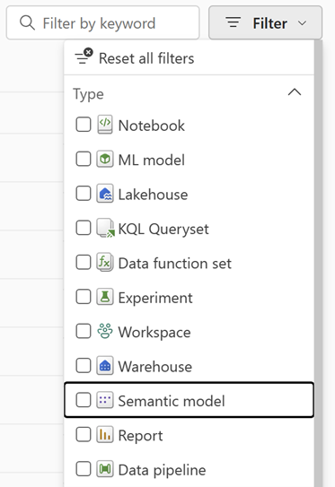

**Conclusion**

The change to the name reflects the immense progress that Power BI datasets have made in becoming an enterprise-grade semantic modeling technology. The semantic model name will help drive awareness of the unparalleled capabilities provided.

**How to locate your downloaded files**

**Introduction**

You may find difficulty locating your downloads when you select a file in an exercise or reading.

This reading contains instructions on finding downloaded files in Chrome, Microsoft Edge, Safari, and Firefox.

**Tip:** In some browsers, the downloaded file can be **Run** directly from the download, but in other browsers, the file must be saved and then opened.

**Browser Instructions**

Select the browser you are using to view instructions on downloading your files.

**Chrome**

To save a file or image on your computer or device, download it. The file will be saved in your default download location. Check out the instructions for locating downloaded files using [Google Chrome](https://support.google.com/chrome/answer/95759) browser.

**Edge**

To locate your saved downloads using the Microsoft Edge browser, follow the instructions provided by [Microsoft Edge](https://support.microsoft.com/en-us/microsoft-edge/find-where-your-browser-is-saving-downloads-d3e83af6-68bb-aa90-3167-eeb657013902).

**Safari**

When using a Mac, Safari may be your default browser. Use the instructions provided by [Safari](https://support.apple.com/guide/safari/download-items-from-the-web-sfri40598/mac) if you are having difficulty locating the files you downloaded.

**Firefox**

Your **Downloads** panel and **Library** keep track of files you download while using Firefox. This article by [Mozilla Firefox](https://support.mozilla.org/en-US/kb/where-find-and-manage-downloaded-files-firefox) explains how to access and manage the files you download and how to configure your download settings.

**Conclusion**

This reading offers a solution to the common challenge of locating downloaded files. By providing specific instructions for popular web browsers such as Google Chrome, Microsoft Edge, Safari, and Mozilla Firefox, you should be able to navigate and retrieve your downloaded content without spending too much time and effort searching.

**Additional resources: Welcome to the course**

You should now have a better idea of what to expect from this *Harnessing the Power of Data with Power BI* course. There may have been some terminology and technical terms in this lesson that are new to you. Don't worry if you don't fully understand everything right now. It should all become clearer soon. After all, that’s part of the reason you are taking this course!

Before diving into the course material, here are some additional resources you can explore to prepare you for the learning journey ahead.

**Data analyst career**

As you build your knowledge about Power BI and data analysis, you may wonder about the career possibilities and daily duties of a data analyst. This article introduces you to how Microsoft [uses high-quality, data](https://www.microsoft.com/insidetrack/blog/how-microsoft-connects-high-quality-discoverable-data/) to create experiences that people love.

**About the PL-300 exam**

By the end of this program of courses, you may intend to take *Exam PL-300: Microsoft Power BI Data Analyst*. This exam measures your ability to accomplish technical data analysis tasks. You will need to be able to:

* Prepare data
* Model data
* Visualize data
* Analyze data
* Deploy assets
* Maintain assets

You are probably not ready for the exam yet! But, for now, you can explore the [details and requirements for taking the exam](https://learn.microsoft.com/en-us/certifications/exams/pl-300/) to know what you are working toward.

**Resources needed for the course**

You will use Microsoft Power BI throughout this course. You can use the links listed below to download the resources you'll need.

* [Power BI Desktop requirements](https://learn.microsoft.com/en-us/power-bi/fundamentals/desktop-get-the-desktop#minimum-requirements): Check that you have access to the minimum requirements to run Power BI Desktop.
* Power BI Desktop download: For this course, you will need to install Power BI Desktop. Install Power BI Desktop free as an app from the [Microsoft Store](https://apps.microsoft.com/store/detail/power-bi-desktop/9NTXR16HNW1T) or as a downloadable executable from the [Microsoft Download Center.](https://www.microsoft.com/en-us/download/)
* [Power BI Service download](https://powerbi.microsoft.com/en-us/getting-started-with-power-bi/): Install Power BI Service for free using the link provided in the Power BI article on the Microsoft website.

**Power BI Desktop user interface**

Power BI Desktop is updated and released on a monthly basis, incorporating customer feedback and new features. You might experience changes in the Power BI Desktop user Interface (UI) that have taken place after the development of this training content. As a result, the screenshots in the videos, readings, or exercises might not align exactly with how you experience the UI. However, please note that these changes do not impact the functionalities of the UI. Hence, you will still be able to perform all the steps shown in that video, reading, or exercise.

**Conclusion**

Working through the additional resources in this course can help you further develop your data analysis skills and knowledge. Best of luck with your learning journey!

**Question**

Which of the following are key responsibilities of a data analyst? Select all that apply.

Collecting data

Correct

Correct! Data analysts are responsible for collecting data, as part of the process to generate insights that inform business decisions.

Analyzing data

Correct

Correct! Data analysts are responsible for analyzing data as part of the process to

Organizing data

Correct

Correct! Data analysts are responsible for organizing data, as part of the process to generate insights that inform business decisions.

**Using data to solve a business problem**

**Introduction**

Imagine you're a manager at a growing e-commerce business. You notice that your sales have been stagnant over the past few months. You know there must be *something* you could do better but you can't say what exactly you need to improve. Proper analysis of your data could help you decide. Data analysis helps identify the root causes of issues, recognize trends, and inform decisions that drive your business forward.

In this reading, you will explore the importance of using data analysis to identify business problems, uncover hidden patterns, and guide decision-making. It lists the steps involved in using data analysis to solve a business problem. You'll learn from a case study that demonstrates the power of data analysis in shaping business decisions, driving improvements, and boosting customer satisfaction.

**Case study: The importance of using data analysis**

Previously you learned that data analysis involves collecting, cleaning, processing, and interpreting data to extract insights, identify patterns, and make informed decisions. It helps businesses of all sizes and industries stay competitive, optimize operations, and achieve their goals. This case study explores how data analysis can be used to solve a business problem.

**The company**

This is a medium-sized e-commerce company that sells a wide range of products.

**The problem**

Over the past few months, the company has experienced stagnant sales and a decline in customer satisfaction. The management team is concerned about these trends and decides to use data analysis to identify the underlying issues and inform their next steps.

**Data analysis phases**

1. **Identifying the problem and gathering data**: The first step in the data analysis process is identifying the problem and gathering relevant data. In this case, the problem is stagnant sales and declining customer satisfaction. The company gathers data from various sources, including sales records, customer feedback, website analytics, and social media interactions.
2. **Cleaning and processing data**: Next, the data must be cleaned and processed to ensure it is accurate and ready for analysis. This involves removing duplicate entries, filling in missing values, and correcting any errors.
3. **Analyzing data**: Once the data is clean and processed, the company's data analysts begin to explore the data and identify patterns and trends. They discover that the decline in sales is primarily due to a decrease in repeat customers. Additionally, they find that customers who leave negative feedback often mention issues with shipping and product quality.
4. **Drawing insights and making recommendations**: Based on the analysis, the data analysts provide recommendations for improving customer satisfaction and increasing repeat business. They suggest that the company invests in better shipping options and implements a stricter quality control process.
5. **Implementing changes and measuring impact**: The management group considers these recommendations and puts them into practice. After a few months, the data analysts perform the data analysis process again to measure the impact of their actions. They find that customer satisfaction has improved and repeat business has increased, resulting in a boost in overall sales.

By following the steps of identifying the problem, gathering data, cleaning, and processing data, analyzing data, and implementing changes, the e-commerce company was able to address the root causes of stagnant sales and declining customer satisfaction.

**Conclusion**

The case study demonstrated the importance of using the data analysis process to solve a business problem and make informed decisions and how data analysis insights can drive successful outcomes. Data analysis can help businesses identify issues they may not have been aware of and empower them to make well-informed decisions that lead to positive results.

The ability to use data analysis is critical in today's competitive business environment, as it can provide a significant advantage to those who use data insights effectively to make data-driven decisions. As you continue your data analysis journey, think about the many ways in which you can apply these principles to business, and how you can use data to drive better decisions and achieve organizational success.

Mark as completed

Like

Dislike

Report an issue

**Question**

What is the primary goal of a Data scientist?

To create predictive models using advanced techniques.

Correct

Correct! Data Scientists create predictive models using machine learning algorithms and statistical techniques to identify hidden patterns and correlations.

SkipContinue

**Question**

Which of the following are important non-technical skills for a data analyst? Select all that apply.

Understanding end-user needs

Correct

That’s correct! Understanding end-user needs is an important non-technical skill that enables data analysts to create actionable insights.

Diplomacy

Correct

hat’s correct! Diplomacy is an important non-technical skill that data analysts may need to negotiate access to data, mediate stakeholder disagreements among stakeholders, or present results that challenge existing beliefs.

Interpreting technical content for non-technical stakeholders

Correct

That’s correct! Being able to explain technical or complex concepts and findings to stakeholders without a technical background is an important non-technical skill for data analysts.

**Tasks of a data analyst**

**Introduction**

Imagine you're a detective. Your task is to solve a mystery using many clues and data at your disposal. This also describes the goal of a data analyst—they dive deep into data to uncover hidden patterns, trends, and insights that drive informed decision-making. In today's data-driven world, the role of a data analyst is critical to help organizations make better decisions and stay ahead of the competition.

Are you ready to examine the data and help solve the mystery? If so, you’ll need to explore the key areas that a data analyst will engage in during the data analysis process.

**The data analysis process**

Data analysis is the process of collecting, preparing, analyzing, and visualizing data to extract valuable insights and support decision-making. The data analysis process has five critical steps:

1. Prepare
2. Model
3. Analyze
4. Visualize
5. Manage

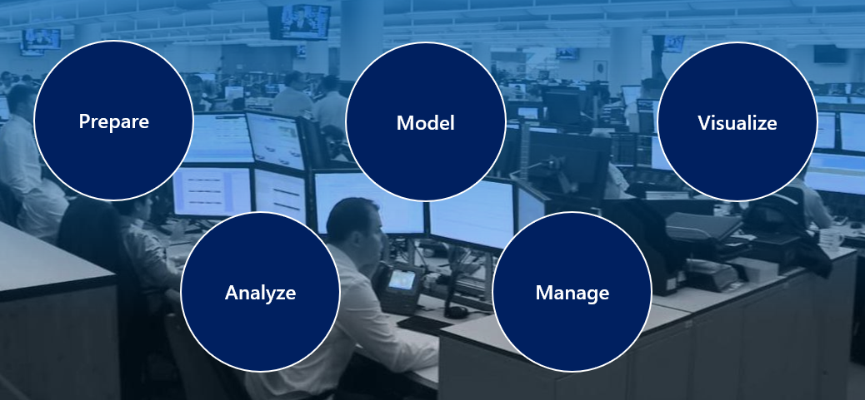

Let’s discover how each step contributes to data-driven decision-making.

**1: Prepare**

Data preparation is the crucial first step in the data analysis process. In this stage, data analysts gather, clean, and pre-process the raw data to make it suitable for analysis. This often involves removing any inaccuracies, inconsistencies, or duplicate records, as well as filling in missing values. Data preparation also includes data transformation, where data is converted into a more suitable format for analysis. For example, if you're analyzing customer purchases, you might need to aggregate individual transactions into monthly or yearly data.

**2: Model**

In the modeling stage, data analysts create a data model that represents the structure, relationships, and constraints of the data. This involves designing a schema, which is a blueprint of how the data is organized and stored. A well-designed schema helps analysts query the data more efficiently and ensures the data remains consistent and accurate. There are several types of data models, such as relational, hierarchical, and network models, each with its own set of rules and conventions. When creating a data model, analysts must consider various factors, such as the granularity of the data, the types of relationships between data entities, and the business requirements of the analysis.

**3: Analyze**

This step is the core of the data analysis process, where data analysts dig deep into the data to uncover insights and answer specific questions. Analysis can take many forms, including:

* Descriptive analysis: Describe what the data looks like in its basic form.
* Exploratory analysis: Dig deeper to try and find interesting patterns or relationships between different parts of the data.
* Inferential analysis: Use available data to make guesses or predictions about things outside the data.
* Predictive analysis: Use statistics to predict what might happen in the future based on what's happened in the past.

During the analysis phase, data analysts use a variety of statistical and machine-learning techniques to test hypotheses, identify patterns, and make predictions. For instance, a data analyst might use clustering algorithms to segment customers into distinct groups based on their behavior. Clustering algorithms are used to group data together based on their similarities, such as grouping customers who behave similarly. Another example is using time series analysis to forecast future sales, which is another algorithm data analysts might use to predict future trends. This involves looking at patterns in data over time, such as sales numbers, and using that information to make predictions about what will happen in the future.

**4: Visualize**

Data visualization is a powerful tool that allows data analysts to explore data, identify patterns, and communicate their findings effectively. By creating charts, graphs, and other visual representations of data, analysts can more easily spot trends, outliers, and relationships between variables. This helps them gain a deeper understanding of the data and communicate their findings to stakeholders in a way that's easy to understand. For example, a data analyst working on a sales analysis project might create a map to show sales performance by region, or a line chart to display sales trends over time.

**5: Manage**

Data management is a critical aspect of the data analysis process that ensures the integrity, consistency, and security of the data being used. This involves implementing best practices for data storage, backup, and access control, as well as maintaining data documentation and metadata. Proper data management helps data analysts and other stakeholders trust the data and its analysis, ensuring that the insights derived are accurate and reliable. For example, a data analyst might work closely with the IT department to implement data governance policies and ensure compliance with data protection regulations.

**Conclusion**

Data analysis is an essential process that enables organizations to make informed decisions based on insights derived from data. As a data analyst, you'll engage in five key areas during the data analysis process: prepare, model, visualize, analyze, and manage. By mastering these areas, you'll be well-equipped to tackle complex data challenges and help organizations uncover the hidden value in their data. As a data analyst, you have the power to reveal hidden truths, solve complex problems, and drive meaningful change.

Mark as completed

Like

Dislike

Report an issue

**Exercise: Identifying stakeholders**

**Introduction**

Data analysis is the process of uncovering hidden patterns and valuable insights from large and complex data sets. Surrounded by data, with the volume of that data often a challenge, how can businesses make sense of it all? That's where data analysts come in. From small businesses to Fortune 500 companies, data analysis is essential to organizations.

Previously you learned that the role of a data analyst is to make sense of the data that organizations collect, turning it into insights that inform decisions. Early in the data analysis process, it is essential for data analysts to engage with stakeholders to understand the goal of the analysis and the data that is relevant to that goal. In this exercise, you'll use a high-level skill called stakeholder analysis to identify key business stakeholders through a case study. By the end of this exercise, you will be able to identify the key stakeholders and understand their perspectives to better guide your data analysis.

**Case study**



**Company**

Adventure Works is in the sports goods business. It is a large, multinational manufacturing company that produces and distributes bicycles and accessories to global markets. The company has established itself as a trusted brand. However, with the entry of new competitors, their market share has been threatened.

**Scenario**

The company has decided to take a new approach to maintain its position in the market. As a result, Renee, the marketing director at Adventure Works, has asked you to conduct a sales data analysis project. Renee is responsible for creating and implementing marketing campaigns.

The goal of the project is to use the insights gained from the analysis of sales data to drive new marketing campaigns and improve the company's market share. The project aims to identify customer preferences, buying patterns, and trends, which will be used to create targeted marketing campaigns that will appeal to the company's existing customer base, and attract new customers.

To achieve this, you need to identify the key people in the business who can provide valuable insights into the company's current sales and marketing strategies. You must interview company managers with different responsibilities and roles to gain a comprehensive understanding of the company's sales and marketing operations.

**Employees**

These are the executives available that you can consider for an interview:

* Ricci is the customer service manager. She is responsible for ensuring that customers are satisfied with the company's products and services.
* Igor is the finance manager. He oversees the company's financial operations.
* Jane is the IT manager. She manages the company's information technology department.
* Renee is the marketing director. She develops and executes marketing strategies that advertise and publicize the business's goods and services.
* Sam is the research and development manager. Sam manages the company's research and development department.
* Alex is the security operations manager. She manages the company's operations, including security and maintenance.
* Nia is the legal counsel. She manages the company's legal affairs.
* Kane is the sales manager. He oversees the sales team and ensures that they meet their sales targets.
* Hassan is the human resources manager. He manages the company's staffing and employment resources.

**Instructions**

Create a new Word document called *The role of the data analyst in identifying stakeholders.* Follow the steps below to complete the exercise.

**Step 1: Understand the context**

Read the case study carefully to understand the business context and the goals of the data analysis project. Take some notes to familiarize yourself with the personas mentioned in the case study, including their roles and responsibilities.

**Step 2: Identify the key stakeholders**

Identify and list the key stakeholders you think you should interview and the reason you selected them. Classify the stakeholders chosen by the level of influence and interest each might have in the sales data analysis project. Your list should be laid out as follows:

* The name of the key stakeholder and their role (for example: Ricci, customer service manager).
* Their level of influence (High, Medium, Low).
* The level of interest they have in the project (High, Medium, Low).
* The reason, or reasons, that you selected them.

**Tip:** For the last item above, be sure to write a few sentences about each selected stakeholder’s level of influence, level of interest, and explain your reason for selecting them.

**Step 3: Prepare interview questions**

Based on the stakeholders selected, write a list of 3 questions you will ask each individual. The questions should steer the data analysis toward achieving the project goals. This question list should include:

* Name of key stakeholder.
* Three questions to ask the stakeholder.

For example, the questions to ask can be something like:

| **Stakeholder name** | **Nia** |
| --- | --- |
| Sample question 1 | Can you provide any examples of successful targeted marketing campaigns? |
| Sample question 2 | How do you determine a marketing campaign's return on investment (ROI)? |
| Sample question 3 | What metrics do you use to measure ROI? |

**Conclusion**

By completing this exercise, you are better equipped to identify relevant stakeholders in a data analysis project and gained insight into why this is an important part of the data analysis process. In addition to selecting relevant stakeholders, you practiced developing questions that you can ask to steer data analysis toward meeting project goals. This exercise provides you with the knowledge needed to effectively identify and interview stakeholders.

**Self-review: Identifying stakeholders**

**1.**

Question 1

Which stakeholder is most likely to provide insights into customer preferences and buying patterns?

Ricci (Customer Service Manager)

Correct

That's correct! Ricci, as the Customer Service Manager, is responsible for ensuring customer satisfaction and would have valuable insights into customer preferences and buying patterns.

1 / 1 point

**2.**

Question 2

When preparing interview questions for stakeholders, what should you focus on to ensure the data analysis project achieves its goals?

Asking questions that align with the stakeholder's role and responsibilities in relation to the project.

Correct

That's correct! Asking questions that align with the stakeholder's role and responsibilities in relation to the project ensures that the information gathered is relevant and helps achieve the project goals.

1 / 1 point

**3.**

Question 3

Which questions would be most appropriate to ask Renee, the marketing director, to steer the data analysis project toward achieving its goals?

Can you provide any examples of successful targeted marketing campaigns?

Correct

That's correct! This question is appropriate for Renee, the Marketing Director, as it is directly related to marketing campaigns and can help guide the data analysis project.

**Exemplar: Identifying stakeholders**

**Introduction**

In the exercise *Identifying stakeholders*, you were tasked with identifying the key stakeholders to interview for the sales data analysis project.

More specifically, you were asked to:

* Identify and list the key stakeholders that you will interview as part of your data analysis project, their level of influence and/or their interest in the project, and the reason you selected them.
* Write a list of 3 questions that you will ask each stakeholder that could help direct the data analysis in achieving the project goals.

This reading presents one version of the expected outcome. Your answer may differ but still be correct.

**Step 1: Understand the context**

In the first part of the exercise, your task was to read the case study carefully to understand the context and goals. An example of an acceptable answer for this is:

The primary objective of the analysis is to analyze the sales data to drive new marketing campaigns and improve the company's market share. To do this effectively, a full understanding of the business context and the challenges the company faces is required. In addition, familiarity with the stakeholder’s role and duties is essential.

**Step 2: Identify the key stakeholders**

In this step, you were asked to identify and list the key stakeholders that you think should be interviewed and give the reason you selected them. Then you were asked to classify the chosen stakeholders by the level of influence and interest each might have in the sales data analysis project. 3 examples of the type of work that you could have submitted for this step of the exercise are presented below.

**Key stakeholder: Sales Manager - Kane**

* **Level of influence:** High—Kane's high level of influence comes from his role as Sales Manager and his responsibility to ensure that the sales team meets their targets. Kane's deep understanding of the company's sales processes and performance directly impacts the company's bottom line. As a result, Kane's involvement in the sales data analysis project is essential to ensure that the project aligns with the company's overall sales goals.
* **Level of interest:** High—Kane's high level of interest in the project comes from his responsibility to improve the sales team's performance. The insights gained from the sales data analysis will help Kane identify areas where the sales team can improve, allowing data-driven decisions that will enhance the sales process and increase the company's market share.
* **Reason for selection:** Directly involved in sales performance and understanding customer preferences. Kane plays a critical role in the success of the sales data analysis project and, as Sales Manager, is directly responsible for the company's sales performance. Kane's expertise in analyzing sales data, understanding customer preferences, and identifying trends make him an important asset.

**Key stakeholder: Marketing Director - Renee**

* **Level of influence:** High—Renee's high level of influence comes from her role as Marketing Director, where her responsibility is to drive marketing campaigns that boost the company's sales. Renee's insights into the effectiveness of existing marketing campaigns, customer preferences, and trends will help create a targeted analysis that can inform future marketing strategies.
* **Level of interest:** High—Renee's high level of interest in the project is rooted in her responsibility to improve the company's market share and attract new customers. The sales data analysis will help her identify trends and customer preferences, allowing her to make data-driven decisions to create more effective marketing campaigns that resonate with the target audience.
* **Reason for selection:** Directly involved in creating and implementing marketing campaigns. Renee is a key stakeholder in the sales data analysis project because she creates and implements marketing campaigns that promote the company's products and services. Renee's extensive experience in marketing, deep understanding of the company's marketing strategy, and ability to identify areas for improvement make her a vital source for the project.

**Key stakeholder: Customer Service Manager - Ricci**

* **Level of influence:** Medium—Ricci's medium level of influence is due to her role in customer service, which, while not directly responsible for sales or marketing, plays a crucial role in retaining existing customers and maintaining the company's reputation. Ricci's insights into customer satisfaction can help the data analyst understand the factors that impact the company's sales and inform recommendations for improving the customer experience.
* **Level of interest:** High—Ricci's high level of interest in the project comes from her responsibility to ensure that customers are satisfied with the company's products and services. The sales data analysis will help her identify trends and areas of improvement, allowing Ricci to make data-driven decisions to enhance customer satisfaction and contribute to the company's overall sales and market share.
* **Reason for selection:** Directly involved in customer satisfaction and feedback, Ricci is an important stakeholder in the sales data analysis project because of her role in ensuring customer satisfaction. Ricci’s understanding of customer complaints, feedback, and preferences can provide valuable insights into areas where the company can improve its products and services. These insights can help the data analyst identify growth opportunities and inform future sales and marketing strategies.

**Step 3: Prepare interview questions**

Based on the stakeholders selected, you needed to write a list of 3 questions you would prepare to ask each stakeholder. The questions should steer the data analysis toward achieving the project goals. Below are some examples of questions you could create for this part of the exercise.

**Renee (Marketing Director)**

* Can you provide an overview of the current marketing strategy and how it has evolved over the years?
* How do you measure the effectiveness of marketing campaigns, and what key performance indicators (KPIs) do you track?
* What have been the most successful marketing campaigns in the past, and what factors contributed to their success?
* Are there any marketing campaigns or strategies that have underperformed or not met expectations? If so, what were the challenges and learnings from those experiences?
* How do you segment the target audience for marketing campaigns, and what are the key demographics and preferences of our customers?

**Kane (Sales Manager)**

* Can you describe the current sales strategy and how it has evolved over time to address changing market dynamics?
* What are the key performance indicators (KPIs) that you use to track the sales team's performance, and how do you ensure that targets are met?
* How do you identify trends in customer buying patterns, preferences, and behaviors that impact on the company's sales performance?
* What have been the most significant challenges the sales team has faced, and how have you addressed those challenges?
* What types of data and insights would be most valuable to you for improving the sales team's performance and meeting sales targets?

**Ricci (Customer Service Manager)**

* How do you measure customer satisfaction, and what key performance indicators (KPIs) do you track to ensure that customers are happy with the company's products and services?
* What are the most common customer complaints or feedback that you receive, and how have they informed changes in the company's products or services?
* Can you provide any examples of how customer feedback has directly impacted the company's sales or marketing strategies?
* How do you segment customers in terms of their preferences and needs, and what are the key demographics and preferences of our customer base?
* What types of data and insights would be most valuable to you for improving customer satisfaction and maintaining a strong relationship with the company's customer base?

**Conclusion**

You should now have a better understanding of identifying stakeholders to gather relevant insights. By understanding the high-level skill of stakeholder analysis, you can more effectively navigate complex business environments. Preparing targeted interview questions allows you to gather specific information that is actionable and aligned with a project’s goals. Stakeholder analysis can help you gather valuable insights that can inform your data analysis, leading to relevant insights that can be used by businesses to make strategic decisions.

**Knowledge check: The role of the Data Analyst**

**1.**

Question 1

**True or False:** Data preparation involves converting data into a format that is more suitable for analysis.

True

Correct

Correct! Data preparation involves gathering, cleaning, and pre-processing raw data to make it suitable for analysis. Data transformation is also a part of data preparation, where data is converted into a format that is more suitable for analysis.

1 / 1 point

**2.**

Question 2

What is the goal of the data analysis process?

Extracting valuable insights and supporting decision-making.

Correct

Correct! The goal of the data analysis process is to extract valuable insights and support decision-making by collecting, transforming, and analyzing data.

1 / 1 point

**3.**

Question 3

Which type of analysis involves using algorithms to segment customers into distinct groups based on their behavior?

Cluster analysis

Correct

Correct! Clustering is an analysis technique that involves segmenting customers into distinct groups based on their behavior.

1 / 1 point

**4.**

Question 4

What is the function of data management in the data analysis process?

Ensuring the integrity, consistency, and security of data.

Correct

Correct! Data management is a critical aspect of the data analysis process that ensures the integrity, consistency, and security of the data being used.

1 / 1 point

**5.**

Question 5

Which of the following is a part of the data preparation process? Select all that apply.

Filling in missing values.

Correct

Correct! Filling in missing values is a crucial step in the data preparation process.

Removing inaccuracies, inconsistencies, or duplicate records.

Correct

Correct! In the data preparation process, removing inaccuracies, inconsistencies, or duplicate records is important.

**Additional resources: The role of the Data Analyst**

This reading lists resources that can lead you to a better understanding of the fundamentals and importance of data analysis. These resources provide comprehensive coverage of data analysis, including the benefits of data-driven decision-making, data management, data visualization, and more. Whether you're just starting to learn about data analysis or looking to deepen your understanding, these resources can help you build a strong foundation and achieve success as a data analyst.

**Microsoft Learn data fundamentals**

* This resource on [Microsoft Learn](https://learn.microsoft.com/en-us/training/paths/azure-data-fundamentals-explore-core-data-concepts/) is designed for beginners and covers data concepts, working with relational data, and non-relational data.

**Get started with Microsoft data analytics**

* In [this learning path](https://learn.microsoft.com/en-us/training/paths/data-analytics-microsoft/), you will learn about the life and journey of a data analyst and the skills, tasks, and processes they go through in order to tell a story with data so trusted business decisions can be made.

**Power BI blog**

* The official [Microsoft Power BI blog](https://powerbi.microsoft.com/en-us/blog/) features articles, updates, and tutorials on how to effectively use Power BI for data analysis and visualization.

**Microsoft Excel blog**

* The official [Microsoft Excel blog](https://techcommunity.microsoft.com/t5/excel-blog/bg-p/ExcelBlog) provides information on Excel features, updates, and tips for beginner and advanced users alike, with many posts discussing data analysis techniques.

**Conclusion**

These resources are selected to enhance your data analysis skills. Such resources are a way to stay up-to-date on the latest developments in data analysis. Continuous learning and practice are crucial to becoming a skilled data analyst. Make the most of these resources and keep exploring new perspectives to stay ahead in this evolving field.

Mark as completed

Like

Dislike

Report an issue

**Question**

What factors are important to consider when determining the ‘right’ data to collect? Select all that apply.

The type of data.

Correct

That’s correct! Considering the type of data needed to answer business questions is important to ensure appropriate, relevant data is gathered.

The purpose of the analysis.

Correct

That’s correct! Considering the analysis purpose is important to ensure the collection of relevant data that is appropriate for the analysis.

The needs of the analysis end users.

Correct

That’s correct! Considering end user needs is important to ensure that the data collected is relevant to the analysis purpose.

The scope of data.

Correct

That’s correct! Considering the scope of data needed to answer business questions is important to ensure that appropriate, relevant data is gathered.

**Question**

What is the purpose of data processing in the data analysis process?

To clean, organize and transform data for data analysis.

Correct

That’s correct! Processing raw data is critical for organizing and transforming data into a structured format that can be easily analyzed and used to make informed business decisions.

**Sharing data insights**

**Introduction**

Imagine you are part of the data analytics team at Adventure Works that has just completed a ground-breaking analysis. Your insights have the potential to revolutionize the way the company makes decisions. But, before you can share your work with others, you need to ensure it's accessible, visually appealing, and secure. This is where the best practices for sharing data insights come into operation.

In this reading, you will learn about the best practices for sharing and collaborating on analysis insights, focusing on the key considerations of accessibility, color schemes, font sizes, access and security, and storage and refresh schedules. You’ll discover how to share and collaborate on reports, ensuring they are engaging, accessible, and secure while keeping them up-to-date with the latest data.

**Best practices for sharing data insights in reports**

Let’s say, Renee, the marketing director at Adventure Works, tasked the analytics team you’re a part of to analyze sales data to identify trends and patterns that could help improve their marketing strategies. You and your colleagues examined and analyzed the data for weeks, creating stunning visualizations, and drawing valuable conclusions. To maximize the impact of your data insights, you now need to apply the best practices for sharing reports.

Let’s explore these best practices and how you and the data analytics team can apply them to effectively share and collaborate on data insights with Renee and other stakeholders at Adventure Works.

**Accessibility**

A key consideration when sharing analysis insights is accessibility. This means you need to ensure that the reports are accessible to everyone who needs to view them. For example, you need to consider any disabilities or limitations that might affect stakeholders’ ability to interact with the data. To overcome this challenge in the Adventure Works project, your report must meet the Web Content Accessibility Guidelines (WCAG) to accommodate users with disabilities. For more information on the WCAG, you can refer to the additional resources for this lesson.

You must also consider the various devices and platforms used by the audience to which your report is aimed. For example, you can ensure that your report and visualizations are designed to adapt to different screen sizes and resolutions so that the report renders well on different devices. You can also consider cross-browser compatibility to ensure that your report’s appearance and functionality are consistent across different web browsers. You may also make the report available for offline and online use and provide the report in various file formats and with different export options, to accommodate users' preferences and ensure they can access the information in the way that works best for them.

By addressing these factors, you can ensure your report is accessible and user-friendly, regardless of the devices and platforms the stakeholders use.

**Color schemes and font sizes**

You must also consider the visual appeal of your report, as a well-designed report is more engaging and easier to understand. How could this look practically? In the Adventure Works project, your team could research color theory and design principles, choosing a color scheme that is visually appealing and clear. Your team could also adjust font sizes to ensure that the text is readable and can be quickly and accurately processed, improving comprehension. Remember that when creating reports and dashboards, it's essential to ensure they are accessible to all users, including those with visual impairments.

**Access and security**

Another key consideration is ensuring the report is secure and accessible only to authorized users. For the Adventure Works project, your team must balance making the data easy to access and protecting sensitive information. To achieve this, you could implement role-based access control, which grants different levels of access to the report depending on the user's role within the company. You could also ensure that the environment is configured securely by enabling security features like data encryption and multi-factor authentication. In sum, before sharing a report, you need to consider who should have access to the data and how to maintain its security.

**Storage and refresh schedules**

Finally, it’s best practice to consider the storage and refresh schedules for generated reports. This means the data analytics team would need to ensure that the report is always up-to-date and that the data storage and processing don’t exceed Adventure Works’ capacity. To do this practically, you could set up automated data refreshes to keep the report current and monitor the storage and processing requirements to ensure that they remain within acceptable limits. When sharing your reports, it’s important to consider how your data is stored and how often it should be refreshed to ensure stakeholders are always working with up-to-date information.

**Conclusion**

As you can tell from the Adventure Works sales data project, sharing data insights is about much more than simply clicking the **Share** button. It requires careful planning and consideration of factors like accessibility, visual design, security, and data management. By mastering these fundamental principles and implementing best practices in sharing your reports, you'll empower your audience with the valuable insights they need to make data-driven decisions. So, in your data analysis work, you’ll be able to share your data stories with stakeholders and inspire change through the power of well-presented, accessible, and secure data insights!

**Stakeholder experience**

**Introduction**

You now know that creating and designing visualizations are an important part of the data analysis process. You learned that these visualizations can help stakeholders understand trends and patterns and can help them make informed business decisions. Visualizations work best when your design connects with your audience. For example, designs created to present to marketing managers may not work well with a group of financial investors. That's where understanding the background, needs, preferences, and expectations of the end-users of your analysis, or stakeholder experience, comes in.

In this reading, you’ll learn about stakeholder experience and its importance for data visualization. You’ll discover the role stakeholder experience plays in creating effective data visualizations and how this can impact stakeholder decision-making and business outcomes.

**Stakeholder experience**

Taking stakeholder experience into account is a critical aspect of data visualization and analysis. Stakeholder experience refers to the specific needs, preferences, and expectations of the stakeholders engaging with the visualizations and insights provided in a data analysis report. These stakeholders can include executives, managers, employees, clients, and partners—anyone with a vested interest in the data insights or can use them to make informed decisions. By acknowledging and catering to stakeholder experience, data analysts can enhance the effectiveness and usability of their visualizations, which in turn leads to better decision-making, increased collaboration, and improved business outcomes.

**The importance of stakeholder experience in data visualization**

Stakeholder experience is an important part of data visualization and analysis because it impacts how relevant, useful, and understandable the visualizations and analysis are. This is because tailored and appealing visualizations make it easier for stakeholders to comprehend and use data insights to make decisions, improving the communication of data insights and encouraging stakeholders to engage more with them. By showing that you understand the stakeholders' goals and priorities, stakeholders are more likely to trust in your ability to provide valuable insights, leading to greater acceptance and use of the analysis, more data-driven decisions, and positive business outcomes. In addition to driving business value, visualizations tailored according to stakeholder experience can also save time and resources by reducing the need for multiple iterations and revisions.

**Factors that influence stakeholder experience**

To gain a comprehensive insight into stakeholder experience, data analysts should consider factors such as the goals and objectives, and technical expertise of the stakeholders, as well as the context in which the stakeholders use and apply the analysis insights.

**Goals and objectives**

Identifying the primary goals and objectives of stakeholders will help align your visualizations and insights with the stakeholders' interests and expectations, leading to a more targeted and effective presentation. This process involves:

* **Identifying stakeholder priorities:** Determine the key concerns, challenges, and opportunities that stakeholders want to address with the data analysis.
* **Clarifying decision-making needs:** Understand the types of decisions stakeholders will be making based on the data insights.
* **Establishing success criteria:** Work with stakeholders to define specific, measurable, and achievable objectives for the data analysis project.
* **Aligning with organizational strategy:** Consider the broader strategic context in which stakeholders operate and ensure that the visualizations and insights contribute to achieving the organization's overall goals and objectives.

**Technical expertise**

Understanding the stakeholders' level of technical expertise is crucial in determining the complexity and depth of the visualizations. This includes:

* **Assessing stakeholder proficiency:** Gauge the stakeholders' familiarity with data analysis concepts, tools, and techniques to determine their level of expertise.
* **Tailoring visualizations:** Based on the stakeholders' expertise, create visualizations that are appropriately detailed and sophisticated.
* **Providing context and explanations:** Include clear explanations, annotations, and supporting information to help stakeholders with varying levels of expertise interpret and understand the visualizations.
* **Offering training and support:** For stakeholders who may require additional assistance in understanding the visualizations, consider providing training or support resources, such as tutorials.

**Context and application**

Knowing the context in which stakeholders will use the visualizations enables you to design visualizations that are relevant, actionable, and easily applicable to the stakeholders' specific situations. This entails:

* **Understanding stakeholder workflows:** Identify how stakeholders will incorporate the visualizations into their daily workflows and decision-making processes.
* **Identifying the intended audience:** Consider the specific groups or individuals who will be using the visualizations and design them accordingly.
* **Considering the environment:** Take into account the physical or digital environment in which stakeholders will view the visualizations. Factors such as screen size, device type, and network connectivity can impact the design and functionality of visualizations.
* **Adapting to stakeholder feedback**: Gather feedback from stakeholders throughout the visualization development process and make adjustments as needed to ensure that the visualizations remain relevant, actionable, and easily applicable to their specific situations.

**Conclusion**

In this reading, you learned about stakeholder experience and the importance of considering related factors such as the stakeholders’ goals and objectives, technical expertise, and context in the data visualization process. Embracing stakeholder experience in data visualization can help stakeholders navigate complex data with ease, make informed decisions and unlock the full potential of their data. As you continue on your journey as a data analyst, remember the powerful impact that thoughtfully designed visualizations can have on stakeholder decision-making.

Mark as completed

Like

Dislike

Report an issue

**Exercise: Stakeholder experience**

**Introduction**

Previously, you learned that analysis insights and visualizations in reports are more likely to be impactful and useful when they are tailored to stakeholder experience (the needs, preferences, and expectations of the stakeholders who will engage with the visualizations in your data analysis report). In this exercise, you’ll work through a case study in which a data analyst undertakes a six-step process to inform data visualization based on stakeholder experience. You’ll then apply the insights you’ve gained to answer questions related to this process.

**Case study**



To help boost sales, Adio, the data analyst at Adventure Works, is tasked with investigating sales, marketing, and customer data. Adio is instructed to create and share a data report with visualizations, based on the insights, patterns, and trends he uncovers during the analysis. Adio knows that creating visualizations with stakeholder experience in mind contributes to improved stakeholder understanding and decision-making. To understand the needs, preferences, and expectations of the stakeholders that form his audience (stakeholder experience), Adio engages in the following process:

**Step 1: Identifying stakeholders**

The first step in the stakeholder experience process is to determine which stakeholders have an interest in the data analysis and visualizations. Adio identifies the executives, marketing team, and product managers as stakeholder groups for his current project.

**Step 2: Defining stakeholder goals**

Aware that these stakeholder groups will have diverse needs, preferences, and expectations, Adio moves on to the next step—understanding the different stakeholders' goals, priorities, and requirements. Through consultation with each group of stakeholders, Adio determines their respective interests in the sales data analysis:

* The group of executives is focused on improving the overall performance of the company and is interested in high-level insights that can drive strategic decisions related to their competitors, products, and customer marketing.
* The marketing team is interested in insights into marketing campaign effectiveness and how to improve conversion rates from their website and social media sites to increase sales.
* The product managers want to understand customer behavior, such as product popularity, preferences of different customer segments or groups, and the profitability of each of these segments.

**Step 3: Choosing the right visualization type**

Adio can now choose visualization types that are tailored to the stakeholders' goals and needs. Bar charts, line charts, and pie charts are common visualization types, but there are many others to consider. The visualizations you choose will depend on the type of data you're working with. You also have to think about which visualization types will best communicate the insights your stakeholders need while being visually appealing and easy to understand. For example:

* For executives, a dashboard with high-level metrics and key performance indicators (or KPIs) such as revenue and profit margins may be the right choice.
* The marketing professionals may find a conversion funnel that tracks the progress of customers from the stage of visiting marketing channels to the final stage of product purchases more useful. A bar chart to compare the effectiveness of different marketing channels may also be an appropriate choice.
* For the product managers, a map that visualizes the distribution of customer segments may be suitable.

**Step 4: Designing with stakeholder experience in mind**

Next, you need to design the visualizations with stakeholder experience in mind, ensuring visualizations are meaningful to each group. This means designing visualizations that answer stakeholder questions, are visually appealing, and easy to read, navigate and understand. When designing his visualizations, Adio keeps in mind that:

* The executives prefer visualizations that are concise, easy to understand, and convey key takeaways quickly.
* The marketing professionals are interested in visualizations that can help them identify trends, patterns, and opportunities for improvement.
* The product managers value visualizations that can help them identify gaps, opportunities for growth, and potential issues with specific products.

**Step 5: Making visualizations interactive**

You can enhance stakeholder engagement, exploration, and understanding of data insights by adding interactive features to your visualizations. For example, you can add filters and sorting options, or explanations that appear when stakeholders hover over different parts of a visualization. Adio uses Power BI to create interactive data visualizations that the stakeholders can explore and interact with. For example, he adds filtering and sorting options. That way, when Adio shares the report, the marketing team can view data by marketing channels or campaigns. Similarly, the product team can view sales distribution data by customer segment or product category.

**Step 6: Testing and iterating**

Before sharing the visualizations with stakeholders, Adio tests them with a small group of users that represent his target audience. Focus groups involve selecting and recruiting a diverse and representative sample of individuals from the different stakeholder groups and then conducting the focus group sessions. In this final step, you should gather and analyze feedback and make any necessary adjustments to ensure that your visualizations effectively communicate the intended insights. In doing so, you ensure that the stakeholders’ needs are met.

**Instructions**

**Create a document**

Create a new Word document called *Stakeholder experience*. Use this document to record your answers to the exercise questions.

**Answer questions about stakeholder experience**

1. What is the primary goal of data visualization in the data analysis process?
2. Briefly define stakeholder experience in the context of data analysis and visualization.
3. Explain two reasons why stakeholder experience is important when creating data visualizations.
4. List the six steps in the stakeholder experience process.
5. How can you identify the goals and preferences of different stakeholder groups when designing visualizations?
6. What is one challenge you think Adio may face in designing data visualizations that meet the needs of the different stakeholders?
7. Briefly discuss what you need to consider when choosing the right visualization type for stakeholders.
8. What is the purpose of making visualizations interactive?
9. A focus group finds a visualization Adio designed difficult to understand. Adio adds more interactive features and updates the design. Which step in the process is Adio engaging in?
10. In no more than two sentences, discuss how you think stakeholder experience can contribute to improving business outcomes through data-driven decision-making.

**Conclusion**

In this exercise, you were introduced to tailoring visualizations based on stakeholder experience. You discovered how these tailored visualizations are essential to communicating data insights and can impact stakeholder decision-making.

**The Role of the Data Analyst in Identifying Stakeholders**

**Step 1: Understand the Context**

Adventure Works is a multinational company specializing in manufacturing and distributing bicycles and accessories. Due to the increasing competition in the sports goods market, Adventure Works aims to leverage data analysis to drive marketing campaigns and regain market share.

The project goal is to analyze sales data to gain insights into customer preferences, buying behaviors, and sales trends. These insights will guide marketing strategies to retain current customers and attract new ones. As the data analyst, identifying the key stakeholders involved in this project is critical to ensure relevant and accurate data collection and interpretation.

**Step 2: Identify the Key Stakeholders**

| **Stakeholder Name & Role** | **Level of Influence** | **Level of Interest** | **Reason for Selection** |
| --- | --- | --- | --- |
| **Renee – Marketing Director** | High | High | As the project sponsor and initiator, Renee is highly invested in the outcome. She needs the analysis to inform her marketing campaigns and improve market share. |
| **Kane – Sales Manager** | High | High | Kane has access to sales data and can provide insights into buying patterns, sales targets, and sales team strategies, which are central to the analysis. |
| **Ricci – Customer Service Manager** | Medium | High | Ricci interacts directly with customers and understands their pain points and preferences, which can help identify behavioral patterns relevant to marketing campaigns. |
| **Igor – Finance Manager** | Medium | Medium | Igor can help determine how sales performance links to revenue and profit. Financial insights support ROI calculations and budget allocations for campaigns. |
| **Jane – IT Manager** | High | Medium | Jane ensures access to the necessary data infrastructure. Her role is crucial for data retrieval, storage, and ensuring system compatibility for data analysis. |

**Step 3: Prepare Interview Questions**

**Renee – Marketing Director**

1. What are your key goals for the upcoming marketing campaigns?
2. Are there specific customer segments you are targeting?
3. How do you currently measure the effectiveness of marketing efforts?

**Kane – Sales Manager**

1. What are the current sales trends and patterns you've noticed?
2. Are there particular products or regions that are underperforming or overperforming?
3. What key sales metrics do you believe should be tracked to inform marketing decisions?

**Ricci – Customer Service Manager**

1. What common feedback or concerns do you receive from customers?
2. Are there any noticeable changes in customer behavior or satisfaction?
3. What customer service metrics or insights could help us understand customer preferences?

**Igor – Finance Manager**

1. How do you currently track revenue and profit in relation to sales performance?
2. Can you provide insights into the cost-effectiveness of previous marketing initiatives?
3. What financial KPIs should be considered to evaluate campaign success?

**Jane – IT Manager**

1. What sales and customer data is currently available in our systems?
2. Are there any challenges in accessing or integrating different data sources?
3. What data privacy or security considerations should we be aware of for this project?

**Stakeholder Experience**

**1. What is the primary goal of data visualization in the data analysis process?**  
The primary goal of data visualization is to effectively communicate data insights, patterns, and trends in a clear, concise, and visually engaging manner to support understanding and decision-making.

**2. Briefly define stakeholder experience in the context of data analysis and visualization.**  
Stakeholder experience refers to the consideration of the needs, preferences, expectations, and goals of stakeholders when creating and presenting data visualizations and reports.

**3. Explain two reasons why stakeholder experience is important when creating data visualizations.**

* It ensures that visualizations are tailored to each stakeholder group, making the data more relevant and easier to interpret.
* It improves stakeholder engagement and decision-making by delivering insights in formats that align with how stakeholders prefer to consume and interact with information.

**4. List the six steps in the stakeholder experience process.**

1. Identifying stakeholders
2. Defining stakeholder goals
3. Choosing the right visualization type
4. Designing with stakeholder experience in mind
5. Making visualizations interactive
6. Testing and iterating

**5. How can you identify the goals and preferences of different stakeholder groups when designing visualizations?**  
You can identify goals and preferences by consulting directly with stakeholder groups, asking questions about their priorities, challenges, and decision-making needs, and observing how they interact with data in their roles.

**6. What is one challenge you think Adio may face in designing data visualizations that meet the needs of the different stakeholders?**  
Adio may struggle to balance the varying needs of multiple stakeholder groups, especially when trying to present both high-level summaries for executives and detailed, granular insights for marketing and product teams within a single report.

**7. Briefly discuss what you need to consider when choosing the right visualization type for stakeholders.**  
You should consider the type of data being presented, the goals of the stakeholder, the level of detail required, and the clarity and visual appeal of the chart type to ensure effective communication of insights.

**8. What is the purpose of making visualizations interactive?**  
Interactive visualizations allow stakeholders to explore data more deeply by filtering, sorting, and drilling down into specific insights, thereby enhancing understanding and engagement with the report.

**9. A focus group finds a visualization Adio designed difficult to understand. Adio adds more interactive features and updates the design. Which step in the process is Adio engaging in?**  
Step 6: Testing and iterating.

**10. In no more than two sentences, discuss how you think stakeholder experience can contribute to improving business outcomes through data-driven decision-making.**  
By aligning data visualizations with stakeholder needs and preferences, organizations can ensure that decision-makers quickly grasp critical insights and take informed actions. This leads to better strategic planning, improved operational efficiency, and more impactful business outcomes.

**Stakeholder Experience**

**1. What is the primary goal of data visualization in the data analysis process?**  
The primary goal of data visualization is to effectively communicate data insights, patterns, and trends in a clear, concise, and visually engaging manner to support understanding and decision-making.

**2. Briefly define stakeholder experience in the context of data analysis and visualization.**  
Stakeholder experience refers to the consideration of the needs, preferences, expectations, and goals of stakeholders when creating and presenting data visualizations and reports.

**3. Explain two reasons why stakeholder experience is important when creating data visualizations.**

* It ensures that visualizations are tailored to each stakeholder group, making the data more relevant and easier to interpret.
* It improves stakeholder engagement and decision-making by delivering insights in formats that align with how stakeholders prefer to consume and interact with information.

**4. List the six steps in the stakeholder experience process.**

1. Identifying stakeholders
2. Defining stakeholder goals
3. Choosing the right visualization type
4. Designing with stakeholder experience in mind
5. Making visualizations interactive
6. Testing and iterating

**5. How can you identify the goals and preferences of different stakeholder groups when designing visualizations?**  
You can identify goals and preferences by consulting directly with stakeholder groups, asking questions about their priorities, challenges, and decision-making needs, and observing how they interact with data in their roles.

**6. What is one challenge you think Adio may face in designing data visualizations that meet the needs of the different stakeholders?**  
Adio may struggle to balance the varying needs of multiple stakeholder groups, especially when trying to present both high-level summaries for executives and detailed, granular insights for marketing and product teams within a single report.

**7. Briefly discuss what you need to consider when choosing the right visualization type for stakeholders.**  
You should consider the type of data being presented, the goals of the stakeholder, the level of detail required, and the clarity and visual appeal of the chart type to ensure effective communication of insights.

**8. What is the purpose of making visualizations interactive?**  
Interactive visualizations allow stakeholders to explore data more deeply by filtering, sorting, and drilling down into specific insights, thereby enhancing understanding and engagement with the report.

**9. A focus group finds a visualization Adio designed difficult to understand. Adio adds more interactive features and updates the design. Which step in the process is Adio engaging in?**  
Step 6: Testing and iterating.

**10. In no more than two sentences, discuss how you think stakeholder experience can contribute to improving business outcomes through data-driven decision-making.**  
By aligning data visualizations with stakeholder needs and preferences, organizations can ensure that decision-makers quickly grasp critical insights and take informed actions. This leads to better strategic planning, improved operational efficiency, and more impactful business outcomes.

**Self-review: Stakeholder experience**

**1.**

Question 1

Which best practice is recommended when designing visualizations for different stakeholder groups?

Identify the goals and priorities of each stakeholder group.

Correct

That’s correct! Identifying the goals and priorities of each stakeholder group is essential to creating visualizations that cater to their specific needs and communicate relevant insights.

1 / 1 point

**2.**

Question 2

Which of the following is a recommended approach to ensure that your visualization effectively communicates the intended insights?

Test your visualization with a small group of users who represent your target audience.

Ignore stakeholder feedback, as they might not understand the data analysis.

Correct

That’s correct! Testing your visualization with a focus group of users helps you gather feedback on your visualization and make necessary adjustments.

1 / 1 point

**Exemplar: Stakeholder experience**

**Introduction**

In the exercise, *Stakeholder experience*, you explored stakeholder experience and its importance in designing effective data visualizations. You were tasked with examining a case study involving a data analyst that engaged with stakeholder experience in the data visualization process. You then answered questions that related to stakeholder experience and the process of understanding and using stakeholder experience in designing effective data visualizations.

You can use the example answers in this reading as a guide to assess your answers to the questions in the exercise. Your answers may differ from these and still be correct.

**Questions about stakeholder experience**

**1. What is the primary goal of data visualization in the data analysis process?**

The primary goal of data visualization in the data analysis process is to help stakeholders understand trends, patterns, and insights from data, supporting them in making informed business decisions.

**2. Briefly define stakeholder experience in the context of data analysis and visualization.**

Stakeholder experience, in the context of data analysis and visualization, refers to the specific needs, preferences, and expectations of the stakeholders who will engage with the visualizations and insights in a data analysis report. It involves understanding the audience's goals, technical expertise, and the context in which they will be using the visualizations.

**3. Explain two reasons why stakeholder experience is important when creating data visualizations.**

Understanding stakeholder experience makes it possible to tailor visualizations based on stakeholders’ goals, priorities, and needs. These tailored and appealing visualizations make it easier for stakeholders to comprehend and use data insights for decision-making, enhancing their engagement with the data. By demonstrating an understanding of stakeholders' goals and priorities, data analysts can build trust, leading to greater stakeholder support, data-driven decisions, and positive business outcomes.

**4. List the steps in the stakeholder experience process.**

The steps in the stakeholder experience process are:

* Identifying stakeholders
* Defining stakeholder goals
* Choosing visualization types
* Designing for stakeholder experience
* Making interactive visualizations
* Testing and iterating

**5. How can you identify the goals and preferences of different stakeholder groups when designing visualizations?**

To identify the goals and preferences of different stakeholder groups when designing visualizations, you can consult with each group, understand their specific interests and priorities, and gather feedback throughout the design process.

**6. What is one challenge you think Adio may face in designing data visualizations that meet the needs of different stakeholders?**

One challenge Adio may face in designing data visualizations that meet the needs of different stakeholders is balancing the diverse needs, preferences, and expectations of each group, while still creating concise, easy-to-understand, and visually appealing visualizations. Adio will need to build different versions of the report with varying levels of detail based on the specific needs, preferences, and backgrounds of each group.

**7. Briefly discuss what you need to consider when choosing the right visualization type for stakeholders.**

When choosing the right visualization type for stakeholders, you need to consider the type of data you're working with, which visualization types best communicate the insights that the stakeholders need and improve understanding, as well as visual appeal.

**8. What is the purpose of making visualizations interactive?**

The purpose of making visualizations interactive is to enhance data insight engagement, exploration, and understanding by allowing stakeholders to interact with the data and filter, sort, and explore various aspects of the visualizations according to their needs.

**9. A focus group finds a visualization Adio designed difficult to understand. Adio adds more interactive features and updates the design. Which step in the process is Adio engaging in?**

When a focus group finds a visualization difficult to understand and Adio adds more interactive features and updates the design, he is engaging in the **Testing and iterating** step of the stakeholder experience process.

**10. In no more than two sentences, how do you think stakeholder experience can contribute to improving business outcomes through data-driven decision-making?**

Stakeholder experience can improve business outcomes through data-driven decision-making by ensuring that visualizations are tailored to the needs and preferences of stakeholders. These visualizations then enable stakeholders to better understand and act upon data insights for informed decision-making.

**Conclusion**

By understanding stakeholder experience and its role in data visualization, you can apply the steps necessary for creating effective data visualizations, driving decision-making, and producing meaningful results. By considering each stage of the process—from identifying stakeholders and defining their goals to choosing the right visualization type, designing with stakeholder experience in mind, making visualizations interactive, and testing and iterating—you can ensure that your visualizations connect with diverse audiences and effectively communicate the insights they need.

**3.**

Question 3

Why is it important to use appropriate colors and design elements when creating data visualizations? Select all that apply.

To ensure that the visualization is consistent with the brand and resonates with the stakeholder audience.

Correct

That's correct! Using appropriate colors and design elements ensures that the visualizations are consistent with the brand and resonate with the stakeholder audience.

To emphasize certain aspects of the visualization over others.

Correct

That's correct! Using appropriate colors and design elements can help emphasize certain aspects of the visualization, although this is not their primary function.

To make the visualizations easier to understand.

Correct

That’s correct! Using appropriate colors and design elements can make the visualizations easier to understand.

**Question**

Which of the following are best practices for enhancing data insights for decision-making? Select all that apply.

* Regularly analyze data.
* Encourage a data-driven culture.
* Collect data from various sources.
* Collaborate and share insights

**Stages in Data Analysis – Evaluating an Analysis Process**

**Data Collection**

**1. What should data analysts do in preparation for data collection to ensure the effectiveness of the data analysis process?**

Before collecting data, data analysts should:

* Define clear goals and objectives: Understand the business problem and what insights are needed.
* Identify key metrics: Determine what data points are most relevant to the analysis (e.g., sales, foot traffic, customer preferences).
* Plan data sources: Select reliable and appropriate sources that align with the business goals.
* Ensure ethical and legal compliance: Address privacy regulations and ethical considerations.
* Develop a data collection strategy: Outline how, when, and where the data will be collected to maintain consistency and accuracy.

**2. As a part of data collection, the data analyst gathered data from various sources. Why is this an important best practice?**

Gathering data from multiple sources is a best practice because it:

* Provides a more holistic view of business performance.
* Enables cross-validation of data for accuracy and reliability.
* Offers richer insights by combining qualitative and quantitative data.
* Helps uncover trends and correlations that may not be apparent in isolated data sources.
* Increases the depth of analysis and supports better decision-making.

**Data Organization and Cleaning**

**3. What is the purpose of this step in the data analysis process?**

The purpose of organizing and cleaning data is to:

* Ensure data accuracy and consistency.
* Remove errors, duplicates, and irrelevant information.
* Format data uniformly for analysis.
* Improve the quality and reliability of the insights drawn.
* Prepare the data for statistical or visual analysis.

**4. What are two common issues the data analyst may have encountered during the data organization and cleaning step?**

* **Missing values:** Some data fields may be incomplete or empty.
* **Data inconsistencies:** Variations in data formatting (e.g., date formats, categorical labels) or inconsistent entries from different sources.

**Data Analysis**

**5. Briefly discuss two data sources that the data analyst may have analyzed to generate the sample of insights.**

* **Point-of-sale (POS) system data:** Provided information on sales volume, peak hours, most/least popular menu items, and revenue trends.
* **Customer feedback forms and online reviews:** Offered qualitative insights on customer satisfaction, preferences (e.g., demand for plant-based milk), and areas for improvement.

**Data Visualization**

**6. What is the role of visualizations in the data analysis process?**

Data visualizations help:

* Communicate complex insights in an understandable way.
* Highlight key trends, patterns, and relationships.
* Support storytelling with data to engage stakeholders.
* Aid decision-makers in quickly grasping critical findings.
* Make comparisons and performance metrics more accessible through visual means (e.g., charts, graphs, dashboards).

**Generating Data-Driven Recommendations**

**7. Why are data-driven recommendations important for businesses like the café?**

Data-driven recommendations:

* Remove guesswork and reduce bias in decision-making.
* Allow businesses to make strategic decisions backed by evidence.
* Help allocate resources efficiently (e.g., marketing budget, inventory).
* Provide a competitive edge by addressing specific challenges and identifying growth opportunities.
* Improve customer satisfaction by aligning offerings with actual customer needs.

**8. Based on the data insights gained, list two actionable data-driven recommendations you could make to help the café improve its foot traffic and sales.**

* **Expand plant-based milk offerings and ensure consistent stock availability** to meet growing demand and attract health-conscious customers.
* **Introduce a customer rewards program and improve social media engagement** to compete with other cafés and chains offering digital incentives and stronger online visibility.

**Implementing the Recommendations and Monitoring Results**

**9. What should the data analyst have done during implementing recommendations and monitoring results step?**

The data analyst should have:

* Worked collaboratively with Taylor to create an implementation plan.
* Established KPIs to measure the success of each recommendation.
* Assisted in developing dashboards or systems to track performance over time.
* Monitored the impact of changes and iterated on strategies as needed.
* Provided ongoing support and analysis to refine initiatives.

**10. Why is the step of implementing recommendations and monitoring results important?**

This step is critical because it:

* Ensures that insights lead to tangible improvements.
* Measures the effectiveness of decisions based on data.
* Identifies whether recommendations had the desired impact.
* Allows businesses to adapt quickly if results are not meeting expectations.
* Promotes a continuous improvement mindset through data feedback loops.

**Additional Steps**

**11. How could the data analyst work with Taylor to promote a data-driven culture throughout the process? Why do you think this is important?**

The analyst could:

* Involve staff in data discussions and share visual dashboards regularly.
* Provide training on how to interpret basic data insights.
* Encourage decision-making based on facts rather than intuition.
* Recommend simple tools or software for Taylor to continue monitoring key metrics.

Fostering a data-driven culture is important because it:

* Enables better, faster decisions at all levels of the business.
* Empowers employees to contribute to business success using data.
* Creates a habit of continuous learning and optimization.
* Builds a strong foundation for long-term business resilience and innovation.

**12. Why do you think it is important to evaluate whether a data analysis process is done correctly?**

It is important because:

* It ensures the validity and reliability of conclusions.
* Identifies potential gaps or biases in data or analysis methods.
* Helps improve future analysis workflows and methodologies.
* Prevents costly mistakes based on incorrect or misinterpreted data.
* Builds trust in the data analysis process and its outcomes.

**Self-review: Evaluating an analysis process**

**1.**

Question 1

True or False: The data analysis process is complete once the data analyst has generated data-driven recommendations.

False

Correct

That’s correct! Although the analyst in the case study did not perform this step, data analysts should support stakeholders in implementing recommendations and then monitoring the results to optimize successful outcomes.

1 / 1 point

**2.**

Question 2

Which of the following are data-driven recommendations that could help the café improve its performance? Select all that apply:

Optimizing menu offerings

Correct

That’s correct! Optimizing menu offerings is a data-driven, actionable recommendation that could help the café improve its performance.

Establishing a social media presence

Correct

That’s correct! Establishing a social media presence is a data-driven, actionable recommendation that could help the café improve its performance.

Adjusting pricing

Correct

That’s correct! Adjusting pricing is a data-driven, actionable recommendation that could help the café improve its performance.

1 / 1 point

**3.**

Question 3

In the context of the café, what should the data analyst do in preparation for data collection to ensure the effectiveness of the data analysis process?

Create visually appealing charts and graphs for the café's menu.

Correct

That’s correct! The data analyst should consult closely with Taylor and other stakeholders to better understand their goals for the analysis. This is crucial because understanding the objectives and expectations of the analysis will help the data analyst to determine what specific data they need to collect in order to conduct an analysis that is relevant to the café's business needs.

**Exemplar: Evaluating an analysis process**

**Introduction**

In the exercise E*valuating an analysis process*, you evaluated the data analysis process performed for a café. The aim of the analysis was to help the owner make informed decisions to help her business remain competitive and regain momentum. You applied your learning about the steps in the data analysis process by answering questions about the steps taken by the data analyst in the case study.

You can use the example answers in this reading as a guide to assess your evaluation of the analysis process and inform your understanding of this process. Your answers may differ from those provided but still be correct.

**Evaluate the data analysis process**

The data analysis process is a systematic approach to extracting insights from raw data. It consists of several key steps, including data collection, data cleaning, data analysis, identification of insights, communication, and implementation of data-driven decisions.

**Data collection**

1. The data analyst began the data analysis process by gathering data. What should data analysts do in preparation for data collection to ensure the effectiveness of the data analysis process? Because collecting the right data is crucial to conducting a successful analysis, analysts should consult closely with stakeholders like Taylor to better understand their goals for the analysis. Before collecting data, analysts must determine what data they need to collect in order to conduct an analysis that is relevant to business needs.
2. As a part of data collection, the data analyst gathered data from various sources. Why is this an important best practice? By gathering data from multiple sources, you can gain a comprehensive understanding of a business and identify trends and patterns that may not be apparent when looking at individual data sources.

**Data organization and cleaning**

1. Before proceeding with data analysis, the data analyst organized and cleaned the data. What is the purpose of this step in the data analysis process? After gathering the data, you need to organize and clean it to ensure its accuracy and reliability. By doing so, you'll create a clean and organized dataset that is ready for analysis.
2. What are two common issues the data analyst may have encountered during the data organization and cleaning step? Data organization and cleaning commonly involves removing duplicate entries, filling in missing values, and correcting any inconsistencies or errors in the data.

**Data analysis**

1. List two data sources that the data analyst may have analyzed to generate the sample of insights. Data sources may have included: sales data, such as the number of items sold and profits, social media data, such as demographics and advertising metrics, customer data, such as demographics, preferences, and feedback and reviews, and data related to operations, such as stock management and inventory levels.

**Data visualization**

1. What is the role of visualizations in the data analysis process? To effectively communicate your findings, you need to create visually appealing and easy-to-understand charts, graphs, and dashboards that consider accessibility issues. These visualizations help stakeholders like Taylor and her team grasp key insights from the data, making it easier for them to understand the implications of an analysis.

**Generating data-driven recommendations**

1. Data analysts make recommendations based on the insights gained during data analysis. Why are data-driven recommendations important for businesses like the café?  Businesses like the café can incorporate data-driven recommendations into their decision-making process, equipping stakeholders to make strategic decisions and drive business success.
2. Based on the data insights gained, list two actionable data-driven recommendations you could make to help the café improve its foot traffic and sales. Recommendations should be supported by the data insights gathered and tailored to address the café's unique challenges and opportunities. These may include:

* Introducing targeted promotions for larger customer segments and to generate business during low-peak hours and days with fewer sales.
* Optimizing the menu by eliminating underperforming items, optimizing the takeaway menu and introducing new items, and adjusting pricing
* Trying different marketing channels, such as social media platforms.
* Adjusting operating hours or staffing levels based on sales data and the inventory management system to avoid stock shortages.

**Implementing the recommendations and monitoring the results**

1. What should the data analyst have done during implementing recommendations and monitoring results step?  Once presenting the recommendations to Taylor and her team, the analyst should have helped them implement the proposed changes and monitor the outcomes. The data analysts should be involved in continuing to collect and analyze data to track the impact of their recommendations and ensure that the café stays on the path to growth and success.
2. Why is the step of implementing recommendations and monitoring results important? This step is crucial for determining the effectiveness of data-driven strategies and making any necessary adjustments based on real-world results. Data analysis is an ongoing process, and continuous improvement and innovation are key to long-term success.

**Additional steps**

1. An additional step is fostering a data-driven culture. How could the data analyst work with Taylor to promote a data-driven culture throughout the process? Why do you think this is important? Throughout the entire process, the data analyst should work closely with Taylor and her team to promote a data-driven culture within the café and ensure that everyone agrees to using the insights to guide their decision-making. This involves encouraging open communication, collaboration, and a mindset of continuous improvement. By fostering an environment where data insights are valued and used to inform decision-making, the data analyst will help ensure the long-term success of the café.
2. It is also important to evaluate the data analysis process itself. This can be done as a part of the overall process or as a separate step once it has ended. Why do you think it is important to evaluate whether a data analysis process is done correctly? Evaluating the data analysis process is important for ensuring that the insights derived from the data are accurate and that stakeholders can make informed business decisions based on these results. It can also be important for identifying areas of improvement to enhance the efficiency and effectiveness of the analysis process in the future.

**Conclusion**

In this exercise, you consolidated your understanding and knowledge of the steps in the data analysis process. You discovered how applying the best practices you have learned about in this lesson can help companies like the café leverage data insights to drive business decisions and improve business outcomes. You are now better positioned to apply these best practices when conducting your own data analysis.

**Knowledge check: Stages in data analysis**

**1.**

Question 1

Which of the following is the most likely outcome of effectively implementing data-driven recommendations?

Increased customer satisfaction

Correct

That’s correct! Effectively implementing data-driven recommendations can lead to outcomes such as increased customer satisfaction.

**2.**

Question 2

Which of the following is a key factor in promoting a data-driven culture within an organization?

Encouraging open communication and collaboration

Correct

That’s correct! Encouraging open communication, collaboration, and a mindset of continuous improvement are key factors in promoting a data-driven culture within an organization.

**3.**

Question 3

What is the primary reason for monitoring the results of implemented data-driven recommendations?

To determine the effectiveness of the data-driven strategies.

Correct

That’s correct! Monitoring the results of implemented data-driven recommendations is crucial for determining the effectiveness of the data-driven strategies and making any necessary adjustments.

**4.**

Question 4

Which of the following is a key advantage of using multiple data sources for the data analysis process?

Gaining a more comprehensive understanding of the business

Correct

That’s correct! Using multiple data sources allows the data analyst to gain a more comprehensive understanding of the business.

**5.**

Question 5

What is the main purpose of data cleaning in the data analysis process?

To ensure the accuracy and reliability of the data.

Correct

That’s correct! Data cleaning is the process of identifying and correcting errors, inconsistencies, and inaccuracies in datasets to ensure that the data used for analysis is accurate and reliable.

**Additional resources: Stages in data analysis**

You’ve completed this lesson on the data analysis process and the steps followed by data analysts. Well done! You should now have a solid understanding of the stages of data analysis. The process starts with engaging with stakeholders to determine the purpose and needs of the analysis, then collecting, processing, and cleaning the data, followed by analyzing and visualizing the data, as well as generating and implementing recommendations, and monitoring the results.

You may find it helpful to explore the following additional resources and tools that can help you with learning about or engaging in the data analysis process.

**Accessibility guidelines**

* [Web Content Accessibility Guidelines (WCAG) documents](https://www.w3.org/WAI/standards-guidelines/wcag/): Explore these documents to discover how to make content accessible. These guidelines can be applied to create data analysis reports that accommodate all users.
* [WCAG.com](https://wcag.com/): Consult this resource for more guidance on applying and conforming to the WCAG.

**Official Microsoft resources and tools**

* [Microsoft Learn](https://docs.microsoft.com/en-us/learn/browse/?products=power-bi&roles=data-analyst): Browse free, self-paced learning paths covering various topics related to data analysis, including Power BI, Excel, Azure Machine Learning, and more.
* [Introduction to modern analytics using Excel and Power BI](https://learn.microsoft.com/en-us/training/modules/modern-analytics-intro/): Excel and Power BI are powerful tools for data analysis. This Microsoft Learn resource introduces you to different Microsoft tools with data analytics capabilities.
* [Power Automate](https://docs.microsoft.com/en-us/power-automate/): Power Automate, formerly known as Microsoft Flow, is a tool for automating workflows and processes, including those related to data analysis. Microsoft provides free resources to help you learn how to use Power Automate effectively.
* [Microsoft Ignite](https://ignite.microsoft.com/): Stay up to date with the latest advancements in data analysis from Microsoft with Microsoft Ignite. This is an annual conference that offers free online sessions, including many related to data analysis and insights. You can even watch recordings of previous sessions to learn more.

**Conclusion**

Use these resources to expand your technical skillset and to help you focus on the details of the steps taken by data analysts during the data analysis process.

Mark as completed

**Question**

What is the primary purpose of Power BI as a business intelligence tool?

To visualize and analyze data for better decision-making.

Correct

**Power BI Desktop, service and Mobile**

**Introduction**

Imagine you've just started a job at Adventure Works, our fictional multinational bicycle manufacturer. You're excited and ready to suggest new and innovative ideas. On your first day, you're asked to analyze sales data spanning different continents, product lines, and customer segments. All these pieces of information are scattered across spreadsheets and databases. You wonder, “How can I turn this raw data into meaningful, actionable insights?” Microsoft’s suite of business analytics tools, Microsoft Power BI, can help you.

This reading will help you explore the core components of Microsoft’s Power BI suite:

* Power BI Desktop
* Power BI service
* Power BI Mobile

You’ll understand the functions and features of each component and appreciate how they work together to transform raw data into insightful, actionable business intelligence. You’ll also learn the key differences between Power BI Desktop and Power BI service.

**Microsoft Power BI Desktop, Power BI service, and Power BI Mobile**

Power BI is a dynamic and powerful suite of business analytics tools designed to provide data-driven insights that fuel decisions and actions. The three main components, Power BI Desktop, Power BI service, and Power BI Mobile, each play vital roles in the data analysis process. Let's explore each of them.

**Microsoft Power BI Desktop**

Power BI Desktop, the cornerstone of the Power BI suite, is a Windows desktop application where you do most of your data preparation, modeling, and report creation. Think of Power BI Desktop as your data workshop. Let's say you're tasked with analyzing Adventure Works’ sales data to create a report on the company's sales trends, customer demographics, and product performance. In Power BI Desktop, you can import data from multiple sources, clean it, transform it, and create relationships between datasets. Once the data is imported, Power BI Desktop provides powerful data transformation capabilities through a feature known as Microsoft Power Query.

Power Query is a data connection technology that enables you to discover, connect, combine, and refine data across a wide variety of sources. With Power Query, you can clean and shape your raw data, transforming it into a structured format ready for analysis. Now that your data is clean, structured, and modeled, it's time to create a report. Power BI Desktop has an impressive array of visualization options. From the standard bar, pie, and line charts to more complex visuals like waterfall, tree-map, or scatter plots - you have the tools to create a comprehensive visual representation of your data. For data analysts and business users, it's a powerful way to turn raw data into actionable insights.

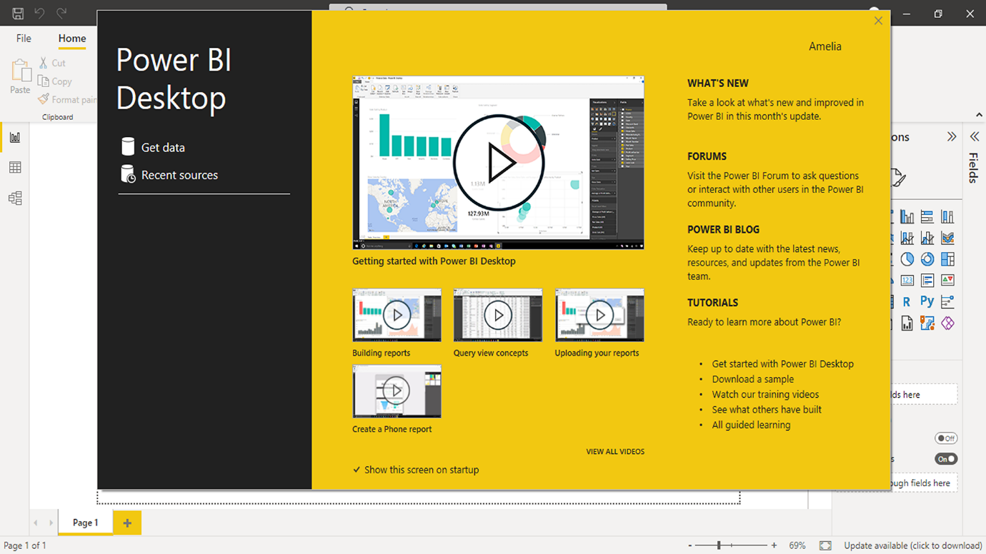

**Microsoft Power BI service**

When you begin your data journey with Power BI Desktop, you continue it with Power BI service. This is Microsoft's cloud-based platform, also known as Power BI online. Imagine you’ve just completed a comprehensive sales report for Adventure Works, utilizing Power BI Desktop. You've transformed the data sources into a well-structured data model, and your report perfectly summarizes the company's sales trends, customer demographics, and product performance. With a report that good, you don’t want to confine it just to your desktop, do you? That’s when you use Power BI service. When you build your report in Power BI Desktop, you then seamlessly publish it to the Power BI service. Select the *Publish* button, and your report is in the cloud, accessible from anywhere, not just locked away on your local machine. This publishing step acts as a bridge between your local data analysis environment (Power BI Desktop) and a collaborative, shareable, cloud-based platform (Power BI service).

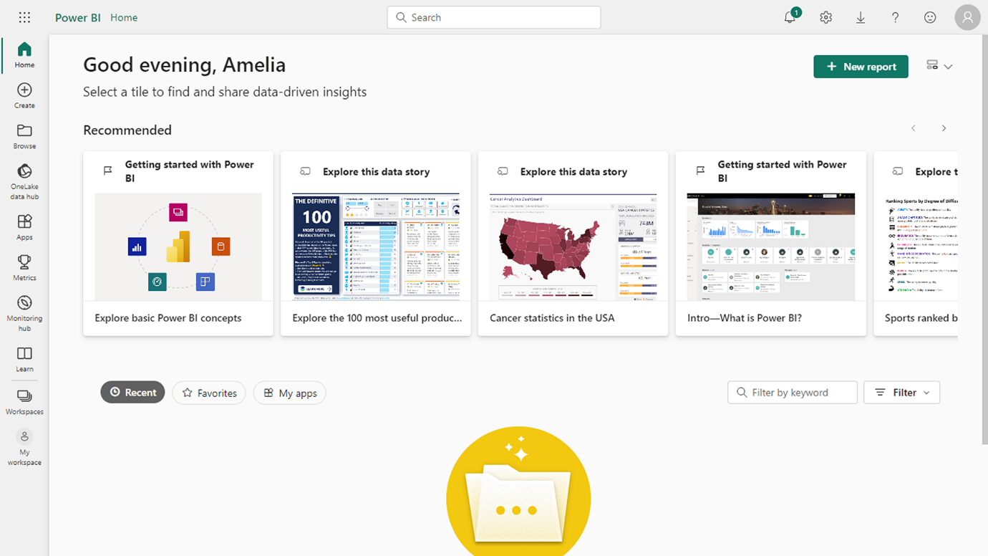

**Microsoft Power BI Mobile**

Power BI isn't just confined to your desktop or a cloud service on your computer; you can work with Power BI wherever you are. With the Power BI Mobile app, on iOS and Android devices, your reports and dashboards are always available on your smartphone or tablet. This powerful app helps ensure that your data insights are always accessible, regardless of your location or device.

Imagine your manager is traveling across continents for a series of meetings. During a meeting, she is asked about the recent sales performance figures. She won’t need paperwork or even a laptop. She pulls out her smartphone and opens the Power BI Mobile. Soon, she is presenting your interactive sales report right there in the meeting room. On the Power BI Mobile app, reports are optimized for mobile viewing, ensuring that the essential details are easy to view and interact with, even on a smaller screen. Monitor your data, collaborate, and share on the go – do everything you would expect from Power BI reports, even when you are out of the office or traveling anywhere.

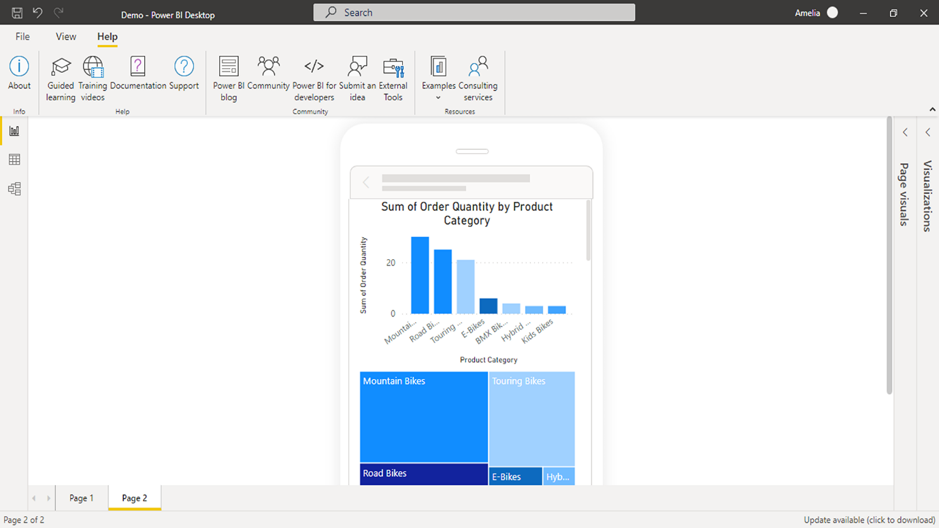

**Compare Power BI Desktop and Power BI service**

While both Power BI Desktop and Power BI service are integral parts of the Power BI ecosystem, they serve distinct roles and cater to different needs. Power BI Desktop is the backstage where all the report authoring happens. It's like a robust data studio designed specifically for deep data preparation, data modeling, and report creation. Power BI service is primarily a collaboration tool for report viewing and sharing, although it can also handle some light editing. More than just a presentation platform, Power BI service enables real-time collaboration and sharing, ensuring that insights can be acted upon promptly. It's like the stage where your reports are presented to the world, where colleagues can view, interact with, and derive insights. Despite their different features and primary functions, Power BI Desktop and Power BI service are designed to complement each other in the data analysis process.

Power BI desktop and Power BI service are contrasted in the following diagram. You may not yet be familiar with all the features shown. Some common functionality is listed in the overlap section. This indicates that you can do some actions in Power BI Desktop or Power BI service. Exclusive characteristics of both products are on the diagram's two outside edges.

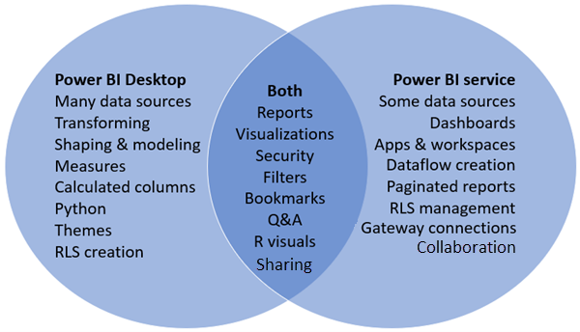

**Conclusion**

Power BI is a powerful suite of business analytics tools from Microsoft. It contains Power BI Desktop, Power BI service, and Power BI Mobile. These three components interact to make Power BI an indispensable asset for any data-driven organization like Adventure Works. The next time you're staring at a large amount of raw data, remember: Power BI is not just a tool—it's your superpower. Whether you're in the depths of data modeling in Power BI Desktop, sharing insights on Power BI service, or reviewing reports on your Power BI Mobile, you have the power to transform data into action. In a world driven by data, that's a superpower worth having. Keep exploring Power BI, investigating its features, and telling your data's full story!

**Question**

What is the main purpose of calculations in Power BI?

To generate new results and insights from data.

Correct

That’s correct! Calculations in Power BI allow you to manipulate data and create new measures or insights for decision-making.

**Setting up your Power BI environment**

**Introduction**

So far, you've learned that Power BI is a powerful tool for data analysis. It's time to explore how to set up your Power BI Desktop environment and kick-start your data analysis journey with Power BI. In this reading, you'll explore different methods for installing Power BI Desktop and how to navigate the installation process to set up your Power BI environment for optimal performance. Setting up your Power BI environment is crucial because it ensures you can access, analyze, and share data efficiently. With a well-configured environment, you can create powerful reports and dashboards that help drive business decisions.

**Power BI Desktop system requirements**

Power BI Desktop is a free download compatible with Windows 7 and later versions. It has minimum and recommended system requirements. Meeting or exceeding these requirements ensures that your Power BI environment runs smoothly and can enhance the application's performance and user experience, especially when working with large or complex datasets.

The minimum requirements include:

* A 1.4 GHz processor
* 1 GB RAM
* 1280x720 screen resolution

However, it's highly recommended to have a system with at least:

* A 2 GHz processor (to enable Power BI to perform more operations per second, resulting in quicker data processing and analysis).
* 4 GB RAM (to allow Power BI to process larger datasets at once without slowing down, which can significantly improve the software's performance).
* 1440x900 screen resolution (to provide more workspace on your screen, allowing you to view more data at once without scrolling).

**Power BI Desktop installation methods**

You can use one of two approaches to access Power BI:

1. Install it as an app from the Microsoft Store.
2. Download it directly as an executable file and install it on your computer.

Although you can install the latest version of Power BI Desktop onto your computer with either approach, there are some advantages to installing it as an app from the Microsoft Store, which will be discussed in the following section.

Let's explore each installation method.

**Approach 1: Install Power BI Desktop as an app from the Microsoft Store**

If you're using Windows 10, you can install Power BI Desktop directly from the Microsoft Store. This method is convenient because it ensures that your Power BI environment is always up to date with the latest features and security updates.

**Advantages**

Installing Power BI Desktop as an app from the Microsoft Store provides the following advantages:

1. **Automatic updates:** Windows downloads the latest version automatically in the background as soon as it's available, so your version is always up to date.
2. **Smaller downloads**: Microsoft Store ensures only components that changed in each update are downloaded to your computer, resulting in smaller downloads for each update.
3. **Admin privilege isn't required:** You do not need to be an administrator for the installation to complete successfully (which is required if you download and install the package directly).
4. **IT roll-out enabled**: Through the Microsoft Store for Business, you can more easily deploy or roll out Power BI Desktop to everyone in your organization.
5. **Language detection**: The Microsoft Store version includes all supported languages and checks the language used on your computer each time it's launched. When you create a Power BI report file (with a **.pbix** extension), it uses the default language you have set on your computer to make the report more understandable and relevant to you.

**Installation instructions**

1. Access the [Power BI download](https://powerbi.microsoft.com/en-us/downloads/) page.

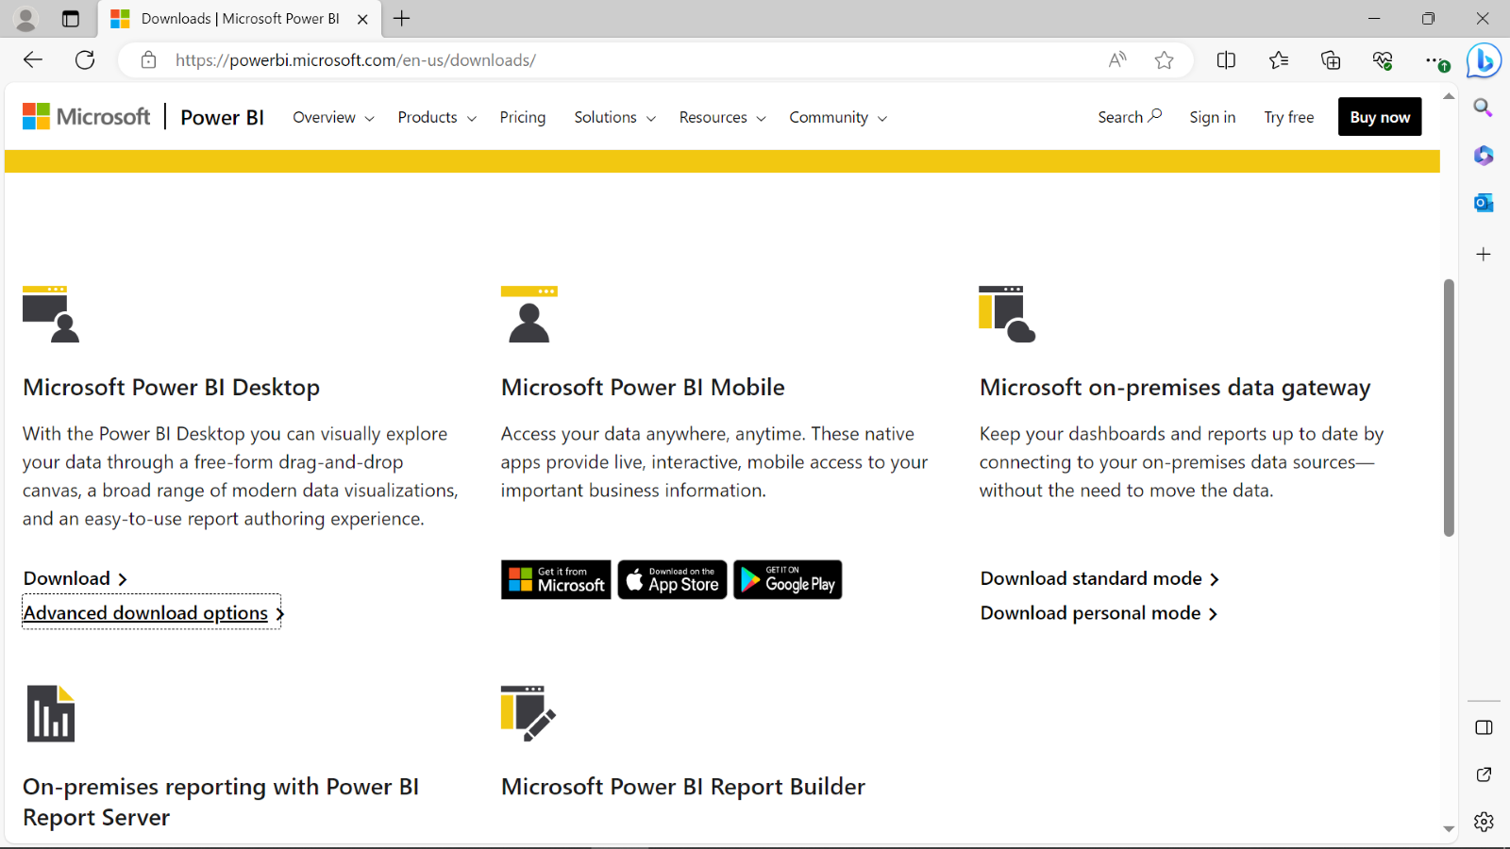

1. Navigate to **Microsoft Power BI Desktop** and select the **Download** option.

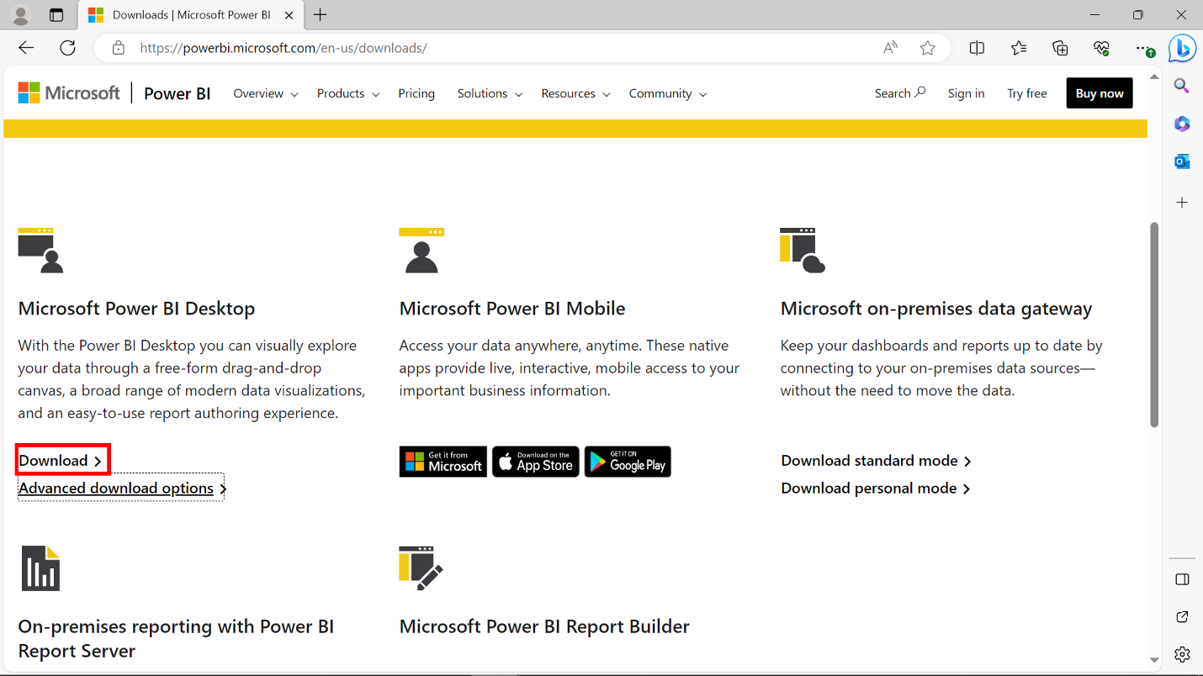

1. A popup appears onscreen, redirecting you to the Microsoft Store. Select **Open Microsoft Store**. The Microsoft Store opens in your system. Select **Get** to download **Power BI Desktop** as an application.

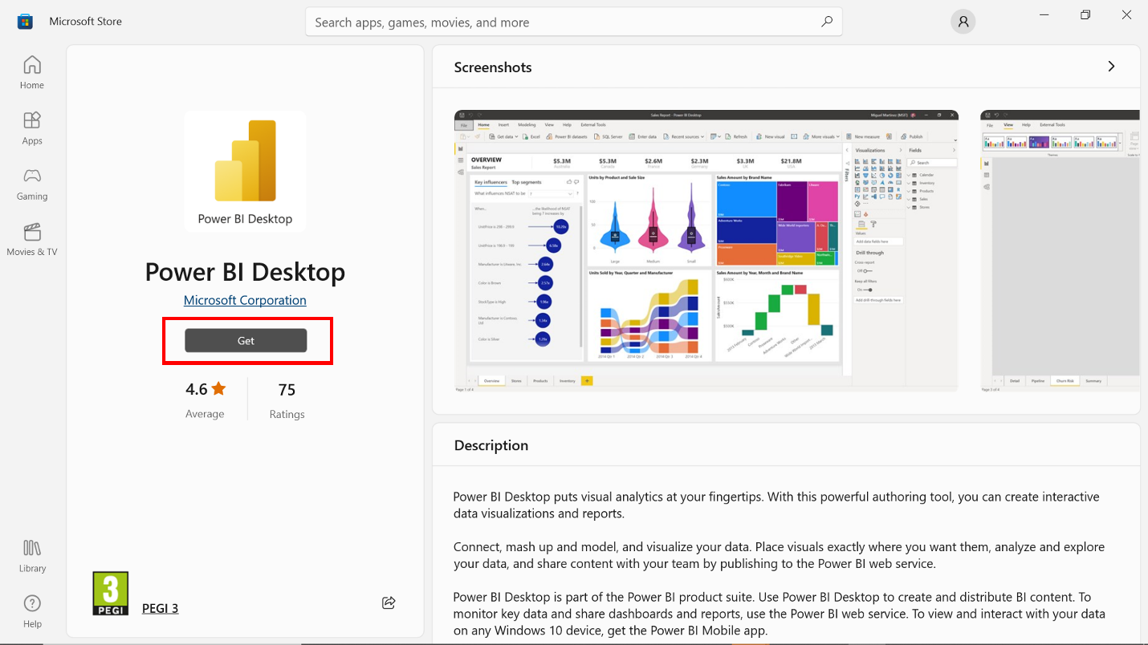

1. The download process begins.

**Approach 2: Download Power BI Desktop directly**

This method is suitable if you're using an older version of Windows or prefer manual installation. Remember to manually update your Power BI environment if you choose this method.

Power BI Desktop is available in a single **.exe** installation package that contains all supported languages, with separate **.exe** files for the 32-bit and 64-bit versions.

As **.msi** installation packages are no longer available, you must install Power BI Desktop using the executable file. This approach makes distribution, updates, and installation easier and more convenient for administrators.

**Installation instructions**

1. Access the [Power BI download](https://powerbi.microsoft.com/en-us/downloads/) page.



1. Navigate to **Microsoft Power BI Desktop** and select **Advanced download options**.

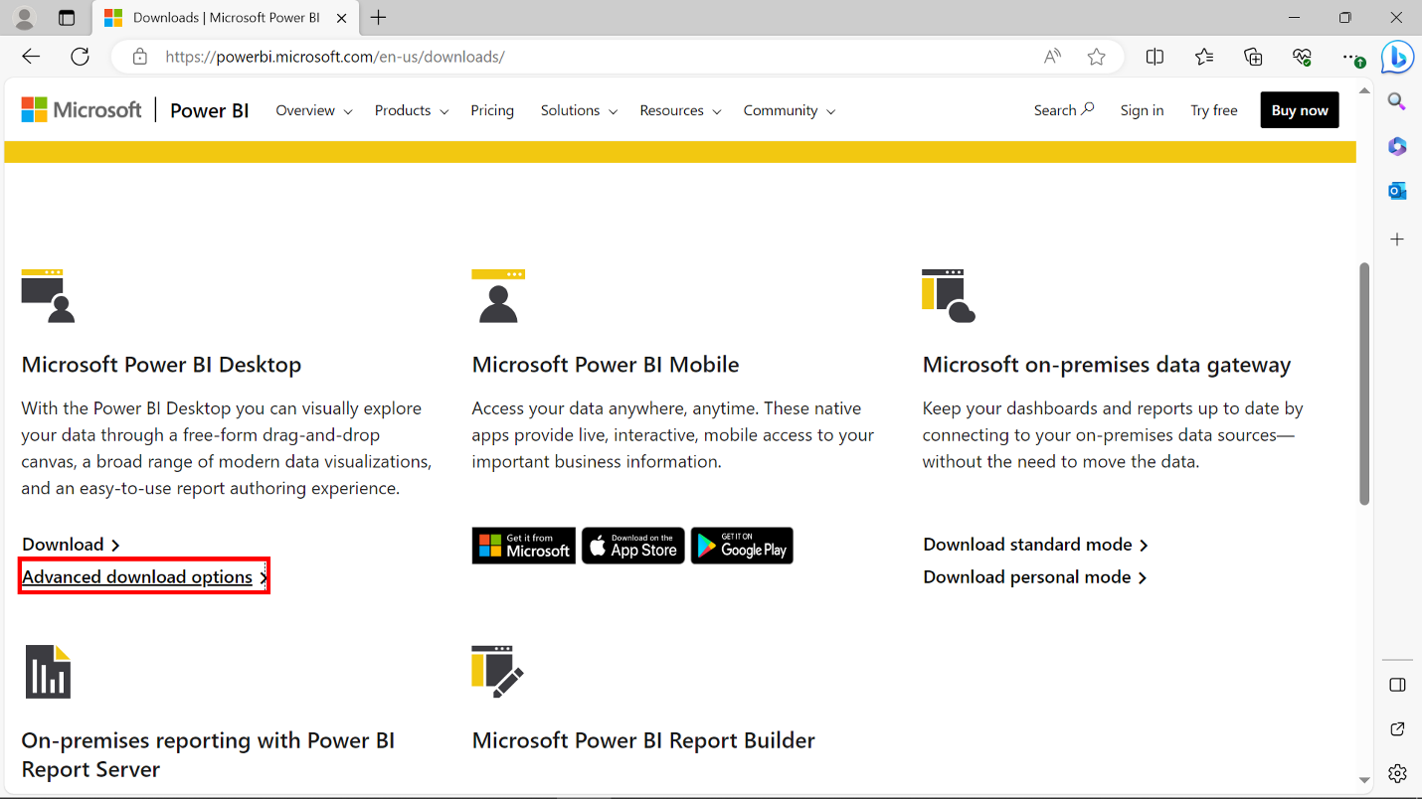

1. Your browser redirects you to the Microsoft Download Center's page for **Power BI Desktop**. Select your preferred language from the options in the **Select language** drop-down list. Then select **Download** to download Microsoft Power BI directly.

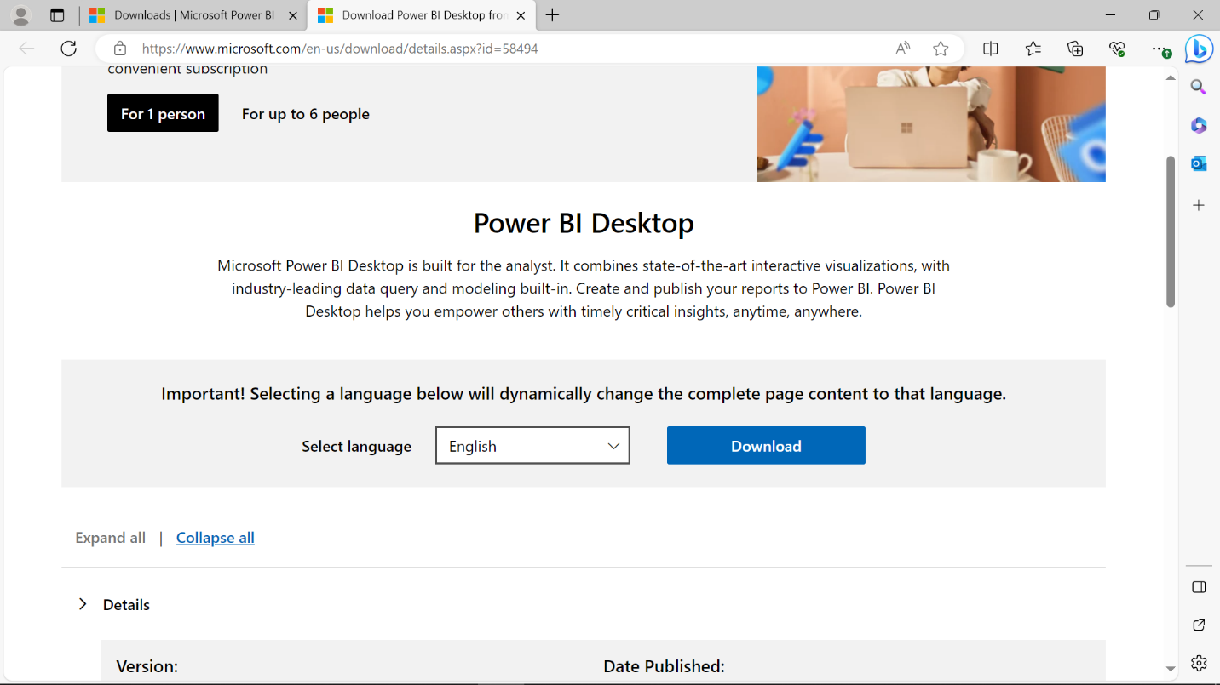

1. A dialog box onscreen offers 32-bit and 64-bit versions of the Microsoft Power BI Desktop setup **.exe** file. Download the version that matches the architecture of your Windows operating system.

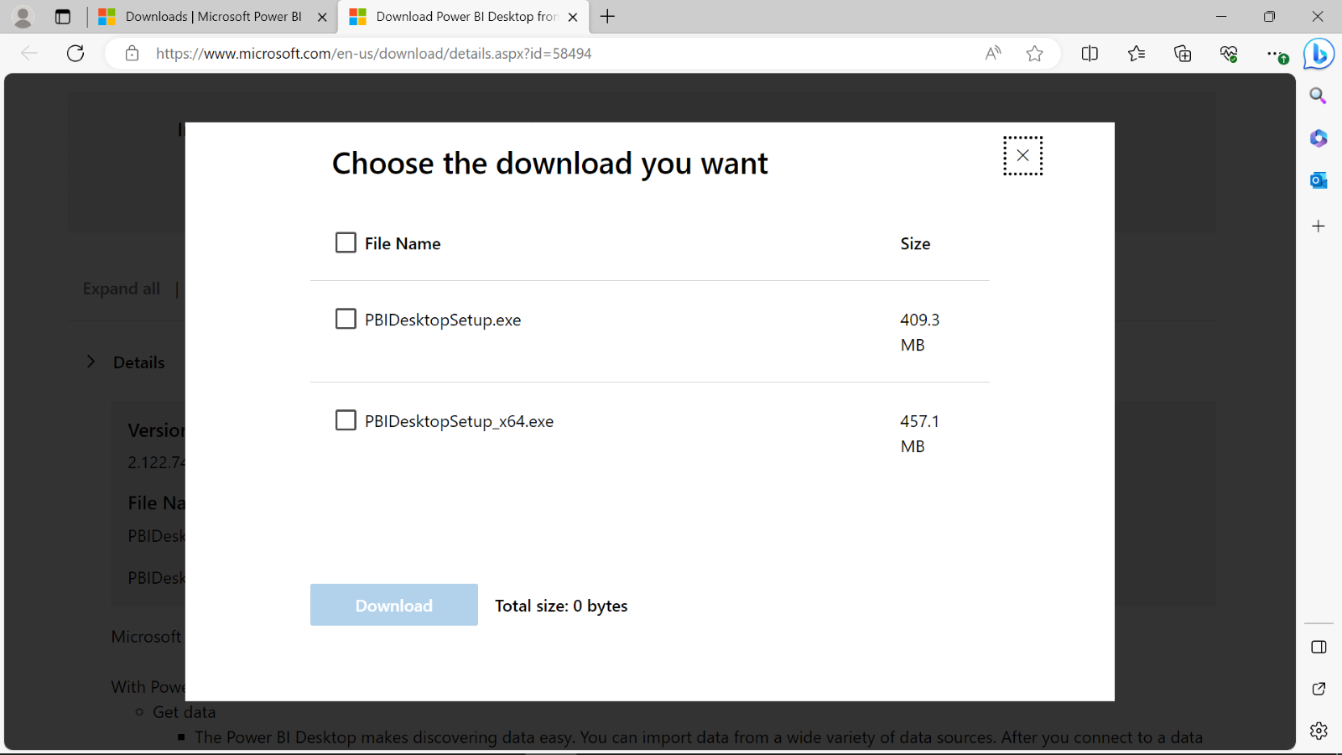

1. Access your downloads folder and select the **PBIDesktopSetup** file for installation.

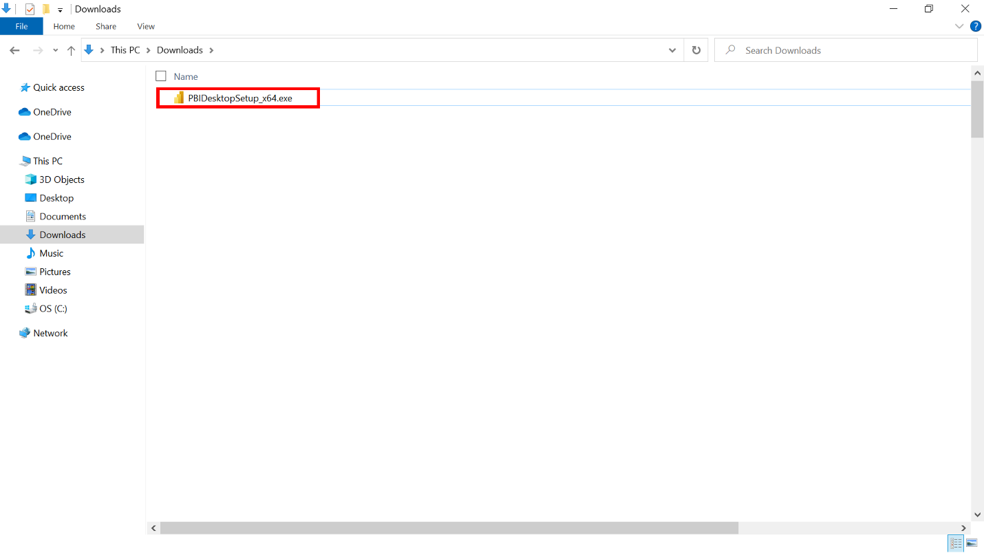

1. Select the appropriate language from the Setup Wizard welcome screen, then select **Next** to begin the installation process.

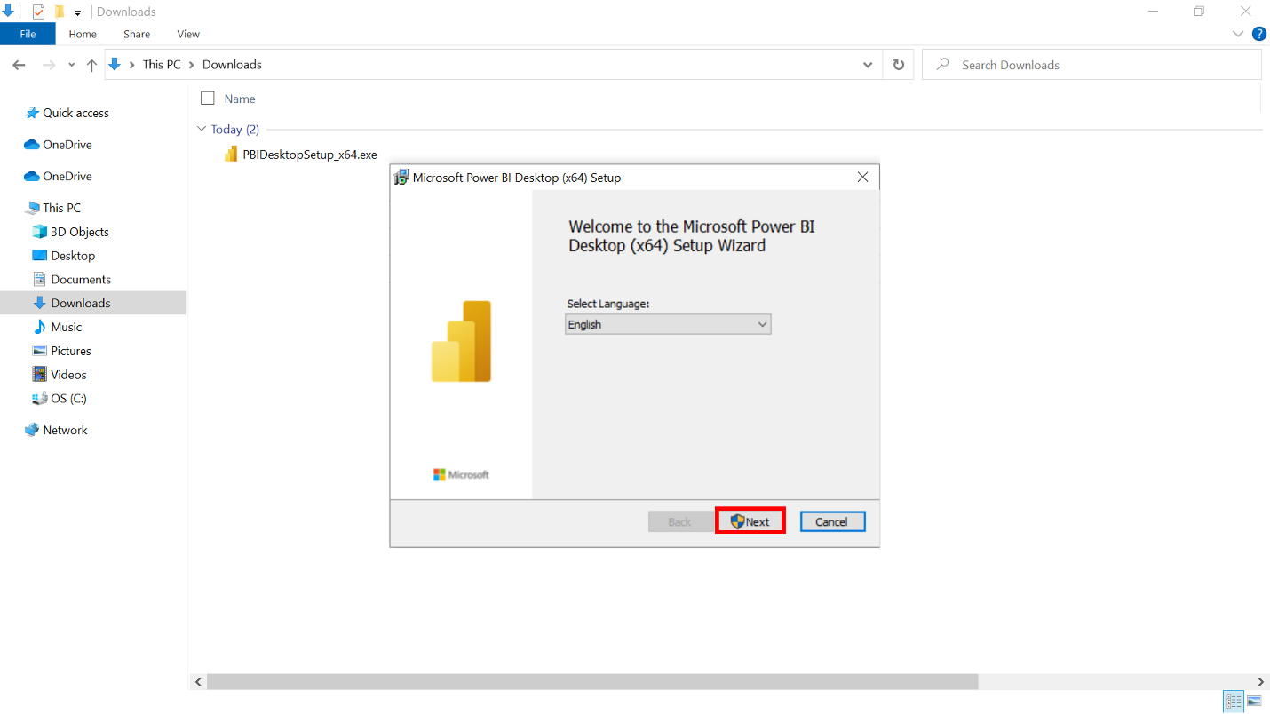

1. Complete the installation process as instructed by the Setup Wizard.

**Launching Power BI Desktop**

After installing Power BI, you can launch it via the **Start** menu. You can also select the search icon and search for **Power BI** to find and launch the application quickly.



**Power BI Desktop user interface**

Power BI Desktop is updated and released every month, incorporating customer feedback and new features.

You might experience changes in the Power BI Desktop user interface (UI) that have taken place after developing this training content. As a result, the screenshots in the videos, readings, or exercises might not align exactly with how you experience the UI.

However, please note that these changes do not impact the functionalities of the UI. This means you can still perform all the steps shown in that video, reading, or exercise.

**Conclusion**

In this reading, you explored the system requirements for Power BI Desktop, two methods of installation and setup (using the Microsoft Store or direct download), and the advantages of installing Power BI Desktop as an app from the Microsoft Store.

**Activity: How to view a report**

**Introduction**

To work as a Power BI analyst, you need to understand Power BI’s features, functionalities, and capabilities. In this activity, you’ll be guided through a Power BI project and explore Power BI’s interactive features and functionalities. From navigating report pages and interacting with visuals to customizing views and exporting reports, you'll gain hands-on experience in Power BI.

**Instructions**

**Open a Power BI report (.pbix) file**

1. Download the provided *Sales and Returns Sample.pbix*file.

[Sales & Returns Sample](https://d3c33hcgiwev3.cloudfront.net/zbBvUetST4u8vCLJmbZDXQ_3c030a94a0ab45f997afa737befed8f1_Sales-Returns-Sample.pbix?Expires=1742083200&Signature=jj4cbNbcmEq8YkLs2zs-rMyPba4qStwPadyplp4ji9~EXAdQmzAWA7KdQhmsAHyWQgCHPc9~7uFGozWHRgcWbV4IFwsnK3Y6IMCwb-tbNRAVOk~tQG7JnzweqajVJwkoWNGH4bCaPkou18VxabIkfYTn-qhHWcf5VDXuT3HDyMk_&Key-Pair-Id=APKAJLTNE6QMUY6HBC5A" \t "_blank)

[PBIX File](https://d3c33hcgiwev3.cloudfront.net/zbBvUetST4u8vCLJmbZDXQ_3c030a94a0ab45f997afa737befed8f1_Sales-Returns-Sample.pbix?Expires=1742083200&Signature=jj4cbNbcmEq8YkLs2zs-rMyPba4qStwPadyplp4ji9~EXAdQmzAWA7KdQhmsAHyWQgCHPc9~7uFGozWHRgcWbV4IFwsnK3Y6IMCwb-tbNRAVOk~tQG7JnzweqajVJwkoWNGH4bCaPkou18VxabIkfYTn-qhHWcf5VDXuT3HDyMk_&Key-Pair-Id=APKAJLTNE6QMUY6HBC5A" \t "_blank)

1. Launch Power BI Desktop.



1. Select **Open other reports** in the welcome screen or go to **File** in the top left corner and then select **Open**.

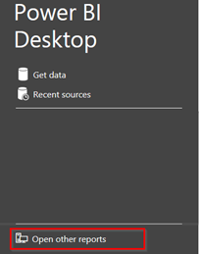

1. Browse to the location where your .pbix file is stored, select the file, and click **Open**.

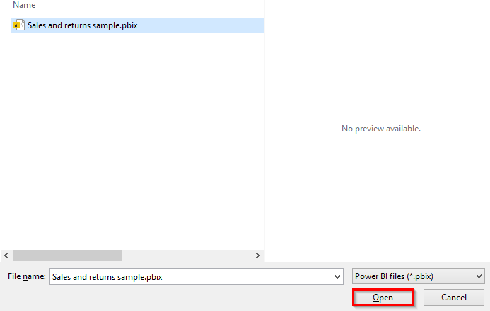

**Explore the Power BI interface**

Locate and familiarize yourself with the following sections of the Power BI interface:

1. **Ribbon:** The ribbon, located at the top of the screen, contains various tools and features to help you create and modify reports.

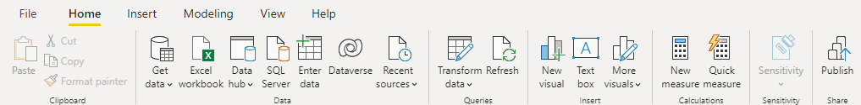

1. **Report View:** This is the main working area where you'll create and edit visualizations.

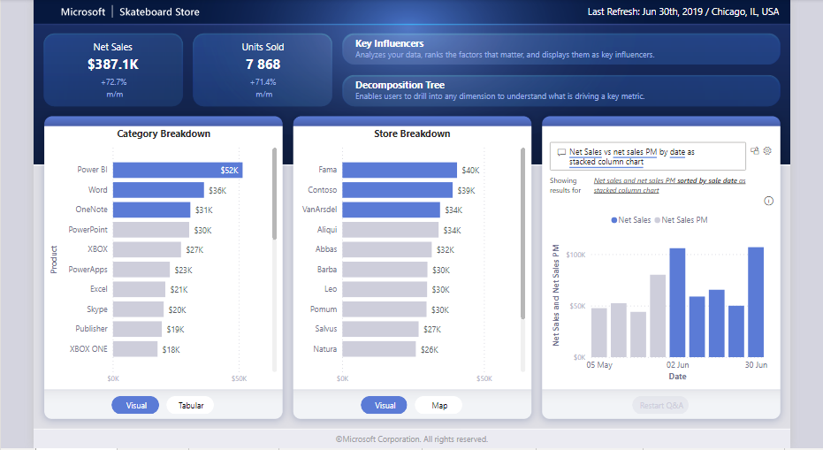

1. **Pages:** Located at the bottom of the screen, the Pages section allows you to switch between different report pages.



1. **Visualizations Pane:** Located on the right side of the screen, this pane displays a list of available visualizations that you can add to your report.

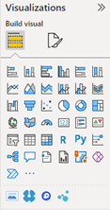

1. **Fields Pane:** Located next to the Visualizations Pane, the Fields Pane displays a list of available data fields from the data model that can be added to visualizations.

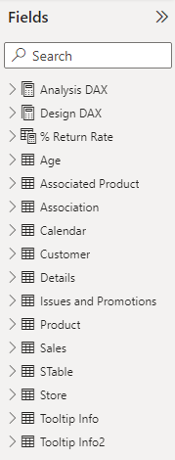

**Navigate report pages**

1. Locate the **Report View**, which should be automatically opened when you open the *Sales and returns sample.pbix* file. If not, select the **Report** icon in the left-hand pane.

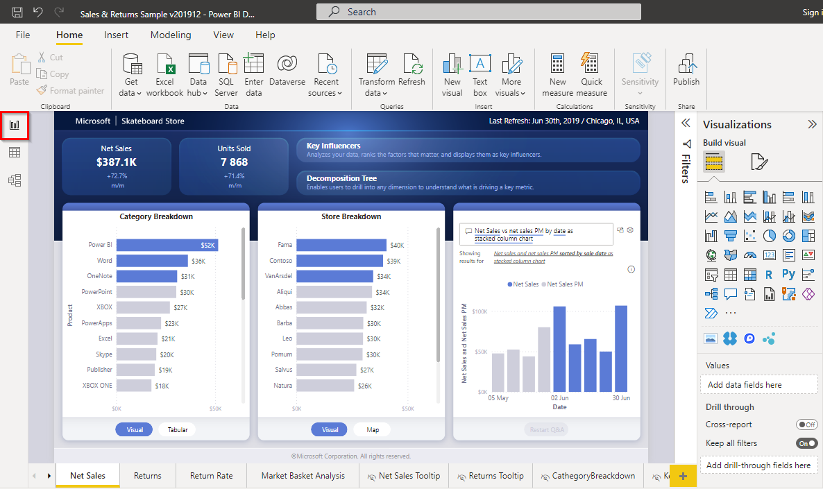

1. To switch between report pages, select the **page tabs** located at the bottom of the screen.

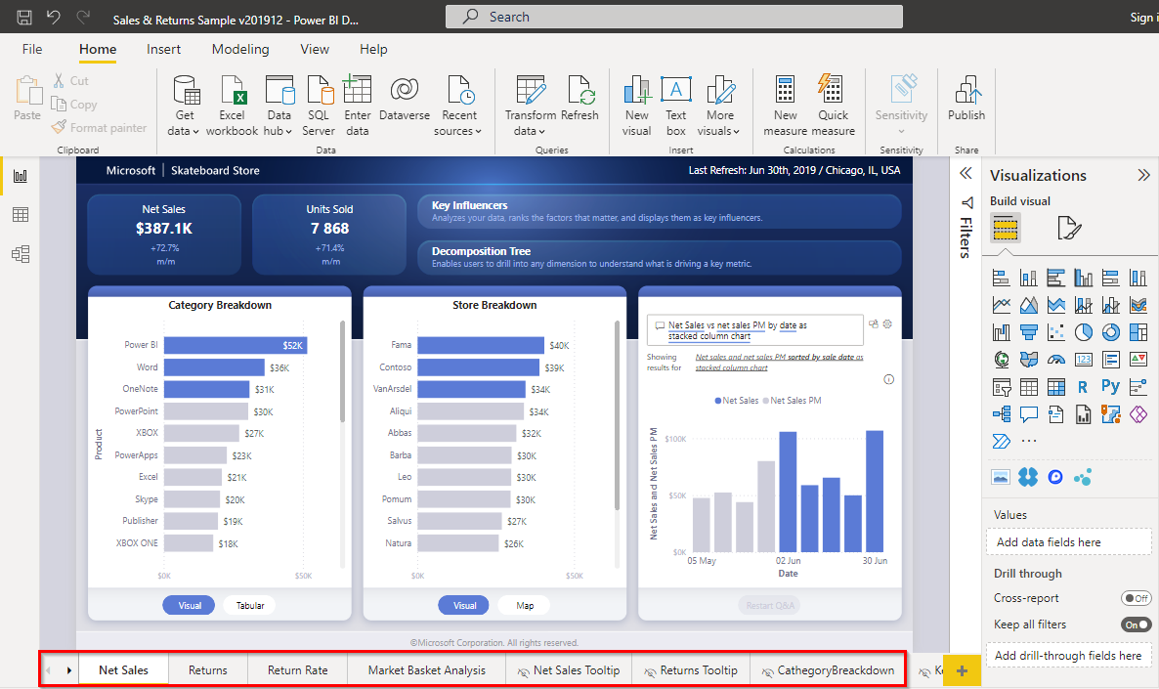

1. To add a new page, select the **+** icon next to the existing pages.

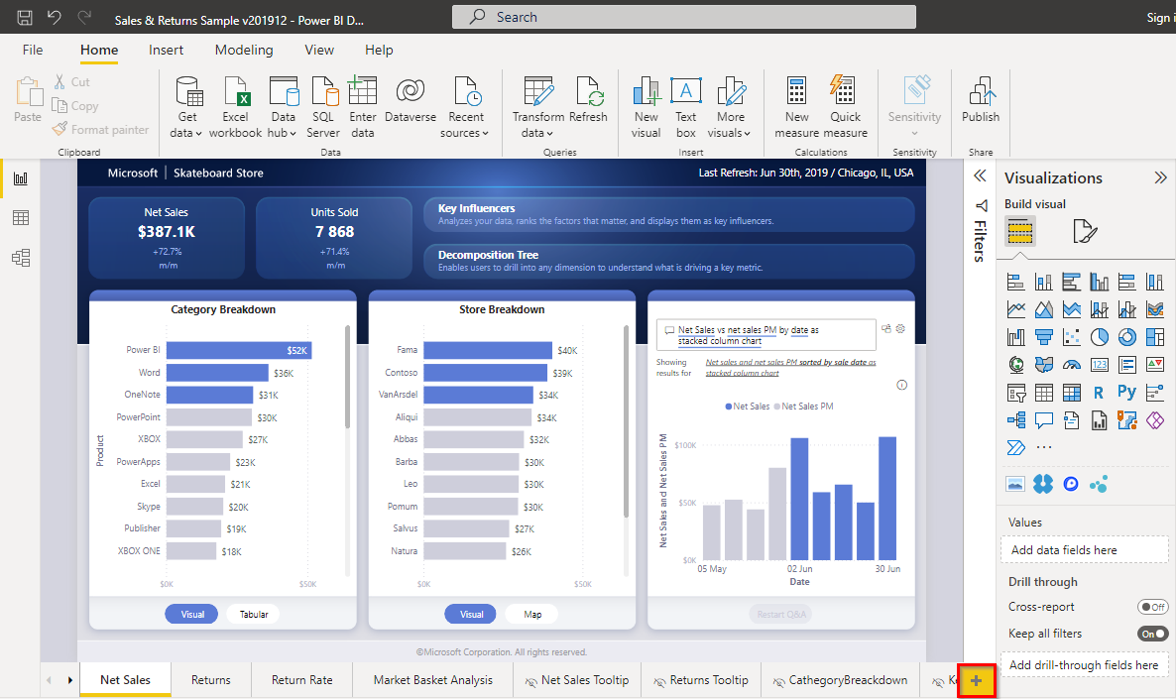

1. To delete or duplicate a page, right-click on the page tab and select **Delete** or **Duplicate**.

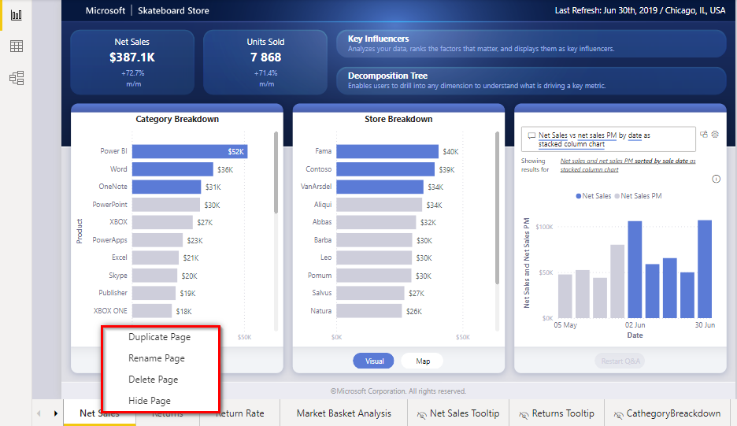

**Interact with visualizations**

1. To select a visualization, select it within the **Report View**.

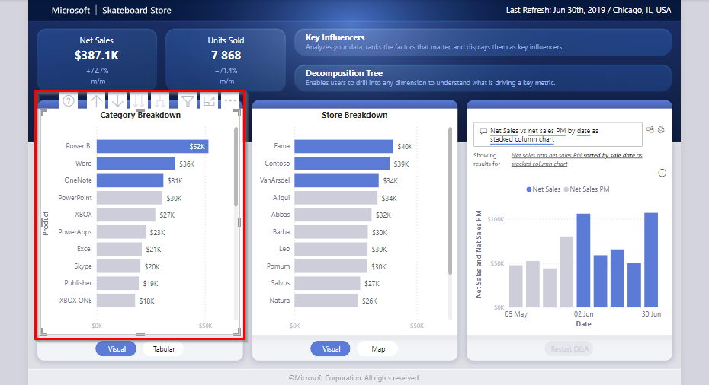

1. To move a visualization, select and drag it to the desired location.

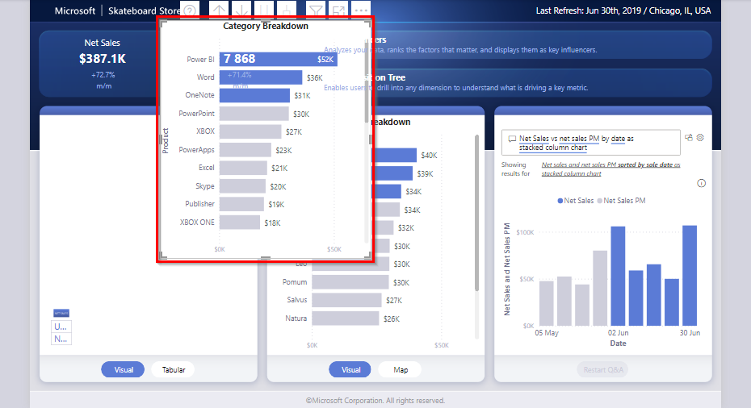

1. To resize a visualization, select and drag the **small borders** located at the edges of the visualization.

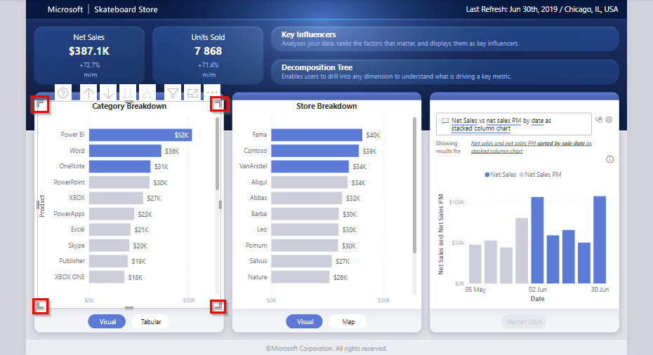

1. To access additional options, such as sort by, spotlight, or export data, select the **ellipsis** (three dots) located at the top-right corner of the visualization.

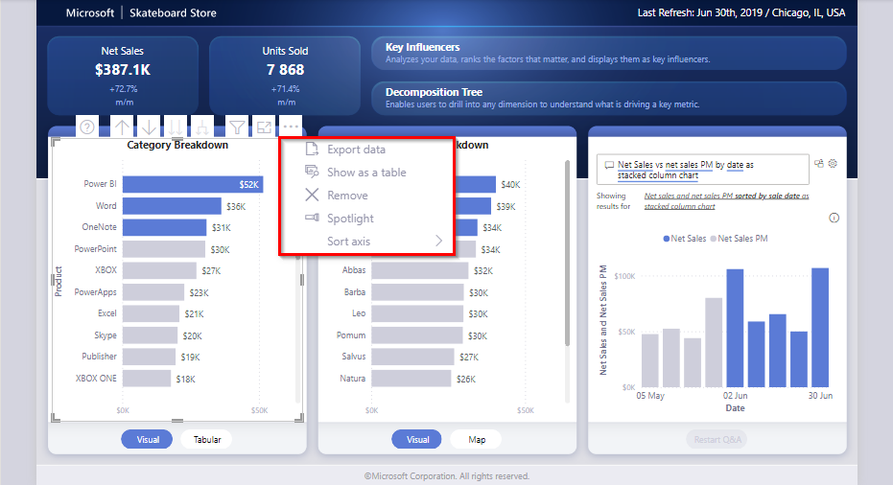

**Interact with the report**

1. Hover over different data points, bars, or lines in the visuals to view **tooltips** with additional information.

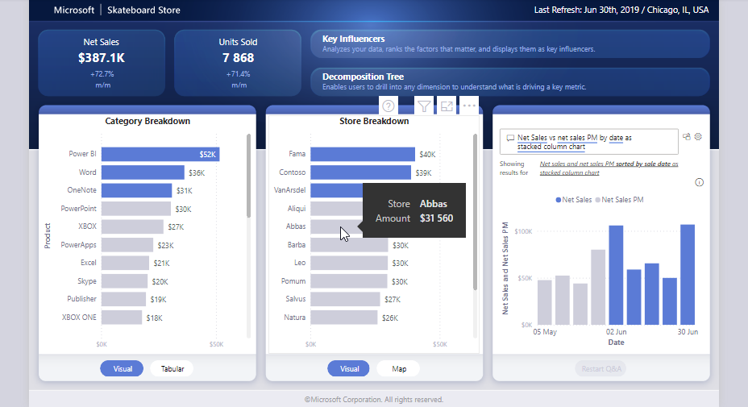

1. Select specific **data points** or **categories** in the visuals to filter or cross-highlight related visuals in the report.

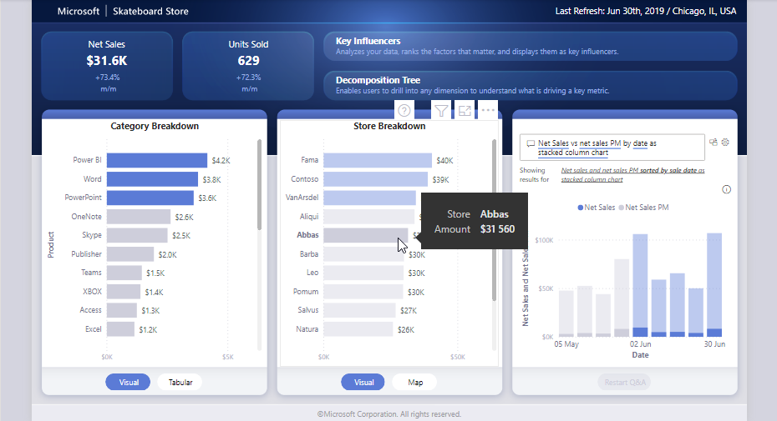

**Drill down into the data**

1. Locate visuals with the **drill down functionality** enabled (usually indicated by a single or double-arrow icon in the visual's top-right corner).

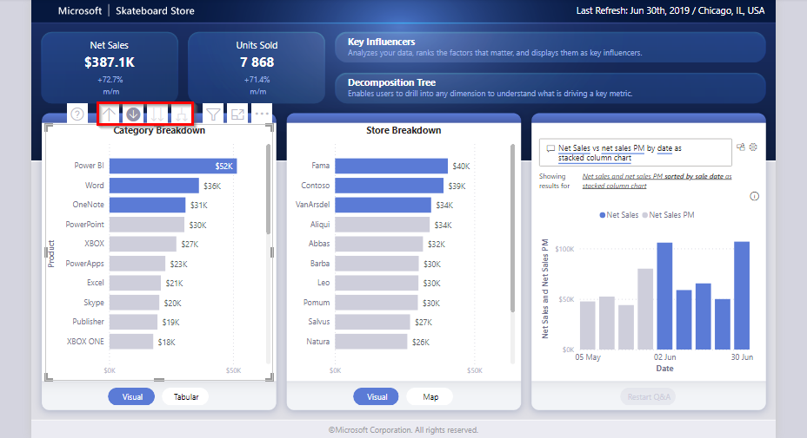

1. Select the **drill down** button and then select a data point to view more granular data.

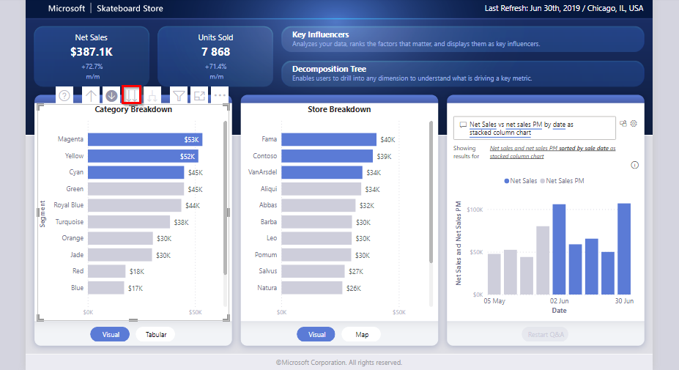

1. Use the **drill up** button (a single upward-facing arrow) to return to the previous level of the visual.

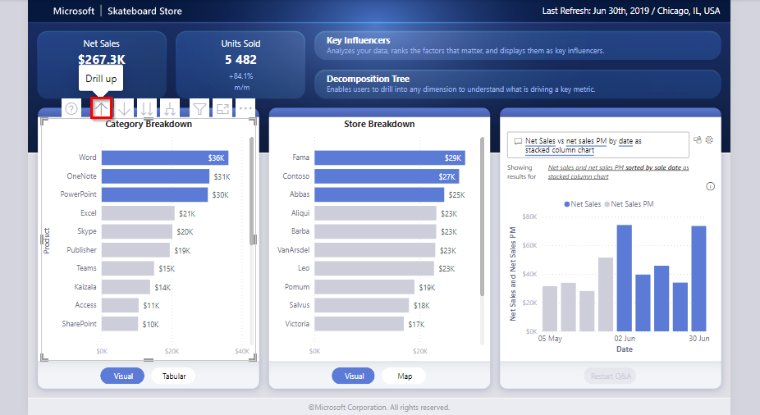

**Conclusion**

In this activity, you navigated a Power BI report (.pbix file), exploring Power BI’s interface and some of the available features and functionalities. By following these steps, you gained hands-on experience with navigating a report and some of the skills necessary for using the Power BI interface to tackle real-world data challenges head-on.

**Exercise: Generate a visualization**

**Introduction**

Visualizations allow you to transform complex data into easily digestible and visually appealing charts, graphs, and maps, enabling you and your team to gain insights, and effectively communicate your findings. Visuals also aid stakeholders in reaching data-driven decisions. In this exercise, you’ll engage in the process of creating interactive visualizations using Microsoft Power BI for Adventure Works. By the end of this exercise, you'll understand how to import data into Microsoft Power BI, create interactive filters, and design different types of visualizations to effectively communicate insights and contribute meaningfully to data-driven decision-making.

**Case study**

Your manager at Adventure Works, Adio, hands you a comprehensive dataset containing information on sales, order statuses, and product performance from the past month. The company wants to understand its performance, identify growth opportunities, and streamline operations to remain competitive in the fast-paced outdoor gear market. As you start reviewing the dataset, you quickly realize that it's a large amount of data. It has hundreds of rows and columns. While the raw data holds valuable insights, its size makes it challenging to evaluate and difficult to communicate insights effectively to your team and stakeholders. This is where visualizations can help!

By using Microsoft Power BI, you'll be able to create a compelling and interactive dashboard to help Adio and the entire Adventure Works team better understand the company's performance and drive strategic decision-making. There is a wide range of core visualizations available in Power BI to help you display your data effectively.

**Instructions**

Create a new Microsoft Power BI project called *Exercise: Generate a visualization*. Follow the prompts below to complete the exercise.

**Step 1: Import data**

* Launch Microsoft Power BI Desktop to allow you to create the visualizations.
* Import the Adventure Works sales dataset called *Adventure Works sales dataset.csv.* This is the dataset you want to visualize.

[Adventure Works sales dataset](https://d3c33hcgiwev3.cloudfront.net/i4LNmR9pROuHP1JLs5i4ng_3652883b57554acc8bc5cac94f5dc5e1_AdventureWorks-sales-dataset.csv?Expires=1742083200&Signature=AbXJS~gh2oqmiAjybDuEX5OkJvgvm6whYSZlSf-te-L5MYTBFahJLS-H7tttWMYyvwyvhjnvvq3lh4wmf3U3-l7XbOBo7yhzseDdU1Ljl-c7zbzVK5Lz07Ww0Z2pFB373qKh2SX4gUqqTAR09QF8YqKhjXeWB2yPpzzWxGjtmCo_&Key-Pair-Id=APKAJLTNE6QMUY6HBC5A" \t "_blank)

[CSV File](https://d3c33hcgiwev3.cloudfront.net/i4LNmR9pROuHP1JLs5i4ng_3652883b57554acc8bc5cac94f5dc5e1_AdventureWorks-sales-dataset.csv?Expires=1742083200&Signature=AbXJS~gh2oqmiAjybDuEX5OkJvgvm6whYSZlSf-te-L5MYTBFahJLS-H7tttWMYyvwyvhjnvvq3lh4wmf3U3-l7XbOBo7yhzseDdU1Ljl-c7zbzVK5Lz07Ww0Z2pFB373qKh2SX4gUqqTAR09QF8YqKhjXeWB2yPpzzWxGjtmCo_&Key-Pair-Id=APKAJLTNE6QMUY6HBC5A" \t "_blank)

**Step 2: Create interactive filters**

One method for filtering data is a slicer—a visual tool that enables users to filter data interactively within a report.

* To add a slicer for the product category, on the **Home** tab, select **Slicer**.

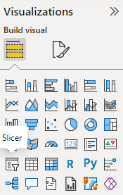

* Drag the **Product Category** field from the **Fields** pane to the slicer visual. This will create an interactive filter based on product categories.

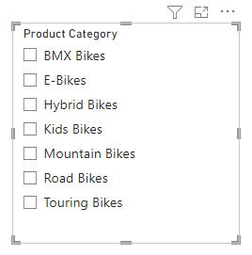

* Repeat the process to create another slicer, this time for the **Payment Method** field.
* For each slicer, add a title by selecting the **Format** tab and choosing **Title** from the options.

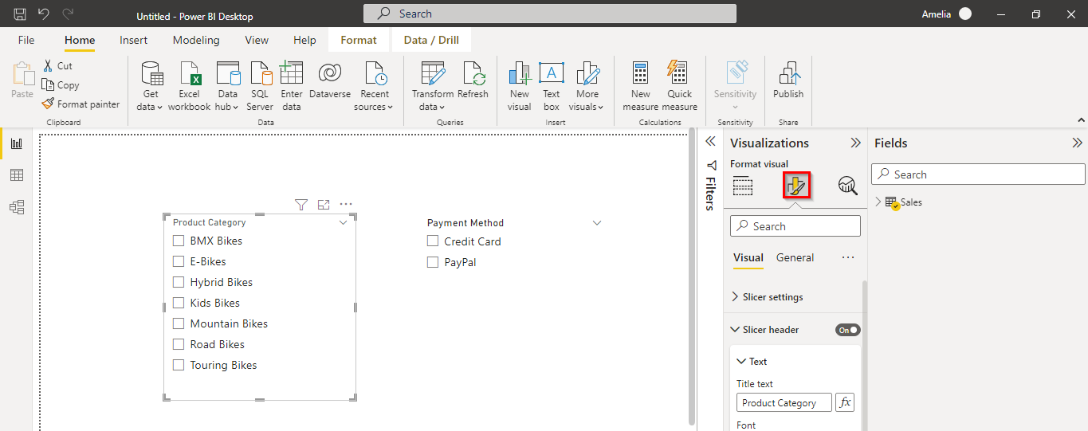

* Drag the positioning of the slicers to the right side of the report area.

**Step 3: Create a stacked column chart**

* Add a stacked column chart to your report. From the **Fields** pane, drag the **Order Total** onto the **Y-Axis**, **Product Size** onto the **X-Axis**, and **Product Category** onto the **Legend**.

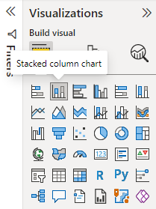

* Set the chart title to **Order Total by Product Size and Product Category for 2023**.
* Drag the stacked column chart visual to the left side of the **Report** area (next to the interactive slicer filters).

**Step 4: Create a donut chart**

* Add a donut chart for **Order Total Share** by **Product Category**.

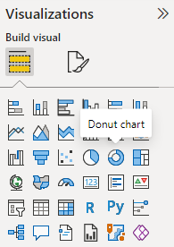

* Set the chart title to **Order Total Share by Product Category for 2023**.
* Drag the donut chart visual below the stacked column chart (created in Step 3).

**Step 5: Create a table**

* Add a table showing all product names with their corresponding order totals.

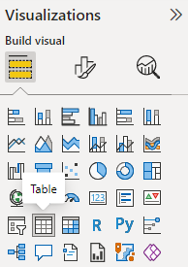

* Drag the table visual to the right side of the **Report** area, below the interactive filters (created in Step 2).

**Conclusion**

In this exercise, you created visualizations that transformed complex data by presenting it in a format that is easier to understand. By using the powerful features of Microsoft Power BI, you can create interactive and compelling dashboards that drive strategic decision-making within your organization.

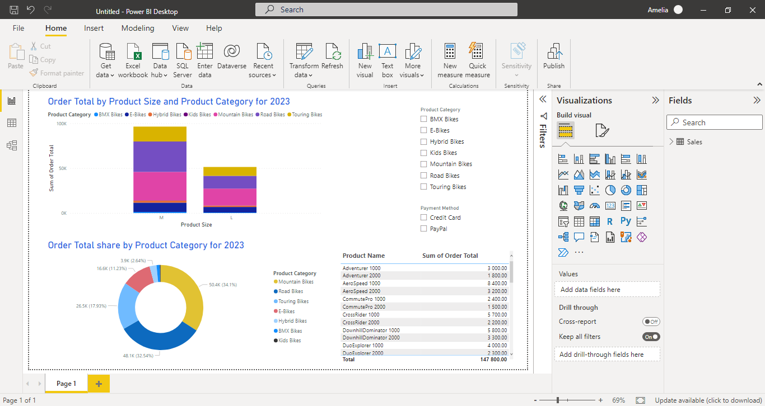

As you continue to develop your skills in data visualization, always remember that the ultimate goal is to communicate complex information in a simple, clear, and engaging manner, enabling everyone to make better decisions and drive positive change.

**Self-review: Generate a visualization**

**1.**

Question 1

Based on your analysis of the Stacked Column Chart visual, which product category has the highest sum of order totals for size M?

Road Bikes

Correct

That’s correct! Road Bikes have the highest sum of order totals for size M, with a total of $33,900. This shows that size M Road Bikes are the most popular among customers.

**2.**

Question 2

In the donut chart displaying the sum of order totals for various product categories, which category has the second highest sum of order totals?

Road Bikes

Correct

That’s correct! Road Bikes have the second highest sum of order totals at $48,100. This indicates that Road Bikes are a popular product category, just behind Mountain Bikes.

**3.**

Question 3

In step 2 of the exercise, what was the purpose of creating slicers?

To allow users to interactively narrow down the data displayed within the report.

Correct

That’s correct! The purpose of the slicers in the exercise was to allow users to interactively filter the data based on product categories and payment methods.

**Knowledge check: Introduction to Power BI**

**1.**

Question 1

What are the main benefits of using Microsoft Power BI for organizations? Select all that apply.

It integrates with a variety of data sources.

Correct

That’s correct! Microsoft Power BI supports many data sources allowing users to consolidate data from multiple sources and create a comprehensive view of their business performance.

It helps organizations make better data-driven decisions.

Correct

That’s correct! Microsoft Power BI enables organizations to make better, data-driven decisions by transforming raw data into meaningful information and insights.

It offers a wide range of visualization options.

Correct

That’s correct! Microsoft Power BI provides a variety of built-in visualization types, such as bar charts and even custom visuals developed by the community.

It reduces the need for technical expertise.

Correct

That’s correct! Microsoft Power BI's easy-to-use interface and drag-and-drop functionality make it accessible to technical and non-technical users.

**2.**

Question 2

What are the benefits of installing Microsoft Power BI Desktop from the Microsoft Store? Select all that apply.

IT roll-out is enabled

Correct

That’s correct! The Microsoft Store for Business allows organizations to quickly deploy Microsoft Power BI Desktop to all staff, simplifying IT roll-out.

Automatic updates

Correct

That’s correct! One advantage of installing Microsoft Power BI Desktop from the Microsoft Store is the automatic update feature.

Smaller downloads for each update

Correct

That’s correct! The Microsoft Store version of Microsoft Power BI Desktop has differential updates, an updating method that results in smaller downloads for each update.

**3.**

Question 3

What is the primary purpose of calculations in Microsoft Power BI?

To manipulate data and create new measures or insights.

Correct

That’s correct! Calculations are used to manipulate data and create new measures or insights to be used for decision-making. They form the foundation of your data analysis in Microsoft Power BI.

**4.**

Question 4

What chart type is most appropriate for comparing the proportions of different categories in a dataset?

Pie chart

Correct

That’s correct! Pie charts are specifically designed for comparing the proportions of different categories in a dataset. They provide a visual representation of each category's proportion relative to the whole.

**5.**

Question 5

Which of the following are valid steps when creating a visualization in Microsoft Power BI Desktop? Select all that apply.

Customize chart titles and colors

Correct

That’s correct! Customizing chart titles and colors is an essential part of the visualization process in Microsoft Power BI Desktop, allowing users to create visually appealing and easily understandable visuals.

Import data

Correct

That’s correct! Importing data is a critical step in creating a visualization in Microsoft Power BI Desktop, as it provides the necessary information for generating visuals.

Create interactive filters

Correct

That’s correct! Creating interactive filters is an important part of the visualization process in Microsoft Power BI Desktop, allowing users to explore the data by filtering displayed information based on specific criteria.

**Module quiz: Data analysis in business**

**NOTE: QUESTIONS MAY CHANGE FOR EACH ATTEMPT**

**1.**

Question 1

Which stage in the data analysis process is specifically focused on creating a data model that represents the structure, relationships, and constraints of the data?

Model

Correct

That’s correct! The model stage focuses on creating a data model that represents the structure, relationships, and constraints of the data. The data model is a foundation for further analysis.

1 / 1 point

**2.**

Question 2

In the data analysis process, what are the goals of data visualization? Select all that apply.

To explore data and identify patterns

Correct

That’s correct! One of the goals of data visualization is to explore data and identify patterns through charts, graphs, and other visual representations of data.

To communicate findings effectively

Correct

That’s correct! One of the goals of data visualization is to communicate findings effectively using visual representations of data.

1 / 1 point

**3.**

Question 3

What is the main responsibility of a Database Administrator (DBA)?

Ensuring the maintenance, performance, and security of an organization's databases

Correct

That’s correct! A Database Administrator (DBA) is responsible for maintaining the performance, security, and overall health of an organization's databases.

1 / 1 point

**4.**

Question 4

What is an important action to ensure your data report is accessible to users with disabilities?

Use small font sizes

Follow the Web Content Accessibility Guidelines (WCAG)

Reduce the depth of data cleaning and preparation

Use complex color schemes

Incorrect

Not quite. Please review the reading [*Sharing data insights.*](https://www.coursera.org/learn/harnessing-the-power-of-data-with-power-bi/supplement/buGEg/sharing-data-insights)

0 / 1 point

**5.**

Question 5

Why is it important to establish a data storage and refresh schedule for your reporting?

To ensure the data is always up-to-date and consistent across reports

Correct

That’s correct! A data storage and refresh schedule for reports ensures users are working with the most current data available and helps maintain data consistency across different reports

1 / 1 point

**6.**

Question 6

What are some primary purposes of data insights in the context of business decision-making? Select all that apply.

To inform business decisions and drive growth

Correct

That’s correct! Data insights are used to inform business decisions and drive growth by helping businesses identify new opportunities, make informed decisions, and improve overall performance.

To optimize business processes and improve efficiency

Correct

That’s correct! Data insights can help businesses optimize their processes and improve efficiency by identifying bottlenecks, streamlining workflows, and uncovering areas for improvement.

1 / 1 point

**7.**

Question 7

In the final stage of data analysis, what is the primary purpose of data insights? Select all that apply.

To support informed decision-making

Correct

That’s correct! Data insights help support informed decision-making by identifying trends, patterns, and opportunities that can help businesses grow.

To identify trends, patterns, and opportunities

Correct

That’s correct! Data insights are used to identify trends, patterns, and opportunities that can lead to actionable business decisions and help businesses grow.

1 / 1 point

**8.**

Question 8

Which of the following Microsoft Power BI features enable users to manipulate, clean, and transform data, or support advanced analytics? Select all that apply.

Query Editor

Correct

That’s correct! The Query Editor in Microsoft Power BI is a tool that allows users to clean, transform, and reshape data as needed before it is loaded into the data model.

Data Analysis Expressions (DAX)

Correct

That’s correct! DAX is a formula language in Microsoft Power BI primarily used for advanced analytics and complex calculations, such as creating calculated columns and measures.

1 / 1 point

**9.**

Question 9

**True or False:** Effective communication is the most crucial non-technical skill for data analysts when presenting findings to stakeholders with different levels of technical knowledge.

True

Correct

That’s correct! Effective communication allows data analysts to present complex information clearly and concisely to various stakeholders, making it the most crucial non-technical skill for presenting findings.

1 / 1 point

**10.**

Question 10

What does the scope of data refer to in the context of data analysis?

The context within which the data is collected, organized, and analyzed

Correct

That’s correct! The scope of the data refers to the context within which the data is collected, organized, and analyzed, including boundaries or limits and the size or amount of the data.

**Additional resources: Introduction to Power BI**

Congratulations on completing your introduction to Microsoft Power BI. In this lesson, you:

* Explored how Power BI can be used as a tool for data analysis.
* Set up your Power BI environment.
* Learned how to view reports and generate interactive visualizations in Power BI using a given dataset.

Although you will learn more about Power BI as you progress through this course, this reading contains links to additional resources that you can explore to gain a deeper understanding of Power BI and Power BI Desktop.

**Official Microsoft Power BI resources**

* [Power BI documentation](https://docs.microsoft.com/en-us/power-bi/): Explore the official Microsoft Power BI documentation for comprehensive guides, tutorials, and examples that can help you get started with Power BI.
* [Power BI learning path](https://learn.microsoft.com/en-us/training/powerplatform/power-bi): Grow your Power BI skills through the guided learning paths for Power BI by Microsoft.
* [Power BI videos](https://learn.microsoft.com/en-us/power-bi/fundamentals/videos): Explore video demos on working with Power BI, view and link directly to the latest videos, and find training and product updates.
* [Power BI e-book](https://download.microsoft.com/download/0/8/1/0816F8D1-D1A5-4F60-9AF5-BC91E18D6D64/Microsoft_Press_ebook_Introducing_Power_BI_PDF_mobile.pdf): If you prefer reading content, discover more about Power BI and its features with this Microsoft e-book.
* [Power BI blog](https://powerbi.microsoft.com/en-us/blog/): Stay updated with the latest news, announcements, and best practices for Power BI.
* [Power BI community](https://community.powerbi.com/): Ask questions, share your knowledge, and learn from other Power BI users.
* [Power BI Desktop](https://powerbi.microsoft.com/en-us/desktop/): Learn more about the Microsoft Power BI Desktop app and its features.

**Conclusion**

These Microsoft Power BI resources should help you enhance your knowledge of Power BI and connect you with recent developments. Use them to update and expand your data analysis skills and techniques.

Mark as completed

Like

Dislike

Report an issue

**Module 2:**

Question

What type of data is primarily collected, stored, and interpreted by Adventure Works' Enterprise Resource Planning (ERP) system?

Structured data

Correct

That’s correct! ERP systems are designed to collect, store, manage, and interpret structured data from various business activities. Structured data is data that is organized into a formatted repository, typically a database, so it's easily searchable.

Question

Which of the following is the SaaS (Software as a Service) based web application of Microsoft Power BI?

Power BI Service

Correct

That’s correct! Power BI Service is the web application, which is a SaaS (Software as a Service) service used by report users and administrators.

**Exercise: Dataset**

**Introduction**

In previous lessons, you explored the importance of data for businesses and organizations, and in this context, you evaluated topics such as defining data, extracting meaningful information from data, deriving insights from this information, and using those insights in business decision-making. You also learned about the components of Microsoft Power BI and started to familiarize yourself with the software and its workflow.

In this exercise, by examining a case study dataset in detail, you will become more familiar with the data, and evaluate whether the data you have is sufficient to achieve a specific defined business objective.

At the end of this exercise, you should feel more confident in understanding, interpreting, and aligning data with business needs.

**Case study**

Adventure Works is a large, multinational manufacturing company that produces and distributes bicycles and accessories to global markets. Renee, an Adventure Works executive, has tasked you with tracking the price increase on a supplier basis from the past to the present for each product the company purchases from suppliers and detecting any unusual price situations, if any.

She shared a file with you, a Microsoft Excel workbook called *Adventure Works Inventory.xlsx*. Your task is to examine the *Products* worksheet of the workbook and decide whether the Excel data is compatible with the required business needs.

**Instructions**

**Step 1: Download and review the data to understand the context**

1. Download and open the Microsoft Excel workbook *Adventure Works Inventory.xlsx.* The workbook consists of a single worksheet named *Products*.

[Adventure Works Inventory](https://d3c33hcgiwev3.cloudfront.net/EClEY2qaTHmyTxk_PF1HEg_18014f96b6da49e78c2f49bbfb5f91e1_Adventure-Works-Inventory.xlsx?Expires=1742083200&Signature=anolnguaDfVyTQtsjtWj~GAi6ZZwJa2ejVOZn89lG~I1GcYPeFO0lpvwrUMlS2IZ61RiT06LqOC5GDT5cDRQrMjGmJUWjaTzIgi62Coq~41SxXMJr3btkvheaTzKi9IUN0hGcZlwCmXPsMsvUI7OiC~7JVQUAYevAcnUOPpVqjo_&Key-Pair-Id=APKAJLTNE6QMUY6HBC5A" \t "_blank)

[XLSX File](https://d3c33hcgiwev3.cloudfront.net/EClEY2qaTHmyTxk_PF1HEg_18014f96b6da49e78c2f49bbfb5f91e1_Adventure-Works-Inventory.xlsx?Expires=1742083200&Signature=anolnguaDfVyTQtsjtWj~GAi6ZZwJa2ejVOZn89lG~I1GcYPeFO0lpvwrUMlS2IZ61RiT06LqOC5GDT5cDRQrMjGmJUWjaTzIgi62Coq~41SxXMJr3btkvheaTzKi9IUN0hGcZlwCmXPsMsvUI7OiC~7JVQUAYevAcnUOPpVqjo_&Key-Pair-Id=APKAJLTNE6QMUY6HBC5A" \t "_blank)

2. Review the data and familiarize yourself with the contents.

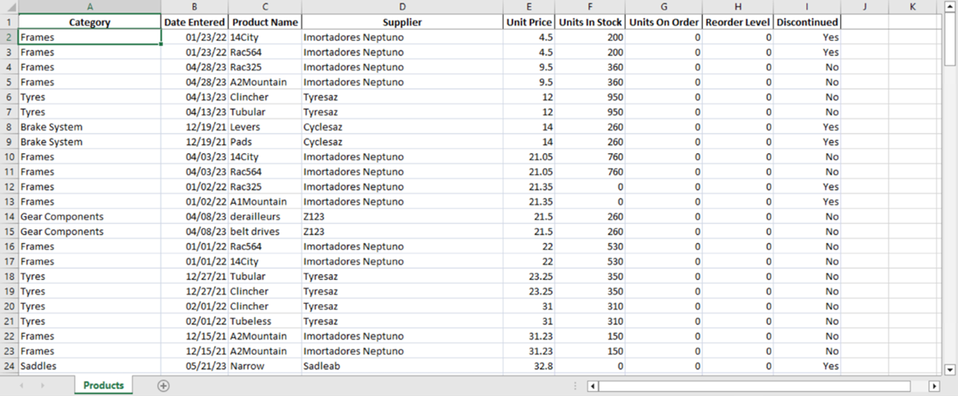

**Step 2: Evaluate the adequacy of the data**

First, you need to evaluate if the data you have is adequate for your assigned task.

The request from Renee can be summarized as monitoring prices by product and supplier from the past to the present.

You will start by examining the data you have been supplied with for this task. Since your assigned task is to analyze the price changes of products from past to present, you must identify the relevant fields accordingly. The existing dataset includes fields such as **Category**, **Date Entered**, **Product Name**, **Supplier**, **Unit Price**, **Units In Stock**, **Units On Order**, **Reorder Level**, and **Discontinued**.

1. In this dataset, locate the required fields for this business need: **DateEntered**, **ProductName**, **Supplier**, and **UnitPrice**.

2. Sort the data based on the **Date Entered** field for each **Product Name**. Examine the **Unit Price** values and take note of the rows that are significantly above or below the average, if any, to be reported in the analysis.

3. Take into account the **Supplier** field in sorting or comparisons. As different suppliers may have different pricing policies for the same product, it would be more accurate to examine any anomalies on a supplier basis, if any.

**Tip:** When you examine the list sorted by products, you may notice that the same supplier is generally used for each product. However, always consider the possibility of examining the data by supplier for this and other similar datasets.

4. Recognize that other fields, namely **Category**, **Units In Stock**, **Units On Order**, **Reorder Level**, and **Discontinued**, are detail fields that are not directly relevant to your current assigned task. They will continue to be included in the list but will not affect our analysis.

In this step, you analyzed in detail how the data supplied to you in the *Adventure Works Inventory.xlsx* file corresponds to the given business needs.

**Conclusion**

By completing this exercise, you should have gained a deeper understanding of the data and learned how to find the relevance between the data and the business need. This exercise has equipped you with the knowledge necessary to effectively match data with business needs and identify the tasks that need to be completed to meet these business requirements.

**Self-Review: Dataset**

1.

Question 1

What is the primary task assigned to you by Renee in the *Assessing a data set* case study?

To track the price increase on a supplier basis from the past to the present for each product the company purchases from suppliers and detect any unusual price situations, if any.

Correct

That’s correct! The primary goal is to track supplier price increases from the past to the present for each product purchased and detect any abnormal price situations, if any.

2.

Question 2

In the *Assessing a data set* case study, which of the following columns need to be considered to track the price increase on a supplier basis from the past to the present for each product and detect anomalies? Select all that apply.

Date Entered

Correct

Correct! The DateEntered column will be used to track the list from past to present.

Supplier

Correct

Correct! In the current dataset, products are purchased from the same supplier. This may vary in the future, giving different price ranges on a supplier basis. Therefore, additional sorting on a supplier basis would be beneficial for the list.

Product name

Correct

That’s correct! The ProductName column is required for this task.

3.

Question 3

Based on your analysis of the data in the *Assessing a data set* case study, is this dataset suitable for the business need as determined by the task assigned to you by Renee?

Yes

Correct

Correct! The dataset contains the required fields for the business need.

**Exemplar: Dataset**

**Introduction**

In the exercise *Assessing a data set,* you should have gained a deeper understanding of the data and learned how to find the relevance between the data and a business need.

This reading is a detailed walkthrough of that process and contains screenshots from key parts of the exercise. Use this reading to compare the outcomes of each step with your own work.

**Excel User Interface**

In this course, we use the Microsoft 365 Desktop version of Excel. Microsoft 365 releases updates on a monthly basis, incorporating new features. You might experience changes in the Excel Desktop User Interface (UI) that have taken place after the development of this training content. As a result, the screenshots in the videos, readings, or exercises might not align exactly with how you experience the UI. However, please note that these changes do not impact the functionalities of the UI. Hence, you will still be able to perform all the steps shown in that video, reading, or exercise.

**Step 1: Download and review the data to understand the context**

1. You downloaded and opened the Microsoft Excel workbook *Adventure Works Inventory.xlsx*. The workbook consisted of a single worksheet named *Products*.

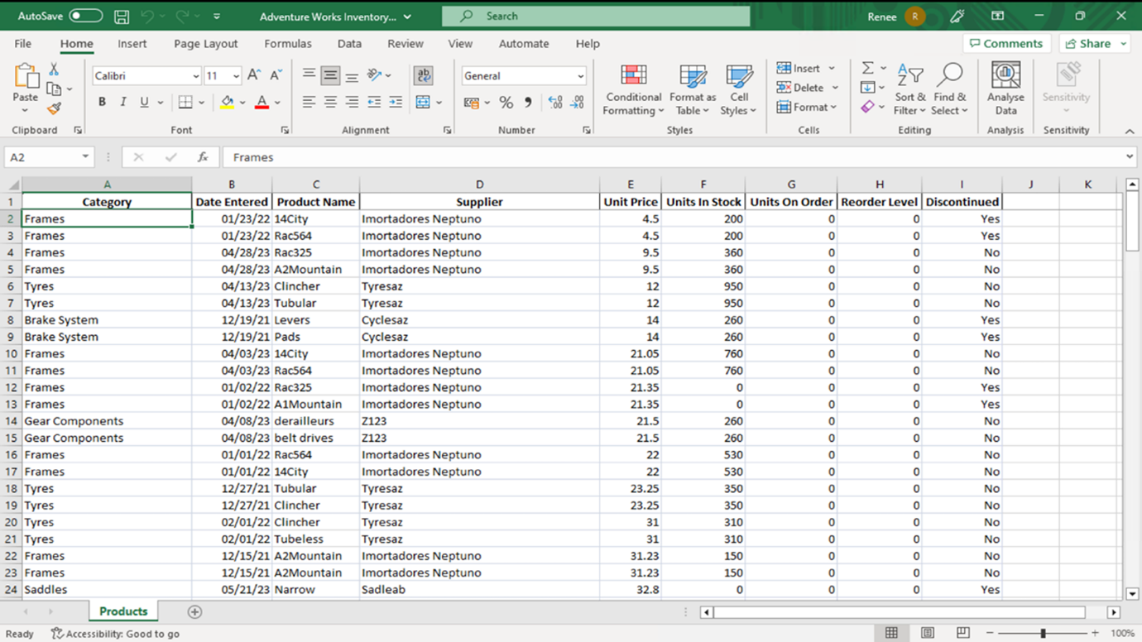

**Step 2: Evaluate the adequacy of the data**

Renee's task can be summarized as monitoring prices by product and supplier from the past to the present. To start, you examined the data in the Excel workbook given to you by Renee. Since your assigned task is to analyze the price changes of products from past to present, you needed to identify the fields relevant to this task. The existing dataset included fields such as **Category**, **Date Entered**, **Product Name**, **Supplier**, **Unit Price**, **Units In Stock**, **Units On Order**, **Reorder Level**, and **Discontinued**.

1. In this dataset, the required fields for this business need were **Date Entered**, **Product Name**, **Supplier**, and **Unit Price**.

You located the column **Product Name** and examined the rows. The variety of products in the rows affects the sorting and analysis.

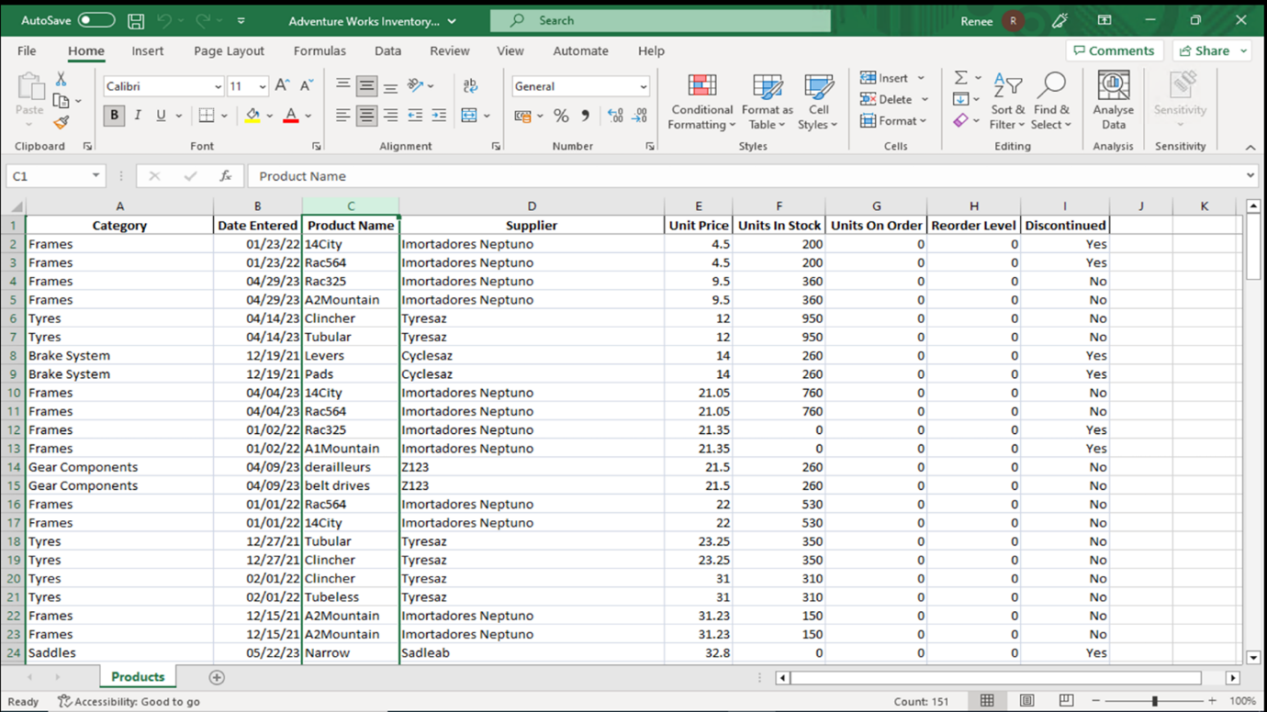

You examined the **Unit Price** values by sorting the data based on the **Date Entered** field for each **Product Name**. You noted the rows that were significantly above or below the average. For instance, rows 2 to 9 might be reported in your analysis.

You located the column **Date Entered** and examined the rows. **Date Entered** was one of the significant columns in your analysis.

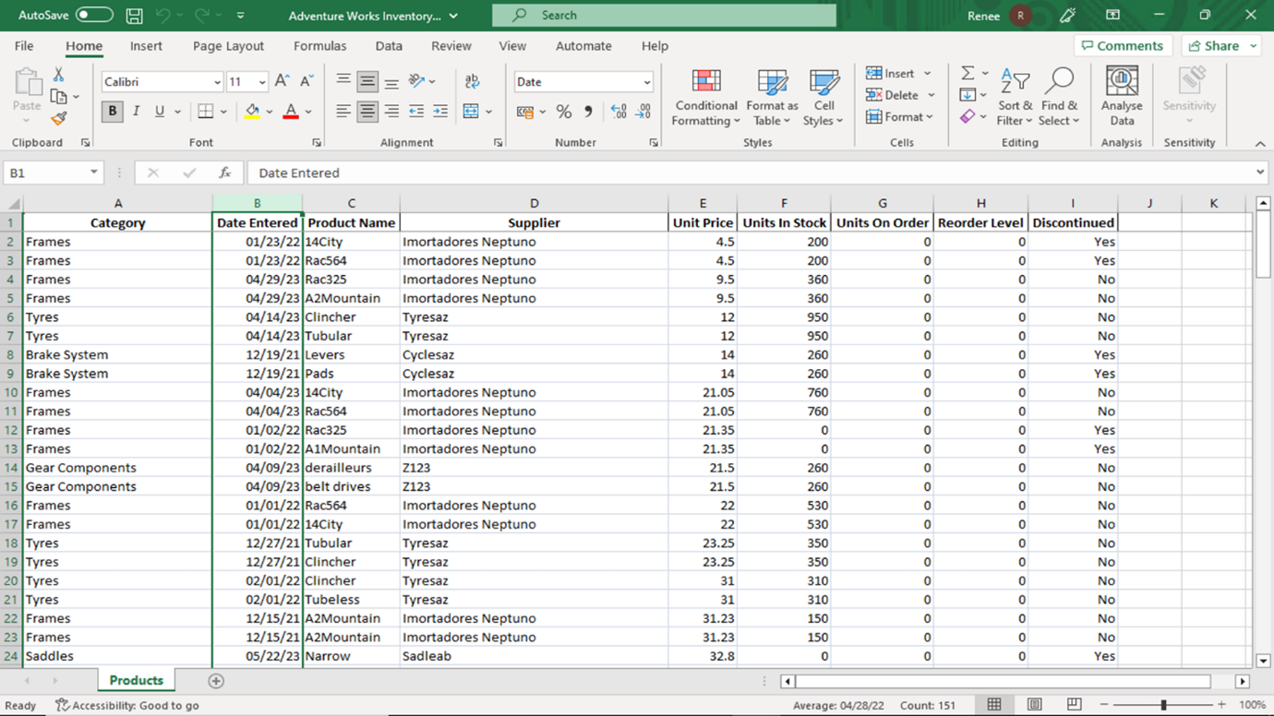

You located the column **Supplier** and examined the rows. **Supplier** was also one of the significant columns in your analysis.

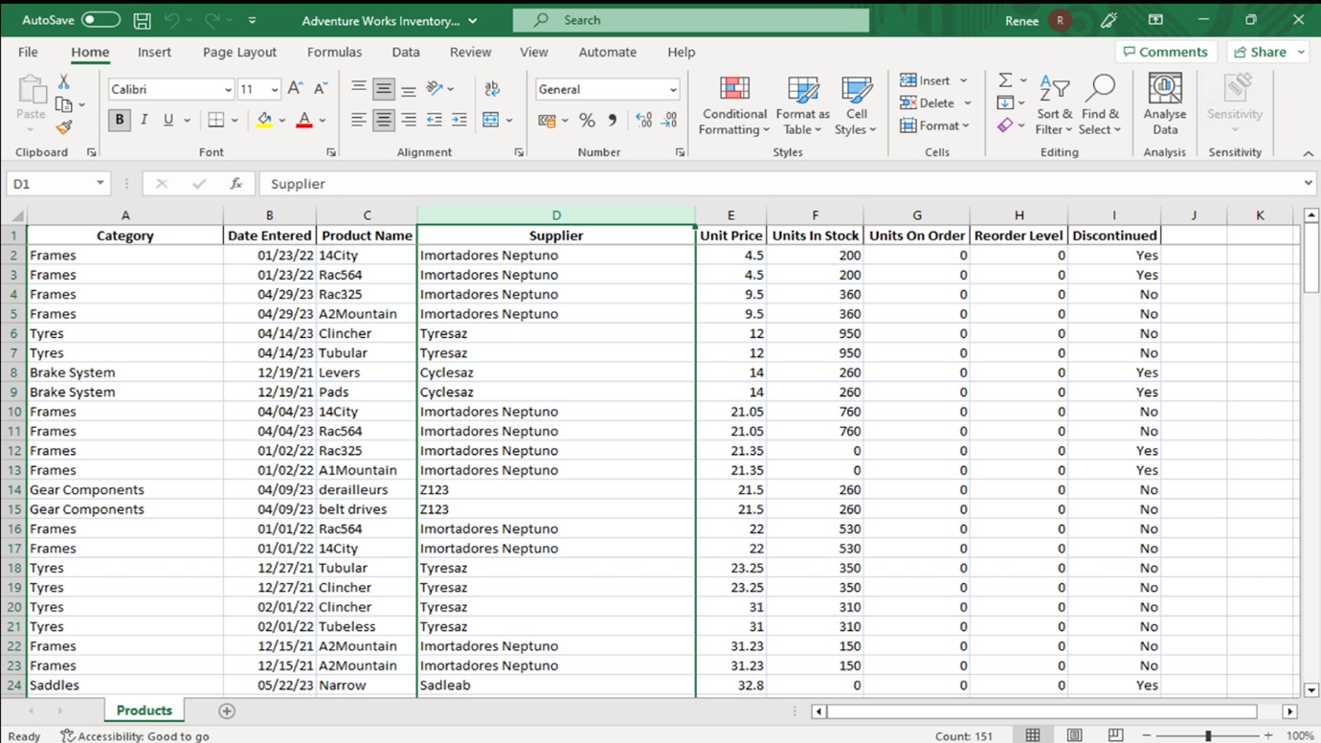

Finally, you located the column **Unit Price** and examine the rows. In your task, part of the task was to find any unusual values in **Unit Price**.

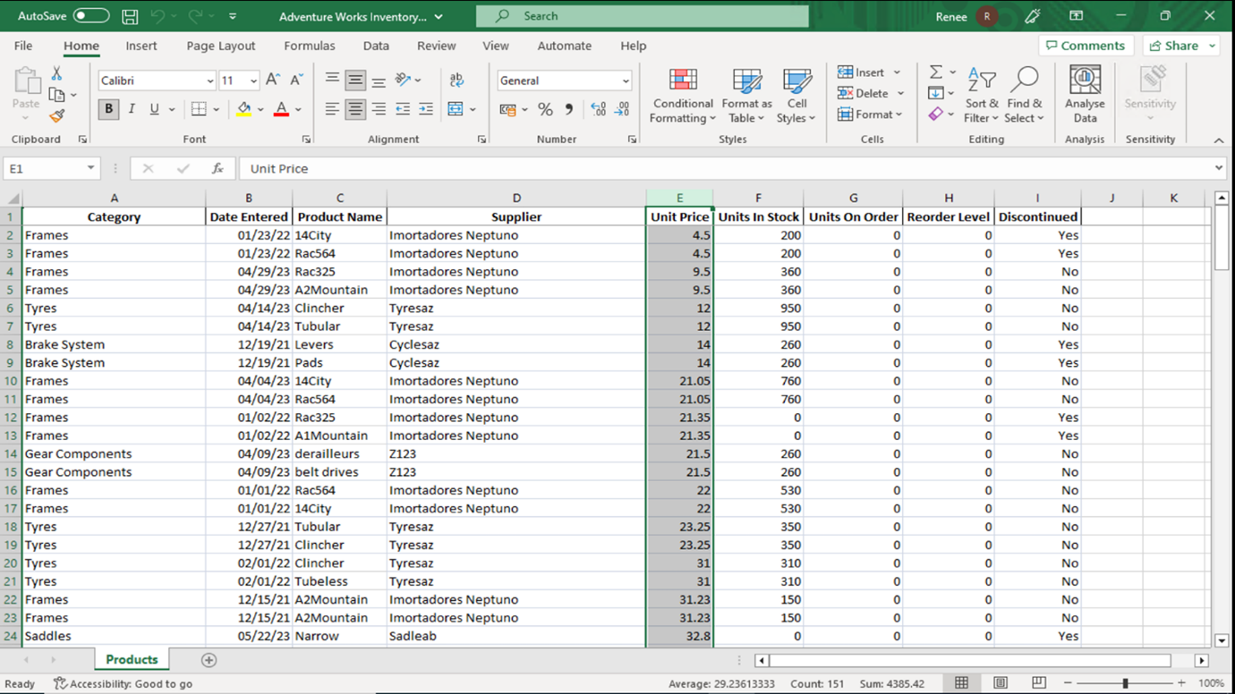

You also considered the **Supplier** field in sorting or comparisons. As different suppliers may have different pricing policies for the same product, it would be wise to examine any anomalies, if any, on a supplier basis. In this list by products, the same supplier is generally used for each product. However, it is important to consider the possibility of examining the data by supplier, as well as other methods. That data examination by supplier might become important if the data was updated in this dataset or you were tasked with examining another similar dataset.

You opened **PowerBI Desktop** and navigated to the **Home** tab.

In the **Data** group you selected **Excel Data**, and loaded the Microsoft Excel workbook *Adventure Works Inventory.xlsx,* which you downloaded in step 1. You need to click on transform data when opening an Excel file in Power BI to open the **Power Query Editor** view.

2. You selected the **Product Name** column and inside the **Sort** group selected **AZ** to sort the data by Product Name.

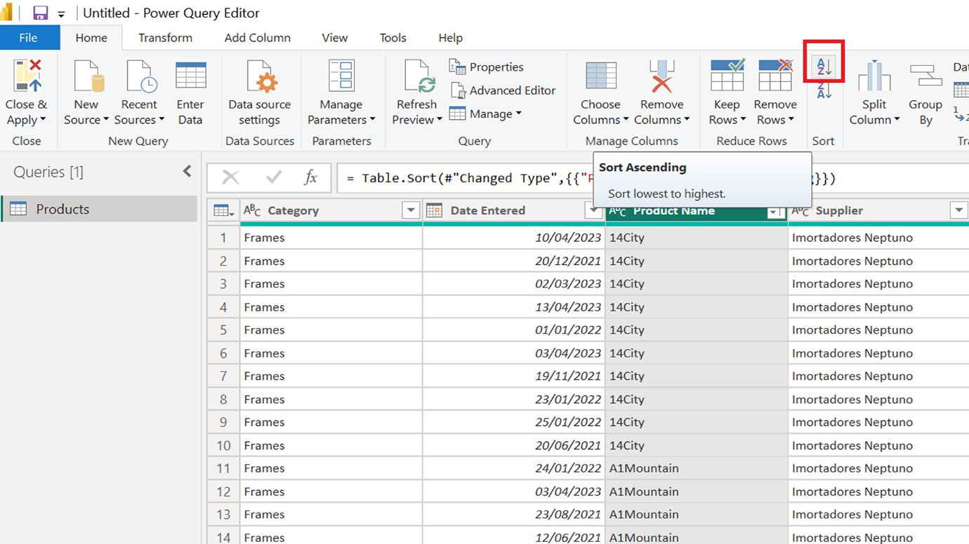

You selected the **Date Entered** column and inside the **Sort** group selected **AZ** to sort the data by **Product Name** and **Date Entered.**

3. You selected the **Supplier** column and inside the **Sort** group selected **AZ** to sort the data by **Product Name**, **Date Entered**, and **Supplier**.

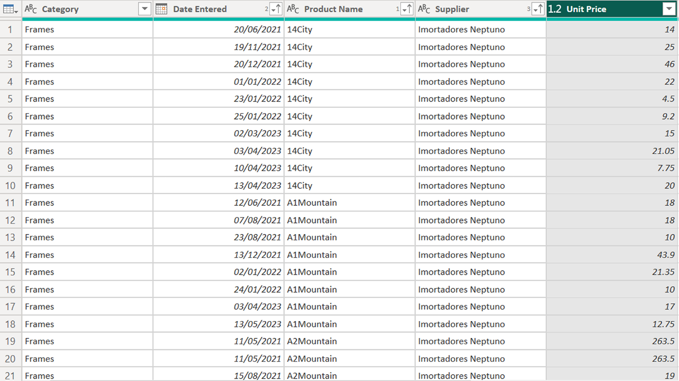

You were then able to examine the price changes of a product by taking the supplier and date entered columns into consideration.

4. The other fields, namely **Category**, **Units In Stock**, **Units On Order**, **Reorder Level**, and **Discontinued**, were detail fields that were not directly relevant to our current business needs. They continued to be included in the dataset but did not affect your analysis.

**Completed example**

Compare your work with the finished version of the exercise.

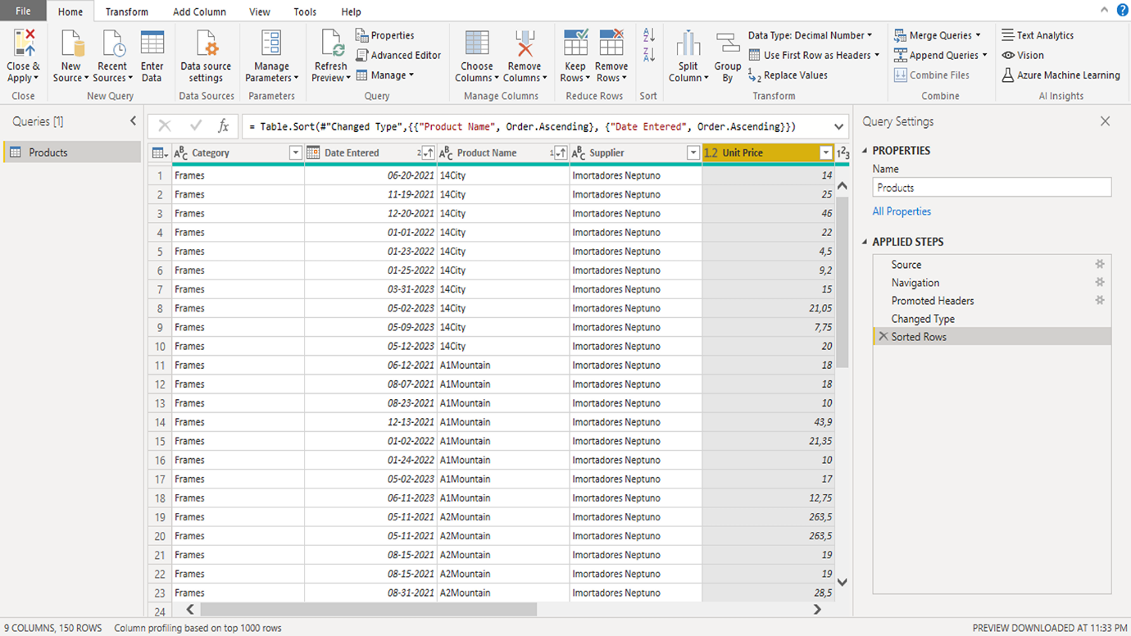

**Conclusion**

This exercise explored whether the Microsoft Excel data you were given could meet the given business requirement. In this case, the business requirement was the task set for you by Renee: to analyze the price changes of products from past to present.

In this context, examining the changes in the **Price** field based on the **Product Name**, **Date Entered**, and **Supplier** fields in the Excel data met the current business requirement, and you were able to prepare the relevant fields for the next step of the analysis process.

**Knowledge check: Data collection**

**1.**

Question 1

Which product has strong reporting features and is typically used to begin a workflow in Power BI?

Microsoft Power BI Desktop

Correct

That’s correct! Microsoft Power BI Desktop is a Windows-based desktop application that is mainly used to design and create reports.

**2.**

Question 2

If you are given Microsoft Excel data and informed of a business need, what method would you use to determine if the data provided is compatible with the business need?

Check if the Microsoft Excel data fulfills the business requirements by examining its content and data types.

Correct

That’s correct! Microsoft Excel data columns and business requirement details have to match in order to fulfill the requirement.

**3.**

Question 3

You want to publish your report and share your data with others by creating dashboards. Which of the following products would you use to accomplish this?

Microsoft Power BI Service

Correct

That’s correct! You can publish your report and share your data with others by creating dashboards on Microsoft Power BI Service.

**4.**

Question 4

**True or False:** The typical workflow in Microsoft Power BI starts with the creation of a report in Power BI Desktop.

True

Correct

That's correct! The Power BI Workflow usually starts with Power BI Desktop and continues with Power BI Service and Power BI Mobile Apps. This way, the entire cycle from report creation to publishing and consumption is completed.

**5.**

Question 5

What term is used to classify data such as word-processing files, images, video, and audio files?

Unstructured data

Correct

That’s correct! Unstructured data examples are media files, word-processing files, images, video, and audio files.

**Additional resources: Data collection**

Congratulations on completing your exploration of how data is produced and gathered in businesses and in organizations. Microsoft Power BI enables you to work with data from various sources by accessing many data sources. In this context, the first step is to identify the data sources, then determine the suitability of the data for business needs, and finally proceed with using the tools provided by Power BI to continue the process.

Microsoft Power BI offers an end-to-end reporting experience with its Power BI Desktop, Power BI Service, and Power BI Apps tools. Accessing many different types of data sources and performing cleaning, transforming, and loading operations on the retrieved data, along with designing, publishing, authorizing, and providing a mobile application experience, we refer to this end-to-end flow as the Power BI Workflow.

* **What is Power BI?** Learn more about how Power BI consists of several elements that all work together, [starting with three elements - Power BI Desktop, the service, and the mobile apps](https://learn.microsoft.com/en-us/power-bi/fundamentals/power-bi-overview).
* **Compare Power BI Desktop and the Power BI service**: Get an overview of [Power BI Desktop and the Power BI service](https://learn.microsoft.com/en-us/power-bi/fundamentals/service-service-vs-desktop) and compare their features.
* **Data sources for the Power BI service**: Research the [data source types you can connect to](https://learn.microsoft.com/en-us/power-bi/connect-data/service-get-data) from the Power BI service.
* **Connectors in Power Query:** View a list of all the [connectors currently available for Power Query](https://learn.microsoft.com/en-us/power-query/connectors/).

Using additional resources to help deepen your knowledge is a great learning strategy. By utilizing the additional resources in this reading, you can deepen your understanding of using Microsoft Power BI to work with data from various sources. You'll also gain practical insights into how to apply your knowledge effectively in a typical Power BI Workflow.

**Question**

In the ETL process, which step involves retrieving raw data from different sources, such as databases and files?

Extract

Correct

That’s correct! The Extract step involves retrieving raw data from different sources.

**Question**

Which method of data ingestion is most suitable for gathering data from many Excel spreadsheets?

File-based ingestion

Correct

That’s correct! File-based ingestion is most suitable as it involves importing data from various file formats, including Excel spreadsheets, and reading and parsing the file contents.

**Question**

You need to consolidate data from multiple sources into a unified view. Which aspect of data management involves this task?

Data integration.

Correct

That’s correct! Data integration is the process of consolidating different data from multiple sources, such as different departments or systems, into a unified view.

**Exercise: Data storage and management**

**Introduction**

Previously, you learned about planning for data storage and management. In this exercise, you’ll evaluate storage solutions for different data sources and formats using a case study about Adventure Works. You’ll also learn the differences between structured and unstructured data, as well as on-premises, cloud-based, and hybrid storage.

**Case study**

Adio, the data analyst at Adventure Works, states that the current data storage and management systems are outdated and unable to handle the increasing data volume from sources like sales, manufacturing, and social media. This affects the data analytics team’s ability to analyze and use this information to improve departmental performance. Adio asks you to review the different data sources and select appropriate storage solutions.

**Data types**

Adventure Works collects and stores structured and unstructured data. Differentiating between structured and unstructured data is essential for choosing an appropriate storage solution, as some systems are more suitable for specific data types. Let’s begin by defining these terms.

* **Structured data:** Structured data is organized in a specific format making it easily searchable and analyzable. It includes data types that can be neatly arranged in rows and columns, like numbers, dates, and text strings. Examples include sales transactions, customer information, and inventory levels.
* **Unstructured data:** Unstructured data is not organized in a predefined format and is harder to analyze and manage. It includes data types that do not fit neatly into rows and columns, such as images, videos, and audio files. Examples of unstructured data include customer reviews, social media posts and engagements, and multimedia content.

**Storage solutions**

Now that you understand structured and unstructured data, let's explore the available storage solutions for Adventure Works and evaluate their advantages and disadvantages.

* **On-premises storage**: On-premises storage involves storing data on physical hardware, such as storage devices, within the company's premises. It’s suitable for businesses with strict security and compliance needs, requiring full control over their data and infrastructure, or storing sensitive or core operational data. On-premises storage can be more expensive, due to the costs involved in purchasing, managing, and maintaining the hardware and software infrastructure.
* **Cloud-based storage**: With cloud-based storage, you store data on remote servers managed by a third-party provider. It offers convenient access and management from anywhere through the Internet. Cloud-based storage is suitable for businesses that need scalability, to reduce IT infrastructure management or to store less sensitive or more collaborative data.
* **Hybrid storage**: Hybrid storage combines on-premises and cloud-based storage solutions. Companies can store sensitive or mission-critical data on-premises while using cloud storage for less sensitive or more collaborative data. Hybrid storage offers the flexibility and scalability of cloud-based storage, while still allowing for control over sensitive information. It optimizes storage by storing different types of data in the most suitable environment.

**Data sources**

Adventure Works’ current Extract, Transform, Load (ETL) process involves extracting data from sources, including sales, manufacturing, financials, human resources, market research, and social media. The data analytics team transforms the data by cleaning, aggregating, and formatting it as required. The processed data is then loaded into Microsoft Power BI for analysis. The data sources used include:

* **Sales data**: Adventure Works collects sales data, including customer information and purchase history. This data is sensitive and structured, crucial for business operations and used to analyze customer behavior, product performance, and sales trends. The storage solution needs to allow for scalability due to growth in sales and collaboration between sales, marketing, and customer service teams.
* **Manufacturing data**: Adventure Works generates data through manufacturing processes, including production schedules, inventory levels, and quality control metrics. This sensitive, structured data is used to optimize manufacturing operations and supply chain management. Storage needs include scalability to handle production increases, and collaboration among manufacturing teams.
* **Financial data**: Adventure Works maintains structured financial data, like revenue, expenses, and profit margins for budgeting, forecasting, and monitoring financial health. As this data is highly sensitive, it needs strict access controls. Storage needs also include some scalability for growing financial records.
* **Market research data**: Adventure Works conducts market research to understand customer needs, preferences, and market trends. This data, from sources like surveys, focus groups, and competitor analysis, is structured and unstructured. Marketing, sales and product development teams share and use this data collaboratively. Scalability is required to accommodate growing market research efforts.
* **Social media and online reviews data**: Adventure Works monitors social media platforms and online review sites to gather customer and public feedback and opinions. This generates high volumes of unstructured data with high scalability needs. This data provides insights into brand and customer perceptions and areas for growth and improvement.

**Instructions**

Create a new Word document called *Data storage and management.* In this document, answer the questions below to complete the exercise.

1. For each data source, list the data type (structured and/or unstructured) and storage needs, for example, security, access and storage capacity in relation to data volume and storage duration (short- and or long-term).
2. Based on the data sources at Adventure Works, which storage solution(s) (on-premises, cloud-based, or hybrid) are most suitable for storing data from each source? Explain your reasoning.
3. Discuss four key factors to consider when selecting a data storage solution for Adventure Works.
4. What are the main advantages of hybrid storage for Adventure Works, and how can it help the company optimize its data storage solutions?
5. Given Adventure Works' rapid growth and expanding data volumes, which aspects of data management should the company prioritize?

**Conclusion**

In this exercise, you analyzed the data sources Adventure Works uses and their storage requirements to determine the appropriate storage solution for the company. You learned about different data types and storage solutions and gained insight into data storage planning.

**Summary – Data Storage and Management**

Adventure Works is facing challenges with outdated data storage systems as data volumes from sales, manufacturing, financials, market research, and social media increase. These data sources include both structured (e.g., sales and financial records) and unstructured data (e.g., social media content), each with unique storage requirements in terms of security, scalability, and accessibility.

A **hybrid storage solution** is the most suitable approach—keeping sensitive, structured data like financial and manufacturing records on-premises for security, while leveraging cloud storage for scalable, collaborative access to unstructured and less-sensitive data such as social media and market research content.

Key factors in selecting the right storage solution include data sensitivity, scalability, cost efficiency, and accessibility. Hybrid storage offers a balance of security and flexibility, supporting business growth while ensuring compliance and collaboration.

To keep pace with rapid growth, Adventure Works should prioritize scalable infrastructure, data security, governance, and lifecycle management to optimize data storage and improve overall analytics capabilities.

**Data Storage and Management – Adventure Works**

**1. Data Sources: Data Types and Storage Needs**

| **Data Source** | **Data Type** | **Storage Needs** |
| --- | --- | --- |
| **Sales Data** | Structured | High security (sensitive customer and purchase data), scalable storage, collaborative access, long-term retention. |
| **Manufacturing Data** | Structured | High security (operational data), scalable capacity for increasing production data, collaborative access, long-term storage. |
| **Financial Data** | Structured | Very high security and strict access controls, moderate scalability, long-term secure storage. |
| **Market Research Data** | Structured & Unstructured | Moderate to high security, collaborative access, scalable storage, both short- and long-term retention. |
| **Social Media & Online Reviews** | Unstructured | Scalable storage for large volumes of data, moderate security, frequent access, mostly short- to medium-term retention. |

**2. Recommended Storage Solution(s)**

| **Data Source** | **Recommended Storage Solution** | **Reasoning** |
| --- | --- | --- |
| **Sales Data** | Hybrid (Primarily On-Premises + Cloud) | Sensitive structured data is best kept on-premises for security; cloud can support collaborative access and scalability. |
| **Manufacturing Data** | Hybrid (Primarily On-Premises) | Structured data with operational sensitivity benefits from on-premises control, with cloud used for backups and collaboration. |
| **Financial Data** | On-Premises | High sensitivity and strict compliance requirements make on-premises storage the most secure and suitable. |
| **Market Research Data** | Hybrid | Mixed data types and collaborative use suit a hybrid model—structured insights on-premises, unstructured in cloud. |
| **Social Media & Online Reviews** | Cloud-Based | Unstructured, high-volume, and low-sensitivity data is best managed with cloud storage for scalability and flexibility. |

**3. Four Key Factors When Selecting a Data Storage Solution**

1. **Data Sensitivity and Security Requirements:**  
   Sensitive financial and customer data require robust security and compliance controls, often best met with on-premises solutions.
2. **Scalability and Flexibility:**  
   As data volumes increase, storage solutions must scale easily and cost-effectively—cloud and hybrid models offer this advantage.
3. **Cost and Resource Efficiency:**  
   Cloud solutions reduce infrastructure costs, while hybrid systems balance capital and operational expenditures efficiently.
4. **Accessibility and Collaboration Needs:**  
   Teams across departments may need real-time access to data; cloud-based or hybrid storage enables efficient collaboration and access.

**4. Advantages of Hybrid Storage for Adventure Works**

* **Security and Control:** Sensitive data remains protected on-premises, while less critical data can be stored in the cloud.
* **Scalability:** Cloud resources can be quickly scaled to meet growing data demands without overhauling infrastructure.
* **Cost Optimization:** Reduces the need for large-scale hardware investments while leveraging flexible cloud pricing.
* **Improved Collaboration:** Enables teams to access and share data seamlessly across departments and locations.

**5. Data Management Priorities for Adventure Works**

* **Implement Scalable Infrastructure:** Ensure the storage system can handle increasing data volumes efficiently.
* **Enhance Data Security and Compliance:** Maintain robust data protection measures and adhere to regulatory standards.
* **Data Governance and Access Control:** Establish clear policies for data ownership, access, and accountability.
* **Lifecycle and Backup Management:** Manage data retention schedules and backups to support business continuity and reduce redundancy.

**Self-Review: Data storage and management**

**Introduction**

In the *Data storage and management* exercise, you were asked to evaluate the different data sources that the data analytics team at Adventure Works uses in the Extract, Transform, Load (ETL) process and determine the appropriate storage for these sources.

Now it’s time to review your understanding of the exercise you completed by answering the questions that follow. Don’t forget that you can revisit the previous learning items to review any concepts or skills.

**1.**

Question 1

What is the main advantage of hybrid storage for Adventure Works?

It combines the benefits of on-premises and cloud-based storage solutions.

Correct

That’s correct! Hybrid storage offers the flexibility and scalability of cloud storage, while maintaining control over sensitive information.

1 / 1 point

**2.**

Question 2

Which statement best describes structured data?

Data that is easily searchable and analyzable, consisting of data types that can be neatly arranged in rows and columns.

Correct

That’s correct! Structured data is data that is organized in a specific format, making it easily searchable and analyzable.

1 / 1 point

**3.**

Question 3

What data source mentioned in the case study is an example of unstructured data?

Social media and online reviews data

Correct

That’s correct! These are examples of unstructured data, as they consist of data types that do not fit neatly into rows and columns, such as customer reviews, social media engagements, and multimedia content.

**Exemplar: Data storage and management**

**Introduction**

In the exercise *Data storage and management,* you evaluated the data sources and types the data analytics team uses in the Extract, Transform, Load (ETL) process at Adventure Works and data storage solutions. You then answered questions addressing key aspects related to data storage at Adventure Works, including the suitability of a specific storage solution, factors to consider in data storage planning, the advantages of hybrid storage, and the importance of data governance.

You can use the example answers in this reading as a guide to assess your answers to the questions in the exercise. Your answers may differ from the ones in this reading and still be correct.

**Exemplar: Data storage and management**

1. For each data source, list the data type (structured and/or unstructured) and storage needs, for security, access, and storage capacity in relation to data volume and storage duration (short-term and/or long-term).

* **Sales data**

| **Data type** | **Structured** |
| --- | --- |
| Data storage needs | Moderate to high scalability to handle the increasing volume of sales data over time, secure access for sensitive data, collaboration and sharing for less sensitive data, short-term storage for recent transactions and immediate customer service, and long-term storage for historical or archived sales data and sales performance analysis. |

* **Manufacturing data**

| **Data type** | **Structured** |
| --- | --- |
| Data storage needs | Moderate to high scalability to accommodate changing levels of manufacturing data related to production and inventory levels, secure access and high security levels for sensitive data, for example, intellectual property, controlled collaboration within the department, short-term storage for immediate operational needs during manufacturing, and long-term storage for analyzing historical data to identify trends and areas for improvement in manufacturing and production. |

* **Financial data**

| **Data type** | **Structured** |
| --- | --- |
| Data storage needs | Secure access (primarily highly sensitive data, so high security is required), strict controls and compliance with legal regulations, low to moderate scalability to accommodate the increase in financial records as Adventure Works grows, short-term storage for current financial management, and long-term storage for financial trend analysis and audits. |

* **Market research data**

| **Data type** | **Structured and unstructured** |
| --- | --- |
| Data storage needs | Moderate to high scalability depending on how often and to what degree market research is conducted, collaboration and sharing, short-term storage for ongoing market research and campaigns, and long-term storage for historical data and conducting market trends analyses. |

* **Social media and online reviews data**

| **Data type** | **Mostly unstructured** |
| --- | --- |
| Data storage needs | High scalability (high volumes of mostly non-sensitive data), collaboration and sharing, short-term storage for real-time social media and website monitoring and responding to customers, and customer perception analysis, and long-term storage for tracking long-term trends. |

1. Based on the data sources mentioned, which storage solution(s) (on-premises, cloud-based, or hybrid) would be most suitable for storing data from each source? Explain your reasoning. **Sales data** A hybrid storage solution is ideal for storing sales data. The structured nature of this data makes it suitable for on-premises storage, which can offer better security and control for sensitive information, such as specific transaction details, personally identifiable customer information, payment information, or any other data that could potentially be exploited if unauthorized individuals accessed it. At the same time, cloud-based storage can be utilized for less sensitive data, enabling easier access and collaboration among different departments. This data may include information such as descriptions of the products and pricing information. **Manufacturing data** On-premises storage would be suitable for manufacturing data since it is structured and may involve sensitive information related to production processes and supply chain management. Ensuring high levels of security and control is crucial for protecting intellectual property and maintaining a competitive edge in the market. **Financial data** On-premises storage is recommended for financial data due to its structured format and the sensitive nature of the information. Strict security and compliance requirements, as well as the need for full control over data, make on-premises storage the best choice for safeguarding financial records. **Market research data** A hybrid storage solution is appropriate for market research data. Structured data, such as survey results, can be stored on-premises for increased security and control. Unstructured data, like focus group recordings or competitor analysis documents, can be stored on the cloud to facilitate easier access and collaboration among team members. **Social media and online reviews data** Cloud-based storage is ideal for social media and online reviews data, as this information is primarily unstructured and requires extensive processing for analysis. Storing this data on the cloud allows for easier scalability, efficient data processing, and simplified access for teams working on sentiment analysis or brand perception.
2. Discuss four key factors to consider when selecting a data storage solution for Adventure Works. **Accessibility and collaboration** With different departments at Adventure Works needing access to various data types, the storage solution should facilitate easy access and collaboration. Cloud-based storage is particularly beneficial for less sensitive data that requires frequent collaboration, such as aggregate sales data or market research data. The ability to access data from anywhere and share it among different departments can also facilitate more efficient workflows and decision-making processes. **Scalability** Given the rapid growth at Adventure Works, it's generating increasing volumes of data, especially from sales and market research efforts. It is crucial to select storage solutions that can scale along with the company's growth. Cloud-based storage solutions are particularly advantageous in this context because they can be easily scaled up or down depending on the company's current needs, without the need for significant hardware investments. **Data sensitivity and security** Adventure Works handles a variety of sensitive data types, including sales data that involves customer personal details, financial data containing the company's financial records, and manufacturing data that can include proprietary information about production processes. Due to the sensitive nature of these data sets, it is crucial to prioritize security measures. For instance, on-premises storage could be used for highly sensitive data that requires strict access controls, such as financial data and proprietary manufacturing information. This ensures that data is less vulnerable to external breaches and the company retains full control over it. **Data type** Adventure Works uses both structured and unstructured data. The sales, manufacturing, and financial data are generally structured, while market research data and social media data can be both structured and unstructured. Therefore, the chosen storage solution should be capable of handling both types of data efficiently. For structured data, the company can use traditional databases on-premises or in the cloud, while for unstructured data, storage solutions that can handle large volumes of non-relational data, such as cloud-based data lakes, are beneficial.
3. What are the main advantages of hybrid storage for Adventure Works, and how can it help the company optimize its data storage solutions? **Flexibility** Adventure Works deals with both structured and unstructured data. Structured data, such as sales transactions, customer information, and inventory levels, is typically organized and easy to analyze. Unstructured data, such as customer reviews and social media engagements, is harder to manage and analyze because it doesn't fit neatly into a predefined format. Hybrid storage provides the flexibility to store these diverse types of data in the most suitable environment based on its sensitivity and usage. For example, Adventure Works could store sensitive structured data like sales transactions or customer information on-premises while storing unstructured data like customer reviews and social media engagements in the cloud where it can be more easily accessed and analyzed. **Scalability** As Adventure Works continues to grow, its data volume will increase. This is especially evident in areas such as sales data, manufacturing data, market research data, and social media data. A hybrid storage solution will allow Adventure Works to scale up their storage resources quickly and cost-effectively. This can be particularly helpful when dealing with high volumes of unstructured data from social media and online reviews, which can be stored and scaled up in the cloud, while more sensitive structured data can be maintained on-premises. **Security and control** Adventure Works handles sensitive data, especially in areas such as sales, manufacturing, and financials. Hybrid storage provides a balance between the security and control of on-premises storage and the scalability and accessibility of cloud storage. Sensitive data such as sales, manufacturing, and financial data can be securely stored on-premises, while less sensitive data can benefit from the easy accessibility of cloud storage. **Improved data management** Hybrid storage allows Adventure Works to manage and organize its data more efficiently by storing it in the most suitable environment based on its type, sensitivity, and usage requirements. For example, structured data like sales transactions and customer information can be stored on-premises for secure, efficient analysis, while unstructured data like social media posts can be stored in the cloud for easier access and analysis. This improved data management can enhance data analysis, decision-making, and overall business performance.
4. Given Adventure Works’ rapid growth and expanding data volumes, what aspects of data management should the company consider? **Data governance** As Adventure Works grows, it is essential to establish a comprehensive framework of data governance. This includes defining clear policies and procedures for data collection, storage, access, and usage throughout the organization. A clear governance policy will ensure that Adventure Works has a holistic view of its data and it can be accessed and used by all relevant parties in a consistent and efficient manner. **Data quality** To support its growth trajectory, Adventure Works must maintain high-quality data. Data quality is important as accurate, complete, up-to-date, and relevant data is foundational to reliable analytics and decision-making. The company must implement and continually refine processes for checking, cleaning, and enriching data. **Data integration** Data integration is a key priority because Adventure Works has a variety of data sources, including sales, manufacturing, financials, human resources, market research, and social media. As the company grows, so does the complexity of the data and the need to consolidate this data into a unified view. This facilitates comprehensive data analysis and deeper insights into business operations and performance. **Data security and privacy** As data volume increases, it's important to prioritize data security and privacy measures to protect sensitive information, such as customer information and financial data. Adventure Works must implement strong access controls and monitoring activities, and comply with data protection regulations to ensure data integrity and maintain customer trust. **Data retention and archiving** Adventure Works must develop and implement a data retention policy to retain data for the appropriate time based on legal requirements and business needs. A system to archive data that is no longer in active use is also critical, as this can help Adventure Works manage data storage costs, improve system performance, and ensure that this data can be accessed when needed.

**Conclusion**

By completing this exercise, you learned about data storage solutions and the role different data types and sources play in the selection of these solutions. You gained hands-on experience evaluating data sources and types, as well as determining an appropriate storage solution, in a business context. As data continues to play an increasingly important role in businesses like Adventure Works, having the right data storage solutions in place is essential.

**Knowledge check: Introduction to the ETL process**

**1.**

Question 1

What is a benefit of on-premises storage?

Full control over data and infrastructure.

Correct

That’s correct! On-premises storage gives businesses full control over their data and infrastructure, which is suitable for businesses with strict security and compliance requirements or that store sensitive or mission-critical data.

1 / 1 point

**2.**

Question 2

What is the primary purpose of the Transform step in the ETL process?

To clean, structure, and enrich the data to make it more suitable for analysis.

Correct

That’s correct! The Transform step in the ETL process involves cleaning, structuring, and enriching the data to make it more suitable for analysis.

1 / 1 point

**3.**

Question 3

Which method of data ingestion allows real-time access to data but may require knowledge of database languages and complex configurations?

Database connections

Web scraping

File-based ingestion

Data streaming

Incorrect

Not quite. While data streaming relates to continuous, real-time data generated by sensors or other sources, it does not primarily require knowledge of database languages.

0 / 1 point

**4.**

Question 4

What does source data refer to? Select all that apply.

Raw, unprocessed information collected, stored, and managed by an organization.

Correct

That’s correct! Source data refers to the raw, unprocessed information collected, stored, and managed by an organization.

The initial input used as the basis for further processing, transformation, and analysis.

Correct

That’s correct! Source data is the initial input used as the basis for further processing, transformation, and analysis.

1 / 1 point

**5.**

Question 5

Which aspect of data management is primarily responsible for establishing clear policies and procedures for data handling throughout an organization?

Data governance

Correct

That’s correct! Data governance is the aspect of data management that establishes clear policies, procedures, and standards for data handling throughout an organization.

**Additional resources: Introduction to the ETL process**

Congratulations. You’ve completed your introduction to the Extract, Transform, Load, or ETL process. You should now have insight into the ETL process and its components, its benefits for data-driven organizations, as well as related key activities, including data gathering and ingestion, and data management and storage. Don’t forget that you can use tools with ETL capabilities like Microsoft Power Query in Microsoft Power BI to perform the ETL process!

As you delve into the ETL process, it's valuable to explore additional resources that can enhance your understanding and broaden your knowledge. This reading lists some online resources that can supplement your learning journey.

**ETL process**

Microsoft's documentation on the ETL process is a valuable resource to consider. Below are some additional resources related to the ETL (Extract, Transform, Load) process that can help you gain a deeper understanding of the process and performing it using Power BI Desktop:

* [**ETL:**](https://learn.microsoft.com/en-us/azure/architecture/data-guide/relational-data/etl) This guide serves as a valuable resource in navigating through the Extract, Transform, and load (ETL) process, linking Power BI Desktop to your selected data source with proficiency. This sets the stage for the next steps in your analysis journey.

**Note:** You can ignore the content under the heading Data Flow and Control Flow, as this is not relevant to your current learning.

* [**Connect to data in Power BI Desktop:**](https://learn.microsoft.com/en-us/power-bi/connect-data/desktop-quickstart-connect-to-data) In this Microsoft quickstart, you connect to data using Power BI Desktop— the first step in building data models and creating reports. Serving as the initial Extract phase of the ETL process, this step harnesses the capabilities of Power BI Desktop to establish a connection to your chosen data source. Once a successful connection is established, Power BI Desktop fetches the required data, priming it for further processing and analysis.
* [**Get and transform data with Power BI Desktop:**](https://learn.microsoft.com/en-us/training/paths/get-transform-data-power-bi/) Gaining valuable insights begins in Power BI Desktop where you connect to and transform your data in preparation for data modeling. Start here to learn how to ingest and transform data in Power BI. This resource will help consolidate your understanding of retrieving data from data sources like Microsoft Excel and applying transformations to your data, preparing it for the final Load stage.

The ETL process plays a crucial role in Power BI and in the data analysis process. The additional resources in this reading can help you extract, transform, and load data efficiently for enhanced data analysis and visualization.

**Question**

What is the primary goal of data cleaning in the context of data analysis?

Identifying and correcting errors and inconsistencies in datasets.

Correct

That’s correct! Data cleaning is a crucial step in the data analysis process, as it ensures the accuracy, reliability, and quality of the data used for generating insights.

**Cleaning at source in Excel**

**Introduction**

You're working in data analysis at Adventure Works, and you've just received a new dataset from your manager, Renee. She's tracking sales and inventory data in Excel, and you're asked to create a Power BI dashboard to visualize the data for management. When you open the file, you realize the data is messy and unorganized. Rows and columns are misaligned, there are missing values, and the formatting is inconsistent. You know that Microsoft Power BI is a powerful tool for visualizing and analyzing data, but you also know that to get the most from the data, you need to clean and prepare the data in Excel first, before importing it to Power BI. How do you go about that?

This reading assists you in understanding the importance of cleaning data at the source in Excel. You will discover the various functions and features that can help you do the cleaning before importing the data into Power BI. By the end of this reading, you should understand how to use Excel functions to clean and prepare your data in Excel for further analysis in Power BI.

**Cleaning at source in Excel**

First, let's reap what cleaning data at the source means. It refers to the process of refining and correcting your data in the original source (in this case, Excel) before importing it into another tool for further analysis or visualization (such as Power BI). Cleaning data at the source can save you time and effort and ensure better quality results in your final reports and visualizations, leading to better insights and more informed decision-making.

Now, let's explore some examples of common Excel functions that can help you clean data at the source.

**Text Functions**

Excel provides a wide range of text functions to help clean textual data. Some examples include:

* **LEFT, RIGHT, and MID**: These functions help extract specific parts of text from a cell. For instance, if you have a dataset with full names in a single column, you can use these functions to separate first and last names into different columns.
* **TRIM**: This function removes extra spaces from a text string. It's useful for cleaning up inconsistent spacing between words and ensuring uniformity in your data.
* **UPPER, LOWER, and PROPER**: These functions convert text to uppercase, lowercase, or proper case (proper case being where the first letter is capitalized, and the rest are in lowercase). This can be helpful when dealing with data that has inconsistent capitalization.

**Date and Time Functions**

Working with dates and times in Excel can be difficult, but these functions can help you manage such data:

* **DATE, TIME, and DATEVALUE**: These functions help you create date or time values and convert text strings into date or time formats. This is particularly useful when importing data from external sources that may have different date or time formats.
* **YEAR, MONTH, and DAY**: These functions extract the year, month, or day from a date value. They can be useful for grouping data by specific time periods.

**Logical Functions**

Logical functions can help you clean up and categorize data based on specific conditions. Some examples include:

* **IF**: This function tests a condition and returns one value if the condition is true, and another value if it's false. For example, you can use the IF function to categorize sales amounts as "high" or "low" based on a threshold value.
* **COUNTIF and SUMIF**: These functions count or sum the values in a range that meet a specified condition. They're useful for aggregating data based on specific criteria.

**Lookup Functions**

Lookup functions help you find and retrieve data from other parts of the worksheet or other worksheets based on specific criteria. Examples include:

* **VLOOKUP and HLOOKUP**: These functions search for a value in the first column or row of a table and return a corresponding value from another column or row. They're useful for merging data from multiple sources or filling in missing data.
* **INDEX and MATCH**: These functions can be combined to perform more flexible lookups than **VLOOKUP** and **HLOOKUP**. They're especially useful when the lookup value is not in the first row or column of the table or when you need to perform a two-way lookup.

**Data Validation and Conditional Formatting**

These features can help you identify and correct errors in your data before importing it into Power BI:

* **Data Validation**: This tool allows you to set criteria for the allowable data in a cell or range of cells. For example, you can restrict the input to numbers within a specific range, dates within a specific period, or a list of predefined options. Data validation can help you prevent errors and inconsistencies in your data.
* **Conditional Formatting**: With this feature, you can apply different formats (such as colors, fonts, or icons) to cells based on specific conditions. Conditional formatting can help you quickly spot errors, outliers, or patterns in your data.

**Tip**: Excel functions and features are explored in detail in the *Creating data in Microsoft Excel and preparing for data analysis* course in this program.

**Conclusion**

Cleaning data at the source in Excel is essential to ensure high-quality results in your Power BI visualizations and reports. By using Excel functions text functions, date and time functions, logical functions, lookup functions, and features like data validation, and conditional formatting, you can refine and tidy up your data before importing it into Power BI. Remember, investing time and effort in cleaning your data at the source will not only save you time during the analysis and visualization stages but also improve the accuracy and reliability of your insights. With these tools and techniques at your disposal, you're well-equipped to tackle any messy dataset that comes your way.

**Question**

How does Power Query promote a structured and repeatable approach to data preparation?

By recording data transformation steps in the **Applied Steps** pane.

Correct

That’s correct! Power Query promotes a structured and repeatable approach to data preparation by recording data transformation steps in the **Applied Steps** pane.

**Data transformed in Power BI**

**Introduction**

You're working in a data analysis role at Adventure Works, and one day, your manager comes to you with a spreadsheet. It’s filled with raw data about sales, production, and inventory. She asks you to find meaningful insights from this data to help optimize the company's processes and make better decisions. You know that transforming this data in Microsoft Power BI using Microsoft Power Query will make it much easier to analyze and extract valuable insights, so you get to work.

This reading assists you in understanding the importance of data transformation in the data analysis process. It explores data transformation functions in Power Query, such as removing duplicates, filling in missing values, and changing data types. You’ll discover how these functions can be combined to suit your specific data transformation needs.

**Data transformed in Power BI**

Data transformation is the process of converting raw data into a more meaningful and usable format. In the context of Power BI, this means taking your raw data, which may be messy, unstructured, or difficult to interpret, and transforming it into a format that is easy to understand and analyze. Power Query is a powerful tool within Power BI that allows you to perform these transformations with ease. The raw data you have been given by your manager at Adventure Works is a massive spreadsheet with thousands of rows containing information about customers, products, sales, and more. However, the data is not in a format that is easy to analyze – there are missing values, duplicate entries, and inconsistencies in the way the data is presented. Let’s examine three stages of the data transformation process.

**Before Transformation**

The initial sales data for Adventure Works is a jumbled mess of information. There are columns with missing values, such as customer addresses and product descriptions. Some rows have duplicate entries, while others have inconsistent formatting (e.g., dates in different formats or mixed use of upper and lowercase letters). The data is difficult to understand and analyze in its current state.

**Power Query in Action**

To tackle the data issues, you turn to Power Query in Power BI. You use Power Query to clean, organize, and structure their data. You start by removing duplicate entries and filling in missing values using various data transformation functions available in Power Query. You then standardize the formatting of dates, text, and other data elements to ensure consistency across the dataset. You also create new columns to better categorize and classify the data for easier analysis.

**After Transformation**

The transformed data now has a more structured and organized format, with no missing values, duplicate entries, or formatting inconsistencies. The new columns created during the transformation process make it easier to understand and analyze the data. With these improvements, you can now perform accurate and efficient data analysis, leading to better insights and more informed decision-making.

Power Query offers numerous transformation functions that cater to various data types and scenarios. Some of the most common transformations include removing duplicates, filling in missing values, splitting or merging columns, and changing data types. These functions can be combined in various ways to suit your specific data transformation needs. To further illustrate the power of data transformation in Power BI, let's take a look at some before and after screenshots.

**Example 1**

**A screenshot of data before cleaning.** It has a cluttered, unorganized sales data table with missing values, duplicate entries, and inconsistent formatting.

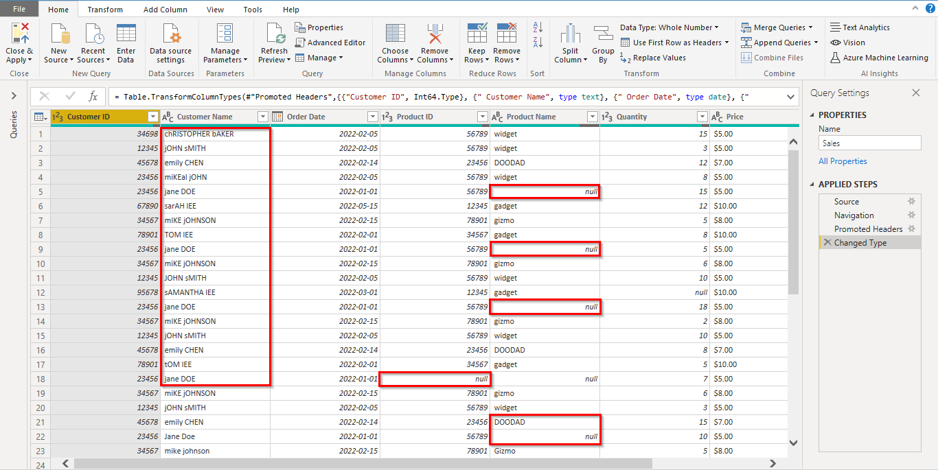

In this initial stage, the sales data table is in disarray. It is difficult to draw any meaningful insights from it due to various issues that hinder its readability and usefulness. Specifically, the table suffers from the following problems:

**Missing values**: The table contains numerous gaps and incomplete data points. These missing values (depicted as ‘null’) can hinder accurate analysis and interpretation, as they may cause inconsistencies and errors in calculations or aggregations. A 'null' value in a table or dataset means that a piece of data is missing or not available.

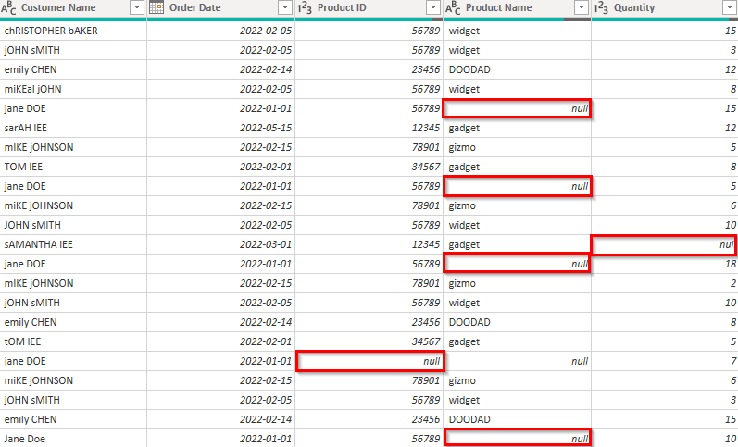

**Duplicate entries**: The presence of duplicate entries can lead to incorrect conclusions, as they may artificially inflate or skew the results of an analysis. It is essential to identify and remove duplicates to ensure the accuracy and reliability of any data-driven insights.

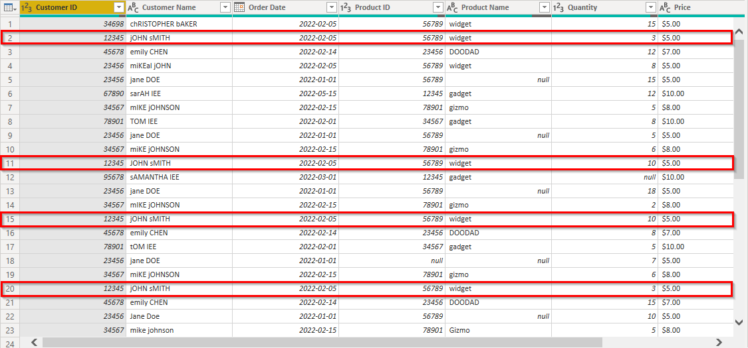

**Inconsistent formatting**: Data formatting inconsistencies, such as varying date formats or text capitalization, can make it challenging to understand and compare data points. Proper formatting is crucial for facilitating data analysis and visualization.

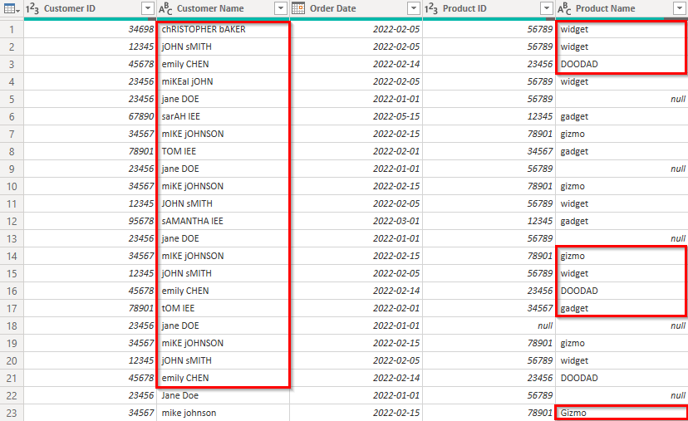

**Example 2**

**The same sales data table, after cleaning.** It is now clean and organized, with missing values filled in, duplicates removed, and consistent formatting applied.

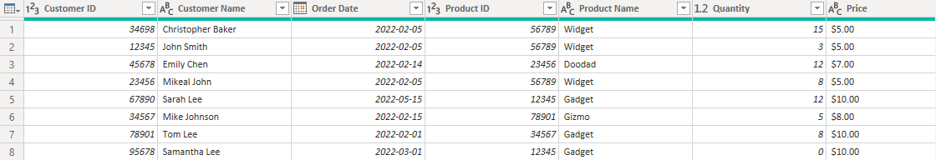

**Example 3**

**This is another example of data before cleaning.** A sales table containing numerical data, such as sales price and total amount, formatted as text, making it difficult to perform calculations or create visualizations.

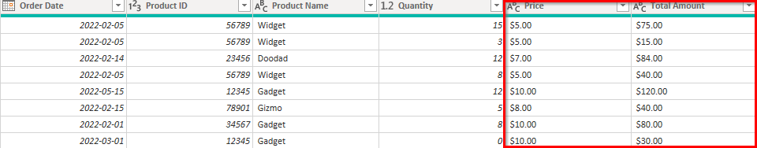

**Example 4**

**The sales table data after cleaning.** The numerical data has been converted to the appropriate data types, enabling calculations and visualizations to be created with ease.

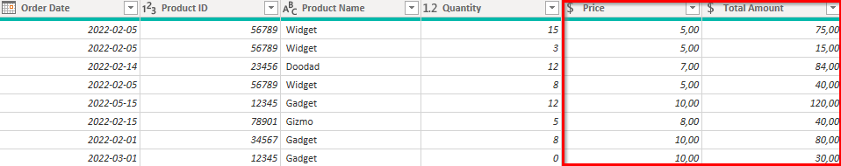

These screenshots demonstrate the incredible difference that data transformation can make in your data analysis process. By taking the time to clean, organize, and structure your data using Power Query in Power BI, you can unlock its true potential and gain valuable insights that drive informed decision-making.

**Conclusion**

Data transformation is a critical step in the data analysis process, enabling you to convert raw, unstructured data into a more meaningful and usable format. Power Query in Power BI is a powerful tool that allows you to perform these transformations with ease, ultimately leading to more accurate and efficient data analysis. In this video, we've seen how data transformation can drastically improve the quality and usability of your data, using Adventure Works as an example.

So, the next time you're faced with a mountain of messy data, remember the power of data transformation and the magic of Power Query in Power BI. Now that you've seen the transformative power of Power Query in action, it's time to put your newfound knowledge to work. Go forth and conquer your data challenges and may Power Query be your guiding light in the world of data analysis!

**Exercise: Evaluating data for transformation**

**Introduction**

Imagine you've just walked into Adventure Works headquarters as a data analyst, ready to tackle the day's challenges. You get an email notification from your manager. She asks you to evaluate samples and descriptions of diverse data blocks using Microsoft Excel. The data will eventually be loaded into Power BI. As you scan the task, you understand this isn't just about analyzing data; it's about transformation, about making the data ready to answer the right questions.

This exercise will assist you in understanding how to evaluate and transform data at source using Microsoft Excel. You will explore specific scenarios of untidy data and learn how to handle missing values, inconsistent formats, and errors to make your data analysis ready.

By the end of this exercise, you’ll understand how to derive meaningful insights from diverse datasets and answer critical business questions by working with data in the *Sales*, *Inventory*, and *Customer Feedback* CSV files.

[Inventory](https://d3c33hcgiwev3.cloudfront.net/e6P59Rc9SV6pL2x2LP65eA_20df4bba459e42828a5492f193d2a8a1_Inventory.csv?Expires=1742428800&Signature=Bngm0uaHsmVq6-y7mXSvazGfnnj2sWmCCdPQH6~FcpJ75ZG8EH3~k3ju1avgQxsHCpw3rpvDB94dlFQU4MnpAOxl-pNHgekorzThXWUPCiJauumhqpPynA9WdtmlujNFeLr8YfvmKo0rnv~xORXRtuFJM~p~zoILjoPFH90-4kk_&Key-Pair-Id=APKAJLTNE6QMUY6HBC5A" \t "_blank)

[CSV File](https://d3c33hcgiwev3.cloudfront.net/e6P59Rc9SV6pL2x2LP65eA_20df4bba459e42828a5492f193d2a8a1_Inventory.csv?Expires=1742428800&Signature=Bngm0uaHsmVq6-y7mXSvazGfnnj2sWmCCdPQH6~FcpJ75ZG8EH3~k3ju1avgQxsHCpw3rpvDB94dlFQU4MnpAOxl-pNHgekorzThXWUPCiJauumhqpPynA9WdtmlujNFeLr8YfvmKo0rnv~xORXRtuFJM~p~zoILjoPFH90-4kk_&Key-Pair-Id=APKAJLTNE6QMUY6HBC5A" \t "_blank)

[Customer Feedback](https://d3c33hcgiwev3.cloudfront.net/Ro5LnGHxTpKVRIoI60vdyA_a3f4f2e2318b4dd89bbf22e7e32b7ea1_Customer-Feedback.csv?Expires=1742428800&Signature=VmY98k6JwnJEqPry6x1NPCRS54IVFzh-7SdqBaQPu2dipycwwhvECH4L5kUzFUyr65WVR0AxLrDtKZt6TfaP0JFEZCU-CdT71mcBpmPaN0x09OmM7NSEQ~nLt4ykDXqQZfgQH4QklKWASFAoOOqb-DIuNxLYMZHIrQmTxIROYOo_&Key-Pair-Id=APKAJLTNE6QMUY6HBC5A" \t "_blank)

[CSV File](https://d3c33hcgiwev3.cloudfront.net/Ro5LnGHxTpKVRIoI60vdyA_a3f4f2e2318b4dd89bbf22e7e32b7ea1_Customer-Feedback.csv?Expires=1742428800&Signature=VmY98k6JwnJEqPry6x1NPCRS54IVFzh-7SdqBaQPu2dipycwwhvECH4L5kUzFUyr65WVR0AxLrDtKZt6TfaP0JFEZCU-CdT71mcBpmPaN0x09OmM7NSEQ~nLt4ykDXqQZfgQH4QklKWASFAoOOqb-DIuNxLYMZHIrQmTxIROYOo_&Key-Pair-Id=APKAJLTNE6QMUY6HBC5A" \t "_blank)

[Sales](https://d3c33hcgiwev3.cloudfront.net/VxG-KyTXRnePllAKeHrWLQ_ee762333820f46c388f0e5a7272b0aa1_Sales.csv?Expires=1742428800&Signature=MlXGAgLtushwpXc5oc2m8jxZlkNcnTmO3kT5X9WXBV8s5PQwdIsC3ZbJplkXI5GBpYv-B0ORIzGRK1XZvSvuv~7ZsOyFBaY3O9g05hat4EhN-lpEqYlgis5HuOQ0TeRrl8Tpz3YaMmea3aCjqDlSil4ShRS4WseCJLo7l7U32Ew_&Key-Pair-Id=APKAJLTNE6QMUY6HBC5A" \t "_blank)

[CSV File](https://d3c33hcgiwev3.cloudfront.net/VxG-KyTXRnePllAKeHrWLQ_ee762333820f46c388f0e5a7272b0aa1_Sales.csv?Expires=1742428800&Signature=MlXGAgLtushwpXc5oc2m8jxZlkNcnTmO3kT5X9WXBV8s5PQwdIsC3ZbJplkXI5GBpYv-B0ORIzGRK1XZvSvuv~7ZsOyFBaY3O9g05hat4EhN-lpEqYlgis5HuOQ0TeRrl8Tpz3YaMmea3aCjqDlSil4ShRS4WseCJLo7l7U32Ew_&Key-Pair-Id=APKAJLTNE6QMUY6HBC5A" \t "_blank)

**Instructions**

1. Download the **Inventory**, **Sales** and **Customer Feedback** CSV data files to your computer.
2. Right-click on the **Sales Data CSV** file and choose **Open with > Excel**. This will open the file in Excel.
3. Repeat the step 2 process to open the other two files.

**Sales Dataset: What is the total sales value per product?**

First, you are presented with the *Sales* dataset. It needs to be more organized. It has missing **TransactionIDs**, **SalesAmounts**, and text in place of numbers. The analysis question to answer is: “What is the total sales value per product?” To answer this, you'll have to fill in missing **SalesAmounts**, transform textual entries into numbers, and then aggregate the sales by product. The transformations you implement here will directly feed into the sales trends that Adventure Works will soon uncover.

**Step 1: Addressing Missing TransactionIDs**

1. Select the header of the **TransactionID** column to select the column.
2. On the Excel ribbon, in the **Data** tab, select the **Filter** button.
3. Select the drop-down arrow on the **TransactionID** column header and uncheck the box next to **Blanks**.
4. Ensure all entries in the column are treated as numerical by setting the data type to **Number**.

**Step 2: Dealing with SalesAmount anomalies**

1. Select the header of the **SalesAmount** column to select the column.
2. Manually go through the column to identify and replace non-numeric values like **four-hundred**. Delete the existing value and type **400** (or the appropriate numeric value).
3. Replace any missing **SalesAmounts** with **0** so that these entries are not excluded from the analysis. To replace **null** or blank cells with **0**, press **CTRL + H** to bring up the **Find and Replace** dialog box. The *Sales* data is now clean and consistent, ready for further analysis in Power BI.

**Inventory Dataset: What is the stock level for each bike category?**

Next up is the *Inventory* dataset. Here, you notice missing **ProductNames** and **Categories**, and inconsistencies in **RestockingFrequency**. The task is to figure out: What is the stock level for each bike category? To discover this, you need to standardize **Category** and fill in missing product details. The transformed data will subsequently support improved inventory management strategies at Adventure Works.

**Step 1: Addressing Missing ProductName**

1. Similar to handling missing **TransactionIDs** in *Sales* data, you will filter out any rows with missing **ProductNames**, ensuring your analysis only includes complete records. Select the **ProductName** column.
2. Go to the **Data** tab and select **Filter**.
3. Select the drop-down arrow on the **ProductName** column and deselect **Blanks**. Click **OK**.

**Step 2: Handling Missing Category**

1. Next, you start evaluating the missing *Category* data. Select the **Category** column.
2. Manually check the column and evaluate the missing entries.
3. Replace any missing with **No Category Provided**, press **CTRL + H** to bring up the **Find and Replace** dialog box.

**Step 3: Standardizing RestockingFrequency**

1. Inconsistencies in **RestockingFrequency** can also hinder accurate analysis. Select the **RestockingFrequency** column.
2. Press **CTRL + H** to open the **Find and Replace** dialog box.
3. In the **Find what** field, type **30 d**, in the **Replace with** field, type **30 days**, and select **Match entire cell contents** from the **Options** menu. Select **Replace All**. With the *Inventory* data clean and standardized, you can easily answer the business question What is the stock level for each bike category? when loaded into Power BI.

**Customer Feedback Dataset: What is the average feedback score for each product?**

Finally, you check the *Customer Feedback* dataset. Here, **FeedbackScores** are irregular, dates are erroneous, and some feedback entries are missing altogether. Your analysis question is: What is the average feedback score for each product? This question requires you to correct the irregularities in **FeedbackScores**, fix erroneous dates, and determine how to treat missing feedback entries. These transformations will give Adventure Works the knowledge it needs to enhance customer satisfaction.

**Step 1: Addressing Missing FeedbackID**

1. Begin by filtering out any rows with missing **FeedbackIDs** in the customer feedback data. Similar to missing **TransactionIDs** and **ProductNames**, missing **FeedbackIDs** can render the corresponding data points anonymous and potentially unreliable. Select the **FeedbackID** column.
2. On the **Data** tab, select **Filter**.
3. Select the **drop-down arrow** on the **FeedbackID** column and deselect **Blanks**. Click **OK**.

**Step 2: Dealing with inconsistent FeedbackScore**

1. Deal with inconsistencies in the **FeedbackScore** column by setting the data type to **Number**, ensuring all scores are treated as numerical values.
2. Manually go through the column to identify and replace non-numeric values like four-comma-seven. To do this, double-click on the cell with the non-numeric value, delete the existing value and type **4.7** (or the appropriate numeric value).

**Step 3: Invalid dates in the FeedbackDate column**

1. Next, address erroneous dates in the **FeedbackDate** column. Select the **FeedbackDate** column.
2. Set the data type to **Date** on the ribbon, which will force Excel to interpret all entries as dates. To change the **Regional Date Format**, select the **FeedbackDate** column and navigate to **More Number Formats** from the dropdown menu on the ribbon. Select **Custom** then select the **mm/dd/yyyy** date format.
3. Manually check the column to identify and replace non-date values like five May 2023. To do this, double-click on the cell with the non-numeric value, delete the existing value and **type 05 May 2023** (or the appropriate numeric value). Evaluation of the *Customer Feedback* data is now complete and prepared for future analysis in Power BI.

**Conclusion**

While working at Adventure Works headquarters as a data analyst, you have explored the heart of data transformation, using Microsoft Excel to evaluate and analyze complex data blocks. You have learned to address real-world issues such as missing values, inconsistent formats, and errors, transforming raw, disorganized data into information that Adventure Works can use to answer critical business questions. The journey you've embarked upon doesn't stop here. In fact, it is just the beginning. As you refine your evaluation skills and deepen your understanding of data analysis, always remember the importance of evaluating your data. You are not just mastering Power BI; you are harnessing the true power of data!

**Self-Review: Evaluating data for transformation**

**1.**

Question 1

Based on the Adventure Works Inventory dataset, what is the **RestockingFrequency** for the product Kidz-K400?

45 days

Correct

Correct! According to the *Inventory* dataset, the **RestockingFrequency** for the product Kidz-K400 is 45 days. This can be verified by referring to the dataset where ProductID 47, theKidz-K400, has a **RestockingFrequency** of 45 days.

**2.**

Question 2

In the *Customer Feedback* dataset, which **ProductID** received a feedback score of 3,5 on May 2023 23rd?

49

Correct

Correct! The product with **ProductID** 49 did receive a feedback score of 3,5 on May 23rd 2023. A score of 3,5 suggests a level of customer satisfaction that is higher than neutral but less than high satisfaction.

**3.**

Question 3

According to the Adventure Works *Sales* dataset, what is the total quantity of products sold on 2023**-**05-05?

3

Correct

Correct! The total quantity of products sold on 2023-05-05 is 3. This can be confirmed by cross-referencing the **ProductID35**, **TransactionID35**, and **SalesAmount** of 750 in the dataset.

**Exemplar: Evaluating data for transformation**

**Introduction**

In the exercise *Evaluating data for transformation*, you were entrusted with the role of a data analyst for Adventure Works. You were required to evaluate and transform blocks of data from different datasets using Microsoft Excel.

More specifically, you were asked to:

* Evaluate and rectify inconsistencies within the *Sales* dataset, such as missing **TransactionIDs** and **SalesAmounts**, and textual entries in numeric columns.
* Analyze the *Inventory* dataset, handle missing **ProductNames** and **Categories**, and standardize RestockingFrequency.
* Review the *Customer Feedback* dataset, correct irregularities in **FeedbackScores**, fix erroneous dates, and handle missing feedback entries.

This reading provides you with a guide that you can use to compare to your own work.

**Exemplar: Evaluating data for transformation**

1. You downloaded the *Sales Data***,***Inventory Data****,*** and *Customer Feedback Data* CSV filesto your computer.
2. You right-clicked the *Sales Data* CSV file and selected **Open with > Excel**.
3. You repeated this process for the other two files. This opened the files in Excel.

**Sales Dataset: What is the total sales value per product?**

**Step 1: Addressing Missing TransactionIDs**

1. The initial step in transforming sales data was to deal with missing **TransactionIDs**. These are key identifiers, and their absence can skew the overall analysis. To handle this, you first selected the **TransactionID** column header to select the column.

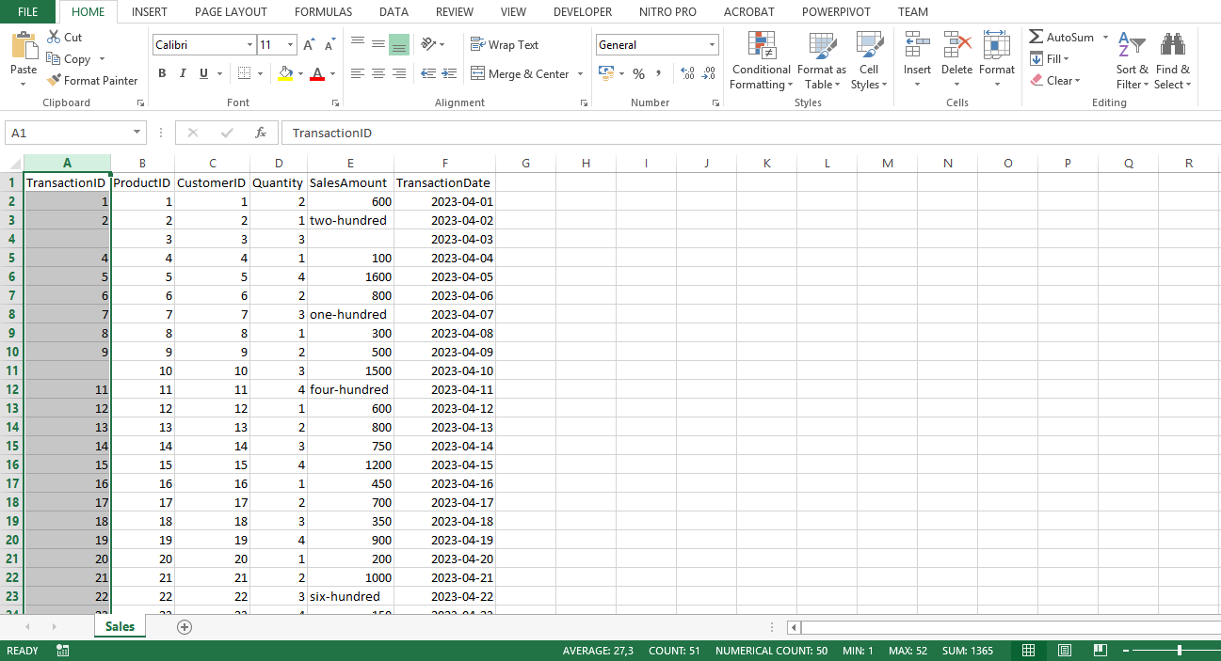

1. In Excel on the **Data** tab, you selected **Filter**. This enabled filtering for your dataset.

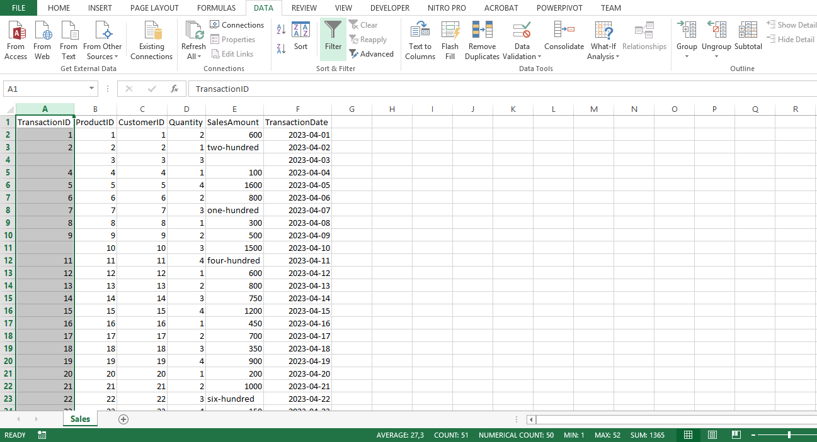

1. Selecting the drop-down arrow on the **TransactionID** column header displayed a menu with several options. You unchecked the box next to **Blanks** to exclude these entries.

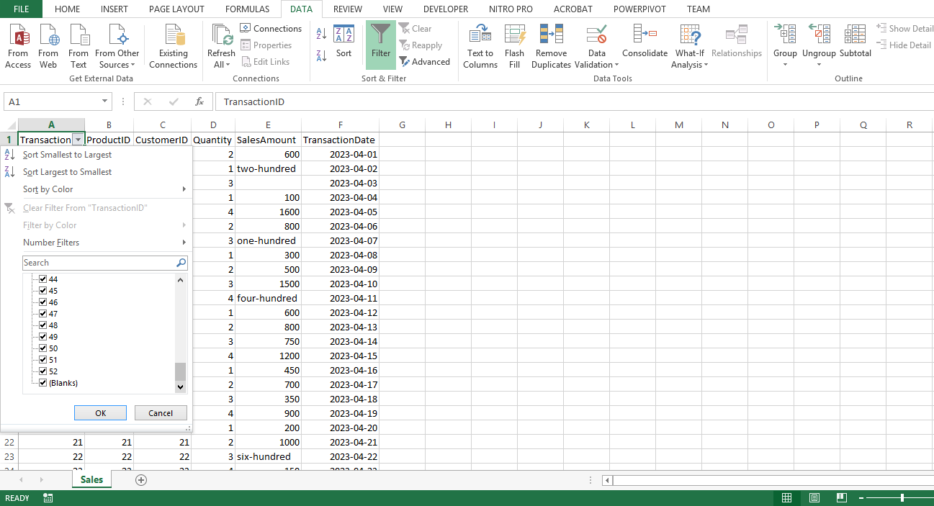

4. Selecting **OK** applied this filter.

5. Finally, you ensured that all the entries in the column are treated as numerical by setting the data type to **Number**.

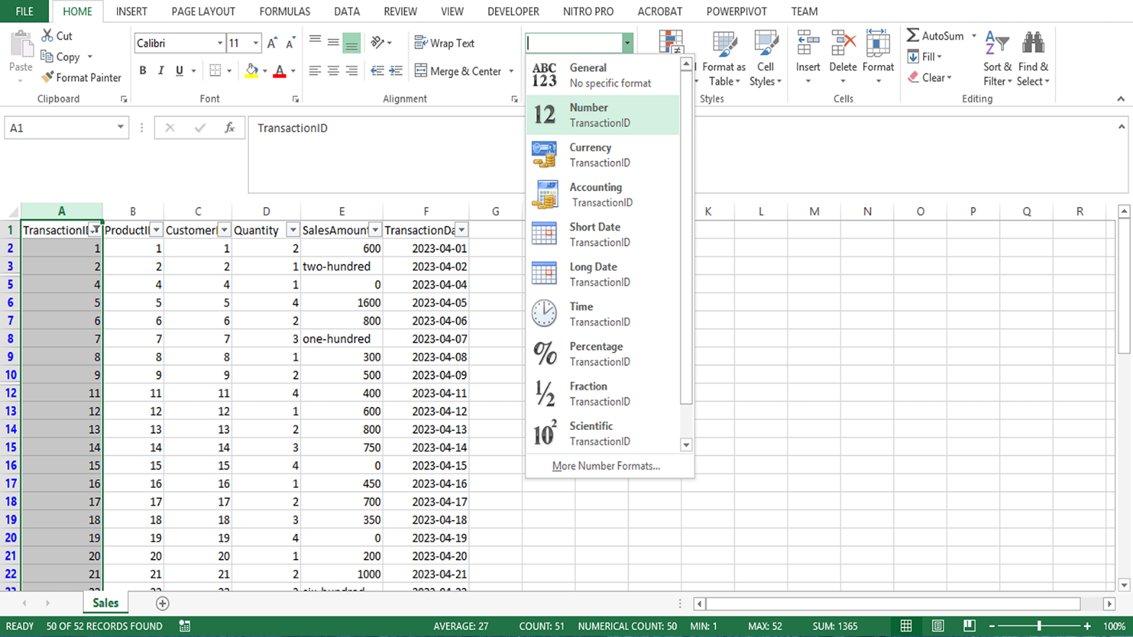

**Step 2: Dealing with SalesAmount anomalies**

1. You encounter anomalies in the **SalesAmount** column, such as text values in place of numbers or missing values. You selected the **SalesAmount** column.
2. You manually checked the column to identify and replace non-numeric values such as four-hundred. To do this, you double-clicked the cell with the non-numeric value, deleted the existing value, and typed the appropriate numeric value.

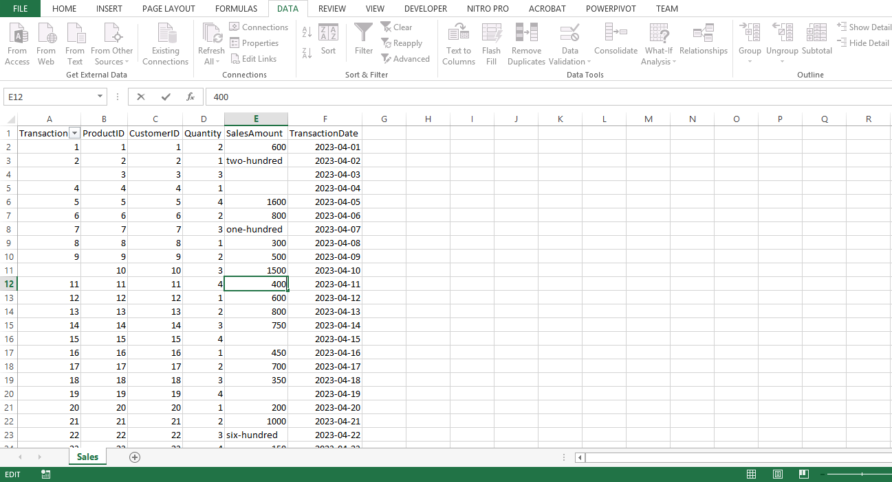

1. Next, you replaced any missing **SalesAmounts** with **0** to prevent the exclusion of these entries from the analysis. To replace null or blank cells with **0**, you pressed **CTRL + H** to bring up the **Find and Replace** dialog box.

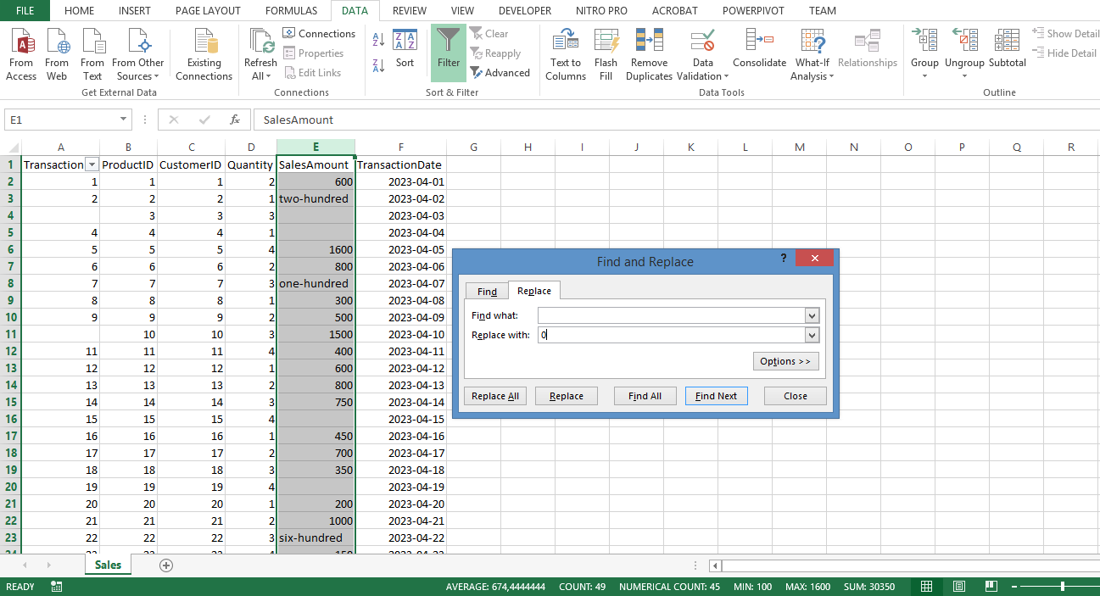

4. You left the **Find what** field, blank (this was to target all blank cells), and in the **Replace with** field, you typed **0**. You then selected **Replace All**. The Sales data was then clean and consistent, ready for further analysis in Power BI.

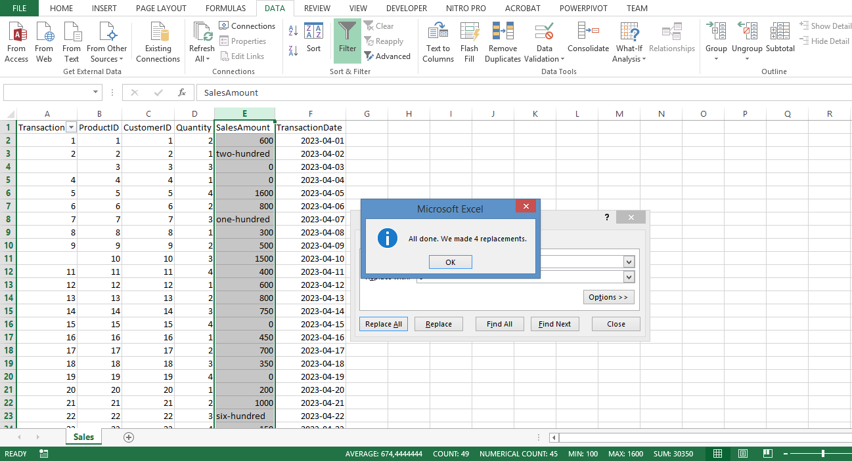

**Inventory Dataset: What is the stock level for each bike category?**

**Step 1: Addressing Missing ProductName**

1. You began by handling missing **ProductNames**. Similar to handling missing **TransactionIDs** in *Sales data*, you needed to filter out any rows with missing **ProductNames**, ensuring your analysis only includes complete records. You selected the **ProductName** column.

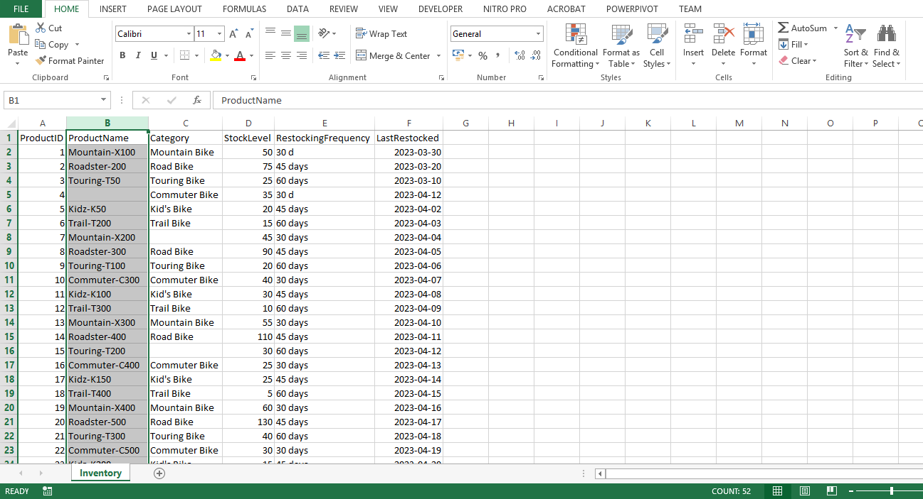

1. In the **Data** tab you selected **Filter**.
2. You selected the drop-down arrow on the **ProductName** column and deselected **Blanks**. Then selected **OK**.

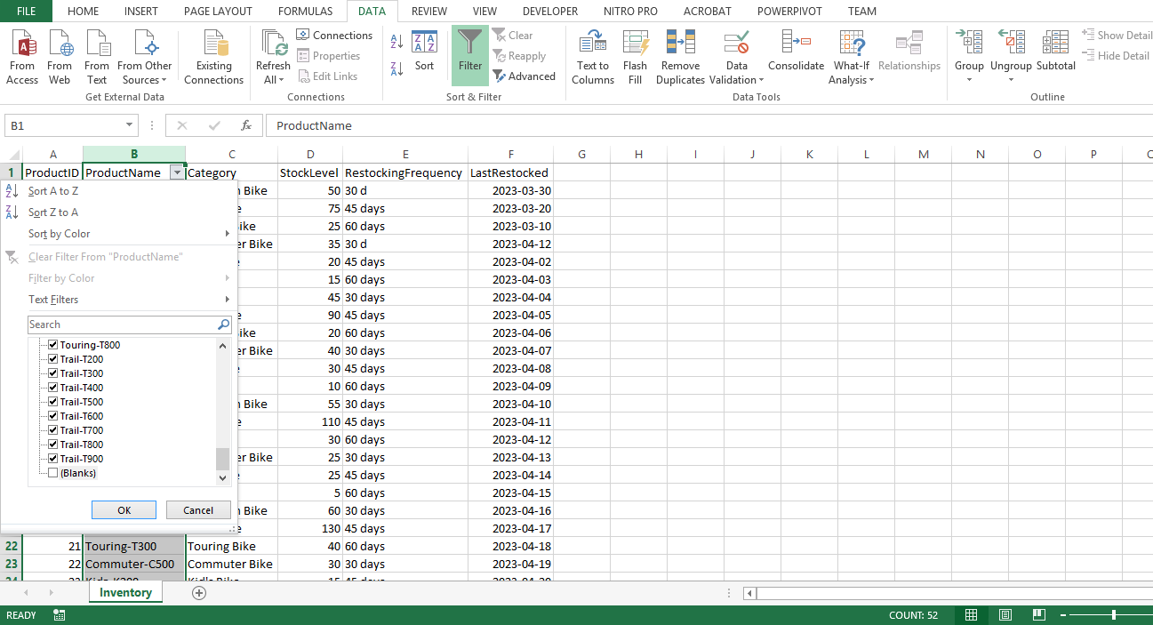

**Step 2: Handling missing Category**

1. Next, you started evaluating the missing *Category* data, first selecting the **Category** column.
2. You manually checked the column and evaluated the missing entries.

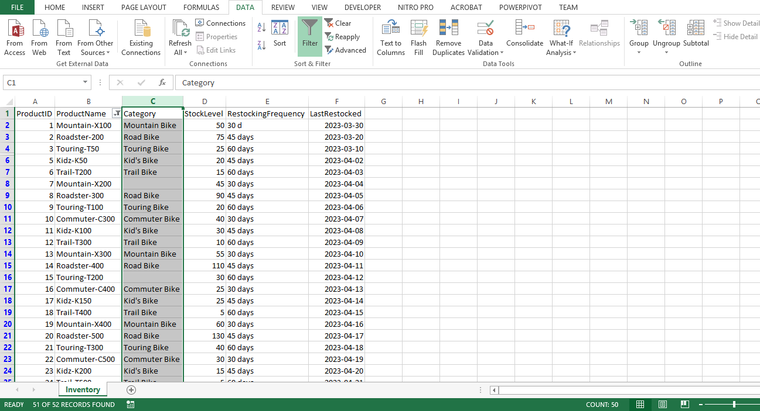

1. To replace null or blank cells with **No Category Provided**, you pressed **CTRL + H** to bring up the **Find and Replace** dialog.

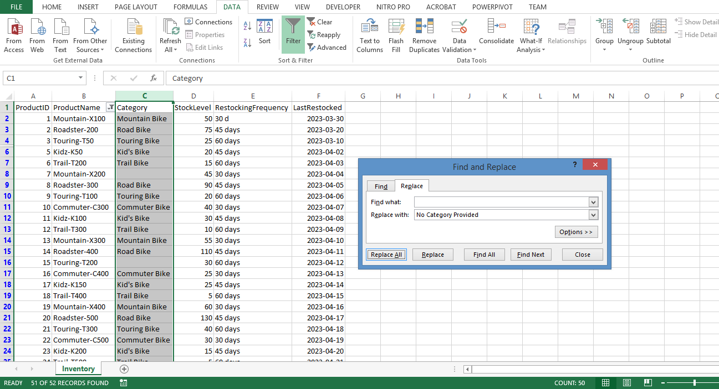

4. In the **Find what** field, you left it blank to target all blank cells, and in the **Replace with** field you entered **No Category Provided**. Then you selected **Replace All**.

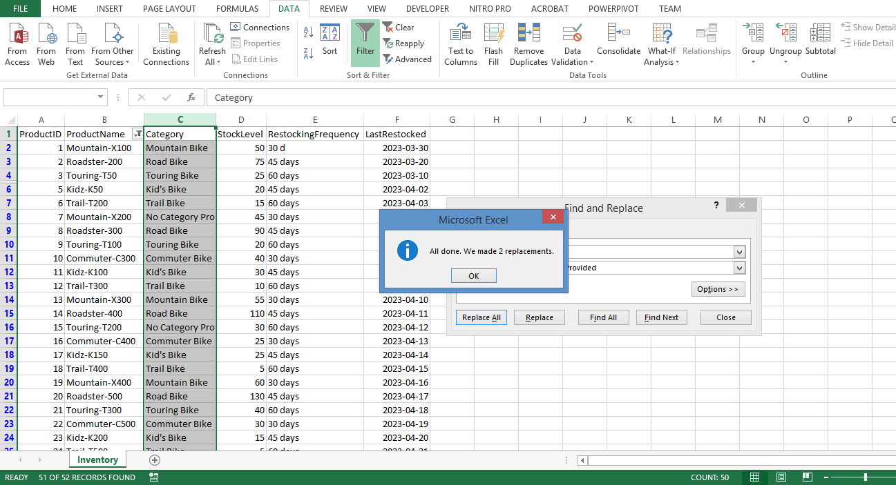

**Step 3: Standardizing RestockingFrequency**

1. Inconsistencies in **RestockingFrequency** can also hinder accurate analysis. You found the **RestockingFrequency** column and selected it.
2. You pressed **CTRL + H** to open the **Find and Replace** dialog.

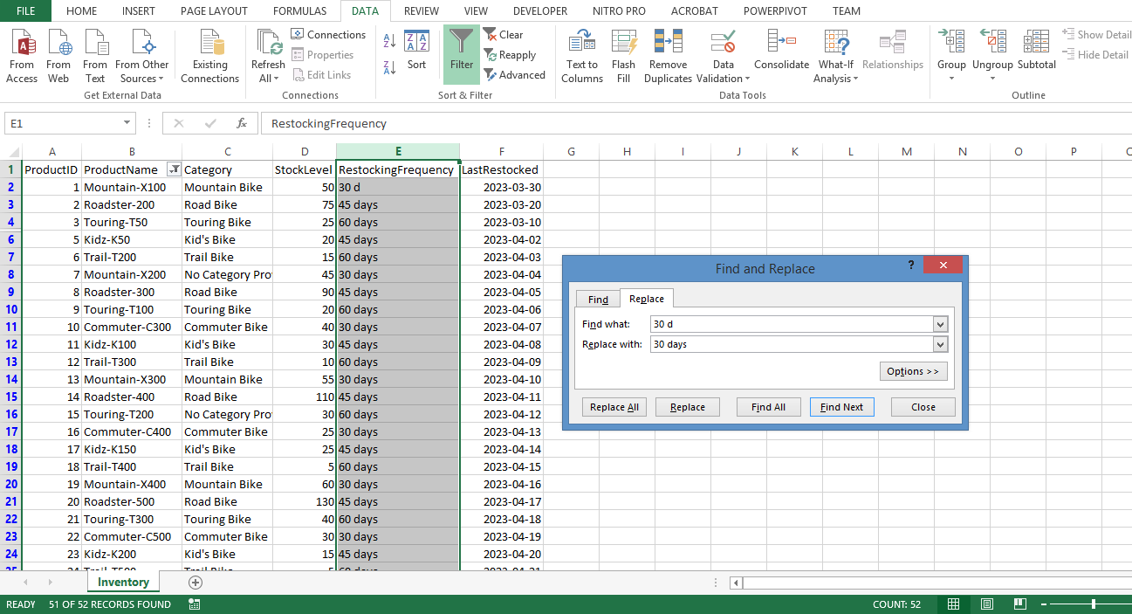

1. In the **Find what** field, you typed **30 d**, and replaced it with **30 days**.

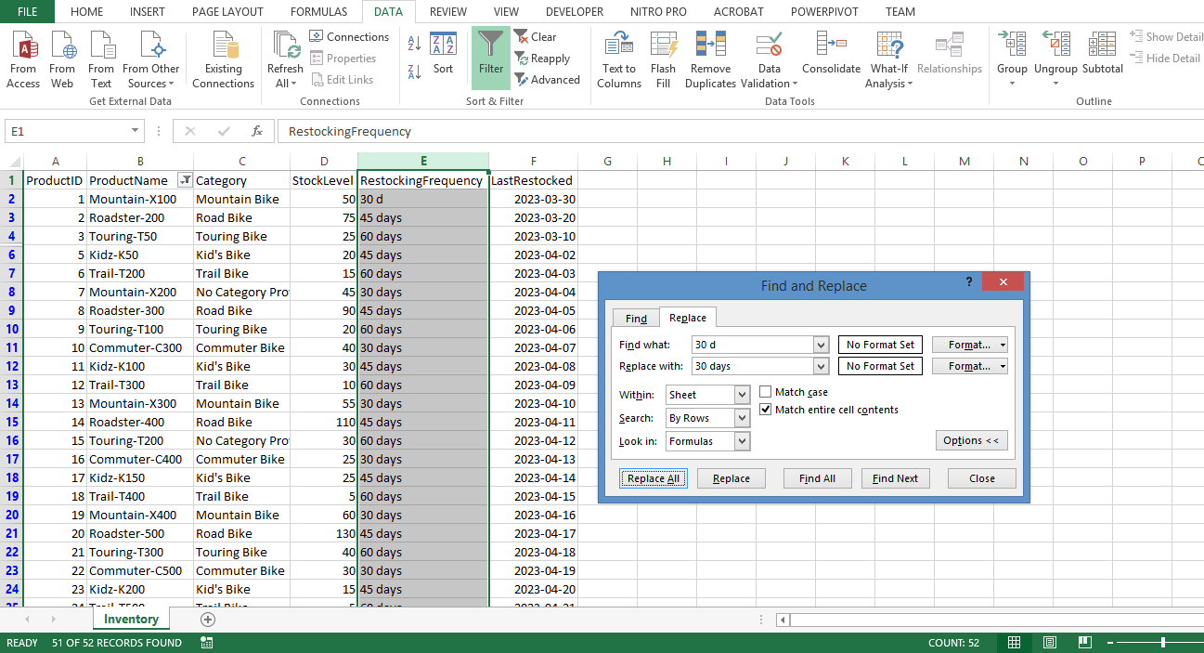

4. Here you expanded the **Options** menu, and selected **Match entire cell contents,** and selected **Replace All**. This step helped to maintain uniformity across data entries. With the *Inventory data* clean and standardized, when the data is loaded into Power BI you were better able to answer the question: 'What is the stock level for each bike category?'

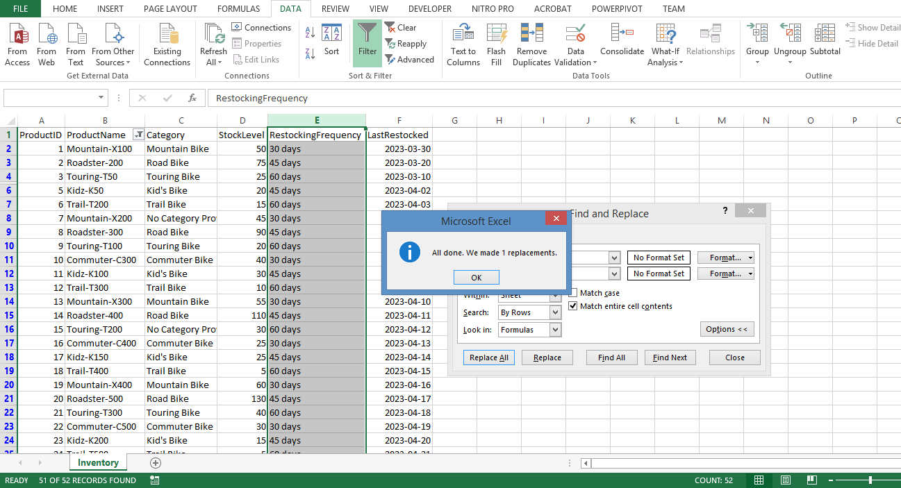

**Customer Feedback Dataset: What is the average feedback score for each product?**

**Step 1: Addressing Missing FeedbackID**

1. You began by filtering out any rows with missing **FeedbackIDs** in the *Customer Feedback* data. Similar to missing **TransactionIDs** and **ProductNames**, missing **FeedbackIDs** can render the corresponding data points anonymous and potentially unreliable. You selected the **FeedbackID** column.

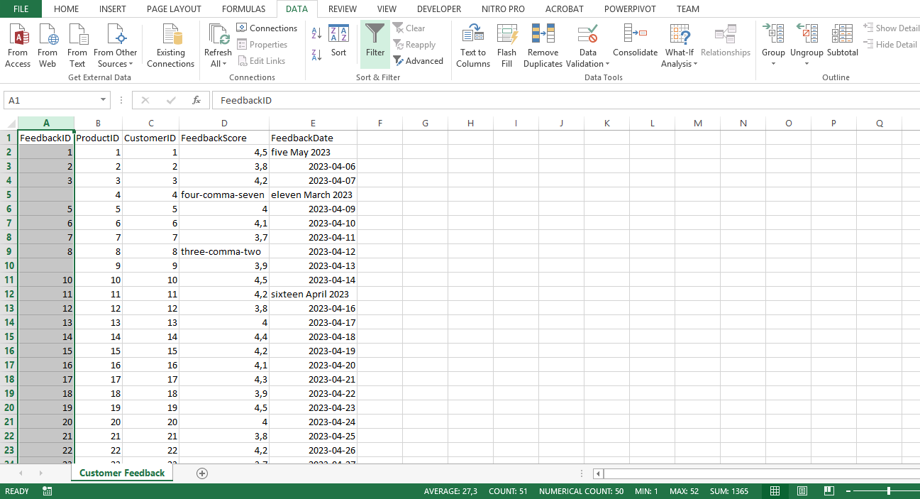

1. On the **Data** tab, you selected **Filter**.
2. Selecting the drop-down arrow on the **FeedbackID** column you deselected **Blanks** and selected **OK**.

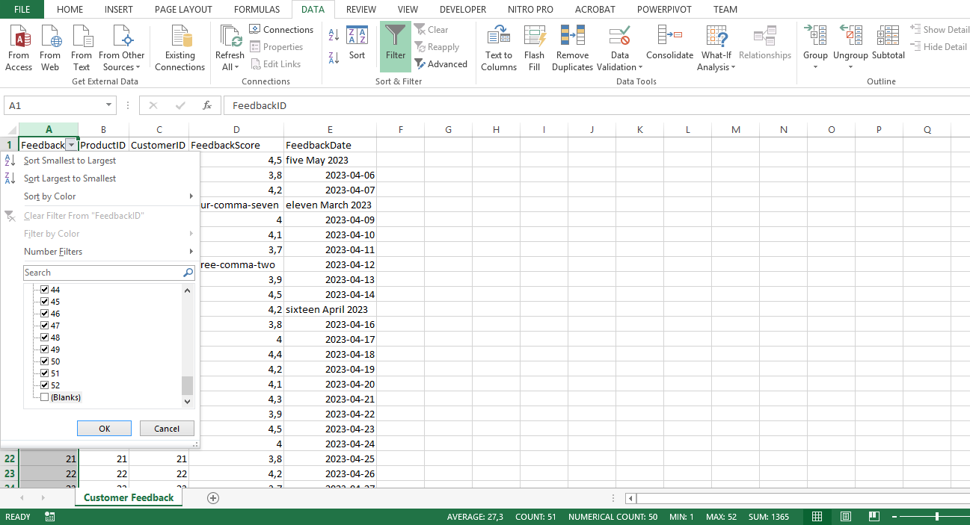

**Step 2: Dealing with inconsistent FeedbackScore**

1. You dealt with inconsistencies in the **FeedbackScore** column by setting the data type to **Number**, ensuring all scores were treated as numerical values.

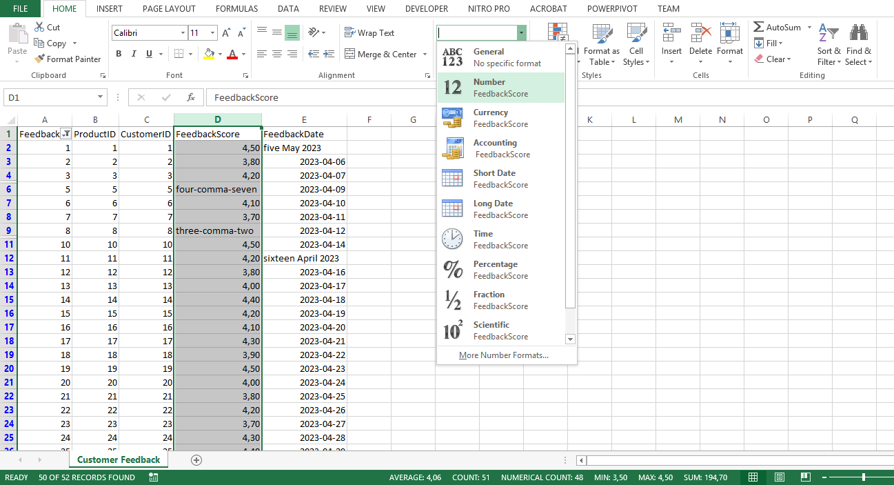

1. You manually edited the content of the column to identify and replace non-numeric values. To do this, you double-clicked on the cell with the non-numeric value, deleted the existing value and typed the appropriate numeric value.

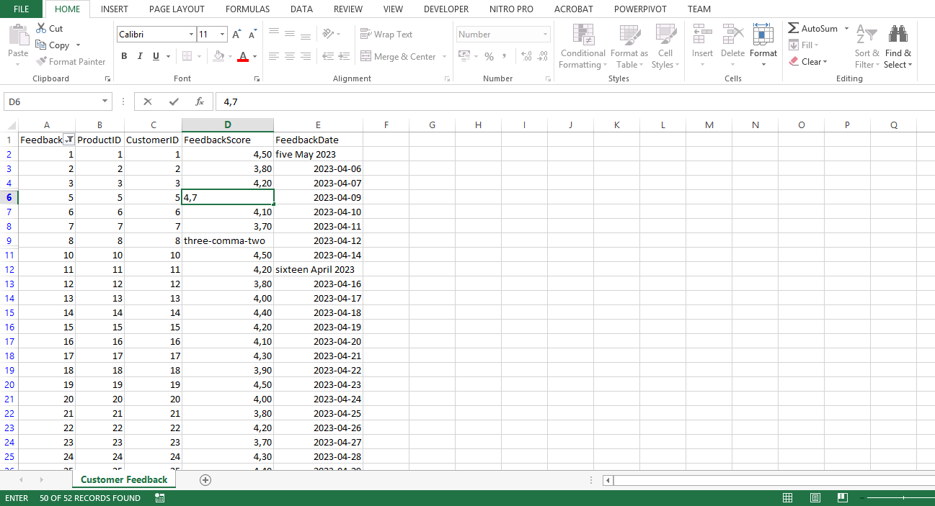

**Step 3: Invalid dates in the FeedbackDate column**

1. Next, you addressed erroneous dates in the **FeedbackDate** column.
2. You selected the **FeedbackDate** column and set the data type to **Date** on the ribbon, which forced Excel to interpret all entries as dates.

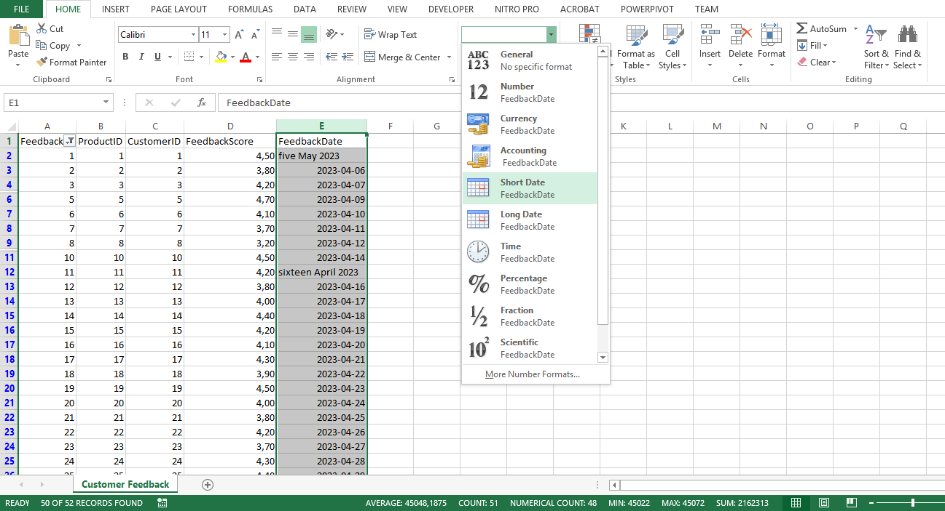

1. You then manually identified and replaced non-date values in the column. To do this, you double-clicked on the cell with the non-numeric value, deleted the existing value and typed the appropriate numeric value. Evaluation of the *Customer Feedback* data was then complete, ready for future analysis in Power BI.

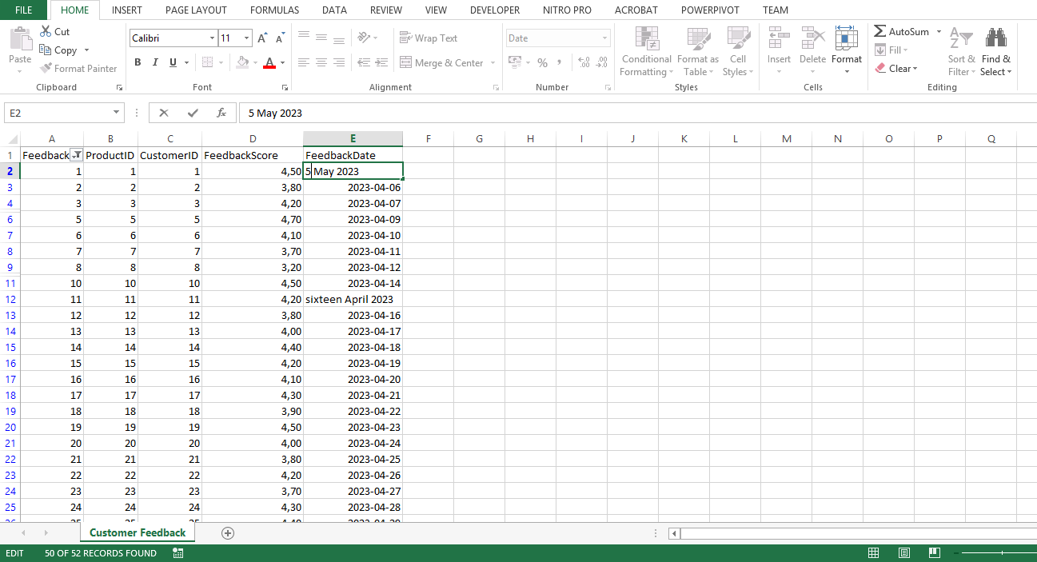

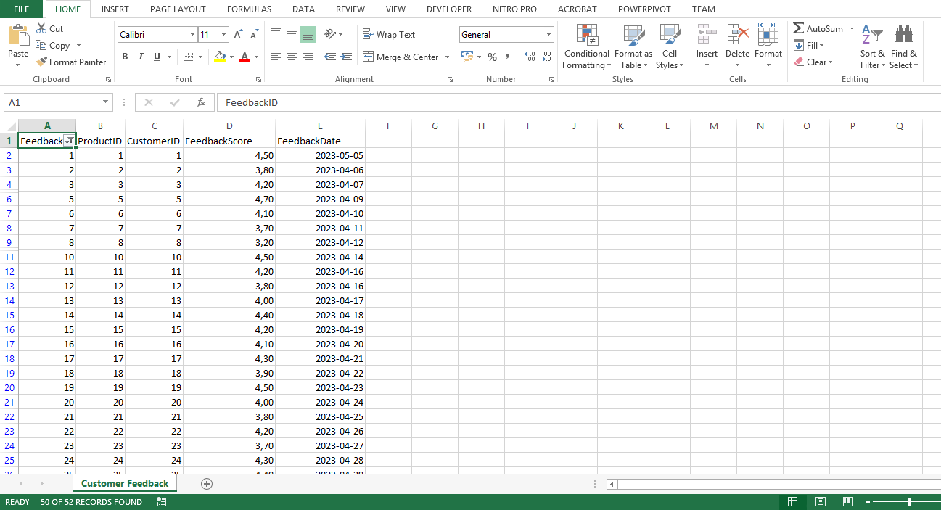

**Conclusion**

By following these detailed, step-by-step instructions, you have demonstrated proficiency in evaluating data with Microsoft Excel, and preparing the data for further transformation and analysis in Power BI. As you continue working with different datasets and analysis questions, you will become more comfortable with the process and better equipped to draw valuable insights from your data. Keep exploring and pushing your data analysis skills to new heights!

**Knowledge check: Introduction to transforming data**

**1.**

Question 1

Which process involves altering the data's structure, format, or values to make it more suitable for analysis?

Data transformation

Correct

That’s correct! Data transformation involves altering the structure, format, or values of the data to make it more suitable for analysis, such as aggregating data, converting data types, or normalizing values.

**2.**

Question 2

What is a primary advantage of cleaning data at the source?

Ensuring future analyses have a clean and consistent foundation.

Correct

That’s correct. Cleaning data at the source ensures that any future analyses using this data will have a clean and consistent foundation, saving time and effort in future analyses.

**3.**

Question 3

Which Excel function can be used to convert text strings into date formats?

**PROPER**

Correct

That’s correct! The **PROPER** function will only capitalize the first character of each word in a piece of text. This function requires only one argument, which is the location of the piece of text you would like the function to work on.

**4.**

Question 4

What is the primary function of Power Query in Microsoft's Microsoft Power BI suite?

Data connectivity and preparation.

Correct

That’s correct! Power Query's primary function is data connectivity and preparation. It enables users to connect to various data sources, clean and transform the data, and then load it into Microsoft Power BI data models for further analysis and visualization. This streamlines and automates the process of preparing data for analysis, making it easier for users to gain valuable insights from their data.

**5.**

Question 5

Which data transformation functions are commonly performed in Power Query? Select all that apply.

Removing duplicates.

Correct

That’s correct! Removing duplicates is a common data transformation function in Power Query. Duplicate entries can skew the results of an analysis, so it is essential to identify and remove duplicates to ensure the accuracy and reliability of any data-driven insights.

Filling in missing values.

Correct

That’s correct! Filling in missing values is a common data transformation function in Power Query. Missing values can hinder accurate analysis and interpretation, as they may cause inconsistencies and errors in calculations or aggregations. Power Query helps to fill in these missing values, improving the quality and usability of the data.

Changing data types.

Correct

That’s correct! Changing data types is a common data transformation function in Power Query. Converting data to appropriate data types is crucial for facilitating data analysis and visualization. Power Query can help to change data types, ensuring consistency across the dataset.

**Module quiz: The right tools for the job**

Note: some questions may change for each attempt

**1.**

Question 1

Which stage of the ETL process is responsible for loading the transformed data into a data warehouse or another storage system for analysis?

Load

Correct

Correct! The loadstage in the ETL process is about loading the transformed data into a data warehouse or another storage system where it can be accessed and analyzed by various tools like Power BI.

1 / 1 point

**2.**

Question 2

What is the primary purpose of data ingestion in the ETL process?

To obtain and import data from various sources for immediate use or storage in a database.

Correct

Correct! Data ingestion is a crucial ETL step bringing data together from different sources and formats, enabling fully informed analysis and decision-making.

1 / 1 point

**3.**

Question 3

Which of the following factors should be considered when estimating storage capacity for data storage? Select all that apply.

The size of your organization.

Correct

Correct! The size of your organization is an important factor when determining how much storage capacity you need.

The type of data you collect.

Correct

Correct! The type of data you collect is a crucial factor when estimating storage capacity for data storage.

How long you need to store the data.

Correct

Correct! How long you need to store the data is an important factor when estimating storage capacity for data storage.

1 / 1 point

**4.**

Question 4

What is the primary difference between data cleaning and data transformation in the context of data analysis?

Data cleaning involves identifying and correcting errors and inconsistencies in datasets, while data transformation involves altering the data's structure, format, or values.

Correct

Correct! Data cleaning involves identifying and correcting errors and inconsistencies in datasets, while data transformation involves altering the data's structure, format, or values to make it more suitable for analysis.

1 / 1 point

**5.**

Question 5

Which Microsoft Excel feature enables setting criteria for allowable data in a cell or range of cells?

Data validation

Correct

Correct! Data Validation in Excel allows you to set criteria for the allowable data in a cell or range of cells. Data validation can help you prevent errors and inconsistencies in your data.

1 / 1 point

**6.**

Question 6

What is the main purpose of Microsoft Power Query in the Microsoft Power BI suite?

To connect to multiple data sources, clean and transform data, and load it into Microsoft Power BI data models

Correct

Correct! Microsoft Power Query is a data connectivity and preparation tool built into Microsoft's Power BI suite, allowing users to connect, clean and transform data, and then load it for analysis

1 / 1 point

**7.**

Question 7

**True or False:** Having too many visualizations is a common issue in raw data that can hinder accurate analysis.

False

**8.**

Question 8

What is the main goal of identifying and evaluating required data for a business decision?

To understand the factors that influence the decision and collect relevant data.

Correct

Correct! Identifying and evaluating required data helps you understand the factors that influence the decision and collect the most relevant data for the analysis.

1 / 1 point

**9.**

Question 9

**True or False:** An Enterprise Resource Planning (ERP) system is classified as an Unstructured data source.

False

Correct

Correct! An ERP system is not classified as an Unstructured data source; it is a Structured data source.

1 / 1 point

**10.**

Question 10

In a typical Microsoft Power BI workflow, what is the primary purpose of Microsoft Power BI Desktop?

To design and create reports.

Correct

Correct! Microsoft Power BI Desktop is primarily used by data analysts or report designers to clean, transform, and load data, create a data model, design reports, and publish these reports.

**Additional resources: Introduction to transforming data**

Well done! You’ve completed your introduction to the key concepts involved in transforming data. You’ve identified problems that can arise with inconsistent, untidy, or duplicated data. To avoid problems during data analysis, you used cleaning and transforming tools to prepare data in various datasets from different sources. This reading has additional resources that can help you gain a deeper understanding of transforming and cleaning data and how these processes are incorporated into the Power BI workflow.

**Official Microsoft Power BI Resources**

* [**Power Query**](https://learn.microsoft.com/en-us/power-query/power-query-what-is-power-query): Power BI offers a data transformation and preparation engine for data extraction and a Power Query Editor for applying transformations. It's an essential tool for ETL processing of data across various products and services.
* [**The Power Query User Interface**](https://learn.microsoft.com/en-us/power-query/power-query-ui)**:** Connect to numerous data sources and shape your data as desired with Power Query. Discover how to create queries, understand the "Get Data" experience, use the Power Query interface, and perform common transformations like grouping and merging data.
* [**Move Columns in Power Query**](https://learn.microsoft.com/en-us/power-query/move-columns): Prepare your data effectively by learning how to move columns in your dataset either by using the Move option or dragging and dropping.

**Other Useful Resources**

* [**Top Ten Techniques to Clean Your Data in Excel**](https://support.microsoft.com/en-us/office/top-ten-ways-to-clean-your-data-2844b620-677c-47a7-ac3e-c2e157d1db19): Get hands-on experience with various methods to transform and clean your data in Microsoft Excel. From spell-checking and removing duplicate rows to reconciling table data, learn how to improve the accuracy and cleanliness of your datasets before loading it into Microsoft Power BI.
* [**Manipulate Text Strings**](https://support.microsoft.com/en-us/office/split-text-into-different-columns-with-functions-49ec57f9-3d5a-44b2-82da-50dded6e4a68) with **LEFT**, **MID**, **RIGHT** and **SEARCH**: Learn to distribute different name components across separate columns using these handy text functions. Understand the significance of character positions and spaces within a string to extract first, middle, and last names from various formats.
* [**Define and Manage Data Types in Power Query**](https://support.microsoft.com/en-us/office/add-or-change-data-types-power-query-b8618bb6-dec6-4fe6-8974-5f799856f218): Discover how to efficiently work with both structured and unstructured data sources in Power Query. This guide covers how to define and detect a data type, setting automatic detection for data types and column headers, making it an essential resource for optimizing data handling in Power Query.

Transforming and cleaning data in Power BI is an indispensable process to harness the full potential of your data. These resources aim to guide you on effectively shaping and structuring your data, examining and changing column data types, and understanding your data's characteristics. As you delve deeper into Power BI's functionalities, remember that clean data is key to revealing powerful insights and enabling impactful decision-making. Every clean data point, every well-structured column, and every optimized table has the potential to spark the next big idea, drive growth, and inspire change. Master the art of data transformation and cleaning, and you can lead your organization toward data-driven excellence.

**Module 3:**

# **About the final project and assessment: Harnessing the Power of Data in Power BI**

**Introduction**

To conclude this *Harnessing the Power of Data with Power BI* course, you’ll complete a final exercise and a graded course quiz. These assessments are designed to evaluate your knowledge and understanding of the course material and ensure you can apply what you have learned throughout the course. They will help you establish which learning objectives you have mastered, and which topics require further study before completing the course. Keep reading to learn more about the final exercise and graded quiz.

**What to expect from the final exercise**

In the final exercise for this course, you take on the position of data analyst assistant at Adventure Works. You are assigned various tasks as part of the initial stages of a product launch analysis. The hands-on exercise consists of practical questions regarding stakeholder identification and engagement, data source identification and evaluation, and data cleaning. The exercise should take approximately 30 minutes to complete. You will then have the opportunity to review your own work and compare it with an exemplar.

**What to expect from the final quiz**

The final quiz consists of 30 graded questions based exclusively on the topics you’ve covered throughout the course, so there shouldn’t be any unexpected elements in the assessment. It will take about 1 hour and 30 minutes to complete, and you need to score 80% to pass. You can take the quiz more than once if you don’t achieve this score but note that the questions will vary with each attempt. As you progress with the questions, review the feedback on your answers. Where necessary, revisit and work through the topics you feel require further attention.

**How to prepare for the final quiz**

This assessment will test you on the topics you covered throughout this course, including:

* Data analysis in business and its role in informing data-driven decisions and driving successful business outcomes.
* The role of the Data Analyst, such as the required skills, tasks, and tools.
* The different stages in the data analysis process.
* Using Microsoft Power BI and related data analytics tools to perform steps in the analysis process.

**Excel User Interface**

In this course, we use the Microsoft 365 Desktop version of Excel. Microsoft 365 releases updates on a monthly basis, incorporating new features. You might experience changes in the Excel Desktop User Interface (UI) that have taken place after the development of this training content. As a result, the screenshots in the videos, readings, or exercises might not align exactly with how you experience the UI. However, please note that these changes do not impact the functionalities of the UI. Hence, you will still be able to perform all the steps shown in that video, reading, or exercise.

**Conclusion**

For additional preparation, it is advisable to review the previous exercises and quizzes you completed during this course, focusing on any questions you answered incorrectly. Take note of the feedback provided and use it as guidance for the topics requiring additional attention. You may also find it beneficial to revisit any videos, readings, and exercises from this course as needed to improve your mastery of the content.

Good luck!

**Exercise: Product launch analysis**

**Introduction**

In the previous week of this course, you discovered more about the stages in the data analysis process, focusing on data collection, processing, and transformation. You learned that data analysts need to identify and engage with stakeholders, identify data sources, and evaluate the data early in the data analysis process. In this exercise, you’ll engage with these tasks to consolidate your learning.

**Case study**

You’re a part of the data analytics team at Adventure Works. The lead data analyst, Adio, informs you that the company wants an in-depth analysis of sales data from the past year to understand sales trends and customer preferences. This isn't a routine analysis. The company is close to launching a new product line next quarter. Your analysis and insights will guide this massive product launch, including the marketing strategy, sales approach, and even the final tweaks to the product! Each number, trend, and pattern you uncover from the dataset could directly impact hundreds of decisions.

You are assigned some initial tasks related to stakeholder engagement, data collection, and data processing—some early steps in the data analysis process that will contribute to the success of the project.

**Instructions**

Create a new Word document and name it *Product launch analysis*. Follow the prompts below to complete the exercise.

**Step 1: Identify the stakeholders**

Understanding who the stakeholders are in a given scenario is a critical step in any data analysis project. In this case, you identify stakeholders (individuals or groups) within the company that will be directly affected by, or have a direct interest in, the sales trends and customer preferences that your analysis will reveal. These include the sales, marketing, and product development teams.

Now, answer the following questions related to stakeholder identification:

1. Briefly explain why any two of the stakeholder groups at Adventure Works may have an interest in the insights related to the sales performance of various products.
2. Which of the stakeholders need to know about customer preferences when it comes to Adventure Works’ products? Why is this information important for them? (**Note:** Customer preferences refer to customer wants, needs, and expectations regarding products and/or services.)

At Adventure Works, different teams are interested in sales performance and customer preferences because it helps them make better decisions for the business.

**Why two stakeholder groups care about sales performance:**

* **Marketing Team:** They use sales data to plan better advertising and promotions. It helps them focus on products that are selling well and improve the ones that are not.
* **Product Development Team:** They use sales trends to know what types of products people like. This helps them improve current products or create new ones that match what customers want.

**Who needs to know about customer preferences and why:**

* **Sales Team:** They need to know what customers like so they can sell products more effectively and offer the right solutions.
* **Product Development Team:** They use this information to design products that match customer needs. This helps make the new product launch more successful.

**Step 2: Identify and consider the data sources**

Download the *Sales.csv* file below and open it in Microsoft Excel.

[Sales](https://d3c33hcgiwev3.cloudfront.net/TTkqjqb2Tvml3KTs67gCrA_cdb73217fa6e44eda44646dfa25a55a1_Sales.csv?Expires=1742601600&Signature=dAbqm7e9~QpnKX8J2zAT4pObmBHagu6KgZ7NMVeU6qLuxCIF2YZn9vfhbqvN9zP9JQfPFiiKSSWZneS7goBhpLNq5LsEy4Kk4TyIEsgpVVZzFEq3miU0I7TJ9MPj--FouCG5ItK0xR1VmMRBaClJYprahik2oK98G2SH63w2dCc_&Key-Pair-Id=APKAJLTNE6QMUY6HBC5A" \t "_blank)

[CSV File](https://d3c33hcgiwev3.cloudfront.net/TTkqjqb2Tvml3KTs67gCrA_cdb73217fa6e44eda44646dfa25a55a1_Sales.csv?Expires=1742601600&Signature=dAbqm7e9~QpnKX8J2zAT4pObmBHagu6KgZ7NMVeU6qLuxCIF2YZn9vfhbqvN9zP9JQfPFiiKSSWZneS7goBhpLNq5LsEy4Kk4TyIEsgpVVZzFEq3miU0I7TJ9MPj--FouCG5ItK0xR1VmMRBaClJYprahik2oK98G2SH63w2dCc_&Key-Pair-Id=APKAJLTNE6QMUY6HBC5A" \t "_blank)

This dataset contains valuable information that will be key to your analysis. The spreadsheet contains various fields, including:

* **Product ID**
* **Product Category**
* **Product Subcategory**
* **Product Name**
* **Product Description**
* **Product Price**
* **Product Weight**
* **Product Size**
* **Order ID**
* **Customer ID**
* **Order Date**
* **Order Status**
* **Order Quantity**
* **Order Total**
* **Payment Method**

**Note:** Excel will not automatically format the *Sales.csv* document. To improve the readability of the data, you need to split the columns in Excel by delimiter, as follows:

1. Launch **Microsoft Excel**.
2. To open the CSV file, select **File** > **Open**. Navigate to the directory where your CSV file is saved. If you can't find your CSV file in the list, make sure you change the file type dropdown to **All Files (.)** or T**ext Files (\*.txt, \*.csv)**. Select your file, then the **Open** button.
3. When you open a CSV file directly in Excel, it might not automatically detect the semicolon delimiter. If the data isn't split properly, you need to use the **Text Import Wizard**. If it doesn't start automatically upon opening the file, you can manually start it by selecting the column with your data, followed by **Data** > **Text to Columns**. Then, select **Delimited** > **Next**. Uncheck any delimiters that are automatically selected, check **Other** and then enter the semicolon character (**;**) in the blank textbox. A preview of your data should display. Select **Next**.
4. In this optional step, you can set specific data formats for the columns. For general purposes, you can just leave the data format as **General**. Select **Finish**. Your data should now display as in the screenshot below.

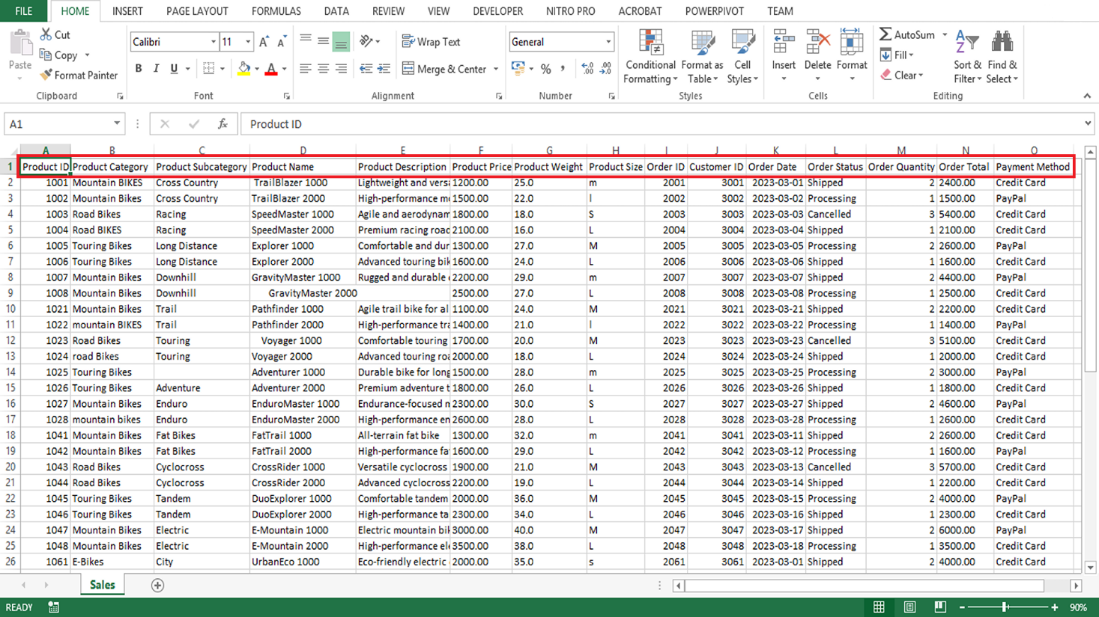

Although the sales dataset is the only data source provided in this exercise, business data ordinarily comes from multiple sources. In the current case study, additional relevant data sources may include customer details, marketing data, supply chain data, feedback data, and website analytics. As a result, part of the data analysis process may be integrating data from different sources to get a complete picture.

Answer the following questions to guide your understanding of data sources in the case study:

1. What kind of information can you gather from the provided dataset in relation to product, order, and customer details?

• **Product details:** Name, category, price, and how many were sold.

• **Order details:** Order ID, order date, total amount, and number of items.

• **Customer details:** Customer ID, location, age group, and buying history.

1. How can you use the data fields provided to understand sales trends and customer preferences? Briefly discuss your suggested approach for gaining insight into these two aspects separately.

* **Sales trends:**
  + Check which products sell the most.
  + See when sales go up or down (e.g., by month or season).
  + Find out which categories or times perform better.
* **Customer preferences:**
  + See which products different customers like (by age or location).
  + Look at repeat purchases.
  + Find popular products in different areas.

**Simple approach:**

* Use dates and sales numbers for trends.
* Use customer and product info to understand preferences.

1. Explain how the other data sources within Adventure Works might be relevant to your analysis or add value to your insights.

• **Marketing data:** Shows which ads or promotions worked.

• **Customer feedback:** Tells you what people like or dislike.

• **Online store data:** Shows what customers look at most.

• **Inventory data:** Helps explain if products were out of stock or delayed.

**Step 3: Data import and cleaning**

Having identified your stakeholders and your data sources, the next step is to import your data and ensure it is clean and ready for analysis. Keep in mind that data often contains errors, duplicates, or missing values. This can compromise the integrity of your analysis, for example, resulting in Adventure Works making poor decisions related to the product launch based on incorrect data.

As a part of the data analysis process, you must evaluate the collected data to determine whether cleaning is required. For example, you may identify data inconsistencies or errors. Ensuring the data is clean and prepared for analysis is important for Adventure Works, as your analysis will help shape this launch in many ways, including marketing plans, sales strategies, and even final product changes.

Answer the following questions related to the data cleaning process:

1. Name and briefly describe an Excel function that can help you clean the **Product Name**, **Product Category,** and **Product Size** columns.
2. For the Adventure Works sales dataset, indicate the most appropriate Excel data type for the content of each column. For example*,* **Product ID**: Number.
3. Explain how you could exclude the missing entry in the **Product Description** column in the Adventure Works sales dataset at the source using Excel.

1. Excel function to clean data:

* Use TRIM()
* It removes extra spaces from words.
* Helps clean Product Name, Product Category, and Product Size.

Example: =TRIM(A2)

2. Best Excel data types for each column:

| Column | Data Type |
| --- | --- |
| Product ID | Number |
| Product Name | Text |
| Product Category | Text |
| Product Size | Text |
| Product Description | Text |
| Order ID | Number |
| Order Date | Date |
| Quantity Sold | Number |
| Total Sale Amount | Currency |
| Customer ID | Number |
| Customer Location | Text |
| Customer Age Group | Text |

3. How to remove missing Product Description entries:

* Click on the Product Description column.
* Go to "Data" tab → Click "Filter".
* Click the arrow in the column.
* Uncheck “(Blanks)” – this hides missing rows.
* You can also delete those rows if needed.

**Conclusion**

Identifying and engaging with stakeholders, identifying data sources, and importing and cleaning the data are essential steps early in the data analysis process. The tasks you engaged with in this exercise can lay the groundwork for a successful data analysis project and can shape later stages in the analysis process. As a data analyst, the insights you draw from data can shape the course of a business and guide new product launches, as with Adventure Works. The power of data is immense, but the true power lies with the analyst who uncovers the insights within this data.

**Self-review: Product launch analysis**

1.

Question 1

Which data type in Microsoft Excel is most appropriate for the Product Price field in the Adventure Works sales dataset?

Currency

Correct

That's correct! The currency data type handles numerical values with decimals, like prices with dollar and cent amounts.

1 / 1 point

**2.**

**Question 2**

What is the primary risk of not properly cleaning and preparing the data for analysis at Adventure Works?

Adventure Works could make poor decisions related to the product launch.

Correct

That's correct! When data isn't properly cleaned and prepared, it can contain inaccuracies that lead to misleading analysis results and ill-informed decisions about the product launch.

1 / 1 point

**3.**

**Question 3**

**What is the most appropriate method for handling missing entries in the Product Description column in the Adventure Works sales dataset using Microsoft ExceI?**

Remove the rows with missing entries for the Product Description.

Correct

That's correct! Removing rows with missing entries is a suitable approach, particularly if the missing values represent a small proportion of your data and your analysis requires complete records.

1 / 1 point

**4.**

**Question 4**

**In the Adventure Works sales dataset, which data field would you primarily analyze to understand sales trends over time?**

Order Date

Correct

That's correct! You can generate a comprehensive view of sales activity, trends, and patterns over a given period by aligning Order Date with fields such as Order Quantity and Order Total.

1 / 1 point

**5.**

**Question 5**

**Which type of additional data could supplement the sales analysis by providing insights into what customers like or dislike about Adventure Works' products?**

Feedback data

Correct

That's correct! Feedback data often comes in the form of customer reviews, ratings, or comments about a product or service can provide qualitative insights into customer preferences, which quantitative sales data may not fully capture.

**Exemplar: Product launch analysis**

**Introduction**

In the exercise *Product launch analysis*, you were tasked with performing some steps as part of a sales data analysis for Adventure Works. More specifically, you were asked to:

* Identify the stakeholders who may have an interest in sales performance and customer preferences.
* Evaluate the contents of the dataset containing information about products and orders and determine which other data sources can contribute to your analysis.
* Identify and clean any potential errors or inconsistencies in the dataset.

This reading provides you with example answers that you can use to compare to your own. Your answers may differ from the ones in this reading and still be correct.

**Excel user interface**

In this course, we use the Microsoft 365 Desktop version of Excel. Microsoft 365 releases updates on a monthly basis, incorporating new features. You might experience changes in the Excel Desktop user interface (UI) that have taken place after the development of this training content. As a result, the screenshots in the videos, readings, or exercises might not align exactly with how you experience the UI. However, please note that these changes do not impact the functionalities of the UI. Hence, you will still be able to perform all the steps shown in that video, reading, or exercise.

**Exemplar: Product launch analysis**

**Step 1: Identify the stakeholders**

**1. Briefly explain why any two of the stakeholder groups at Adventure Works may have an interest in the insights related to the sales performance of various products.**

Several internal stakeholders at Adventure Works may have an interest in the sales performance of various products. These can include:

* Sales team: The sales team is directly responsible for selling products. By understanding the company’s sales performance and sales trends, the sales team can tailor their sales strategies, understand which products are selling well, identify opportunities for improvement, and maximize sales opportunities in preparation for the product launch.
* Marketing team: The marketing team's efforts play a significant role in driving sales. They would be interested in sales data to understand the effectiveness of their marketing strategies and to guide future campaigns that promote sales of the new product line.
* Product development team: The product development team would be interested to check how well their developed products are performing in the market. The sales data of various products can guide them in the development and adjustment of products for launch. For example, they can identify opportunities in the market new products can fill and make data-driven decisions regarding pricing, production volume, and resource allocation for the new line of products.

**2. Which of the stakeholders need to know about customer preferences when it comes to Adventure Works’ products? Why would this information be important to them in relation to the product launch?**

Insights into customer preferences are valuable to a number of teams within Adventure Works:

* Marketing team: The marketing team can use this data to target their marketing efforts more effectively and to tailor their messages to better connect with their customers, generating interest and demand for the new product line.
* Sales team: Understanding customer preferences will allow the sales team to better tailor their sales strategies or approaches and to recommend products that better meet customers' needs, ultimately driving more sales.
* Product development team: The product development team can use customer preference information to inform the design and development of new products or to refine existing ones. Insights into customer preferences will help the development team ensure that the products align well with what customers want and enable them to make data-driven improvements or tweaks, increasing the chances of market success.
* Customer service team: Knowing customer preferences can help the customer service team provide more personalized service and support, leading to improved customer satisfaction.

**Step 2: Identify and consider the data sources**

**1. In your own words, what kind of information can you gather from the provided dataset?**

The dataset includes a wealth of information about product details, orders, and customers. Here is a brief description of what can be gathered from each field:

* Product details: The **Product ID**, **Product Category**, **Product Subcategory**, **Product Name**, **Product Description**, **Product Price**, **Product Weight**, and **Product Size** fields provide detailed information about Adventure Works’ products. Understanding the variety and specifications of products can help stakeholders gain insights into the performance of specific products and the reasons behind this performance. For example, fields like **Product ID** make it possible to track the performance of each product individually, and product description, weight, and size fields can provide valuable insights into customer preferences and purchasing behaviors.
* Order details: The **Order ID**, **Order Date**, **Order Status**, **Order Quantity**, and **Order Total** fields provide information about each order, including the total cost, the number of products ordered, and the status of the orders. This data can help stakeholders track sales performance over time and identify any trends or issues (such as bottlenecks in production that delay delivery) and gain insight into the overall order processing workflow.
* Customer details: This dataset includes a unique identifier for each customer in the **Customer ID** field that can be used to track individual customer behavior over time. This can help stakeholders understand customer loyalty and repeat purchase behavior, which can help stakeholders gain insight into customer preferences, tailor marketing strategies, and identify opportunities to improve customer retention. The **Payment Method** field provides information about how customers choose to pay for their orders. It can offer insights into customer payment preferences and potentially inform payment options and strategies.

**2. How can you use the data fields provided to understand sales trends and customer preferences? Briefly discuss your suggested approach for gaining insight into these two aspects separately.**

* Sales trends: You can use the **Order Date**, **Order Quantity**, **Order Total**, and **Product ID** fields to understand sales trends. By grouping and summarizing this data by date and product, you can identify trends in product popularity and sales volume over time.
* Customer preferences: You can infer customer preferences from the **Product ID**, **Product Category**, **Product Subcategory**, **Product Size***,* and **Payment Method** fields. By analyzing which products and product categories sell the most, you can gain insight into what customers prefer. The preferred product size and payment method can also provide insights into customer behavior and preferences.

**3. Apart from the provided dataset, what other data sources within Adventure Works might be relevant to your analysis or add value to your insights?**

While the provided dataset is comprehensive, additional data could enhance the analysis:

* Customer details: Additional data about customers such as demographic information (for example, age and location) could provide further insights into customer behavior and preferences.
* Marketing data: Information about marketing campaigns, including dates, marketing channels, costs, and reach, could be used to correlate marketing efforts with sales performance.
* Supply chain data: Information about inventory levels, production costs, and supplier details could be used to understand the cost of goods sold and profit margins. This data could also help stakeholders identify opportunities to manage inventory more effectively.
* Feedback data: Customer reviews or feedback could provide qualitative insights into what customers like or dislike about the products and the ordering process. This could supplement the sales data and provide deeper insight into customer preferences and purchasing behaviors.
* Website analytics: Data from the company's website or e-commerce platform could provide insights into customer behavior online, such as popular search terms or commonly viewed products.

**Step 3: Data import and cleaning**

**1. List and briefly describe a common Excel function that can help you clean each of the following columns:**

* **Product Name**: **TRIM** This function removes leading, trailing, and double spaces in cells. In the *Adventure Works Sales* dataset, it can be used to clean up inconsistencies in text entries and to remove any additional spaces that have occurred during data entry.
* **Product Category**: **PROPER** This function converts the first letter of each word in a text string to uppercase and all other letters to lowercase. In the *Adventure Works Sales* dataset, it can be applied to the **Product Category** column to maintain consistency in data presentation.
* **Product Size**: **UPPER/LOWER** The **UPPER** function converts text to all uppercase and **LOWER** converts text to all lowercase. This could be useful for standardizing entries in **Product Size** columns in the *Adventure Works Sales* dataset.

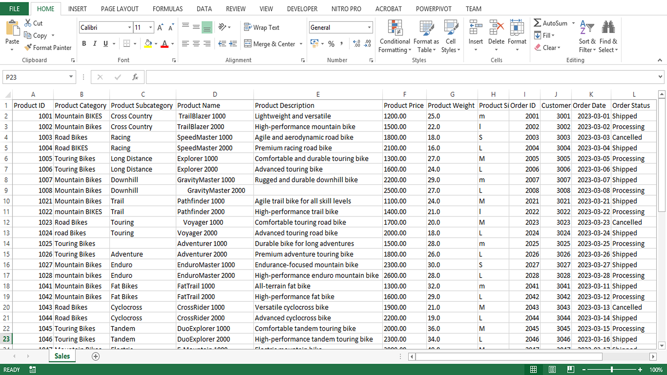

**2. With reference to the Adventure Works sales dataset, indicate the most appropriate Excel data type for the content of each column.**

| **Column title** | **Excel data type** | **Explanation** |
| --- | --- | --- |
| **Product ID** | Number | This column contains unique identification numbers for each product. As IDs are integers (whole numbers), the Excel data type should be set to number, with zero decimal places. |
| **Product Category** | Text | Categories are typically represented by descriptive names (strings of text), making the text data type appropriate here. |
| **Product Subcategory** | Text | Similar to the category, the subcategory is also descriptive and represented as a string, therefore the text data type is suitable. |
| **Product Name** | Text | Product names are strings of text that describe or label each individual product. The text data type is ideal for this. |
| **Product Description** | Text | Product descriptions provide additional details about each product. They are typically composed of longer strings of text, which makes the text data type the best choice. |
| **Product Price** | Currency | Prices can include decimal values (for example, $19.99). To capture this level of detail, the currency data type is appropriate. |
| **Product Weight** | Number | Because weights often include fractions (for example, 1.25 kg), the number data type, with 2 decimal places, is appropriate. |
| **Product Size** | Text | Sizes can come in various forms, such as (S) small, (M) medium, or (L) large. Because they might include text, the text data type is appropriate. |
| **Order ID** | Number | Similar to the **Product ID**, the **Order ID** is a unique identification number for each order, so the number data type with zero decimal places is used. |
| **Customer ID** | Number | **Customer ID** is a unique identifier for each customer, typically represented as a number with zero decimal places. |
| **Order Date** | Date | This field contains the date. Excel’s date data type allows for the correct sorting and time-based analysis of this data. |
| **Order Status** | Text | The **Order Status** column may contain status descriptions such as **Completed** or **Pending**, which are best represented with the text data type. |
| **Order Quantity** | Number | This is the number of products in each order. Because you can't order a fraction of a product, this field is a number data type with zero decimal places. |
| **Order Total** | Currency | This is the total price of each order. This can contain currency symbols, making the currency data type appropriate. |
| **Payment Method** | Text | This column could contain various payment methods like **Credit Card** or **Bank Transfer**. As a result, it should be treated as text. |

**3. Explain how you would exclude the missing entry in the Product Description column in the *Adventure Works Sales* dataset at the source using Excel.**

An appropriate way to exclude the missing entry at the source is to use Excel's filter functionality as follows:

* First, select the **column header** for **Product Description**.
* Next, go to the **Data tab** and select the **Filter button**. This will add drop-down arrows to each column header.
* Select the drop-down arrow on the **Product Description** header.

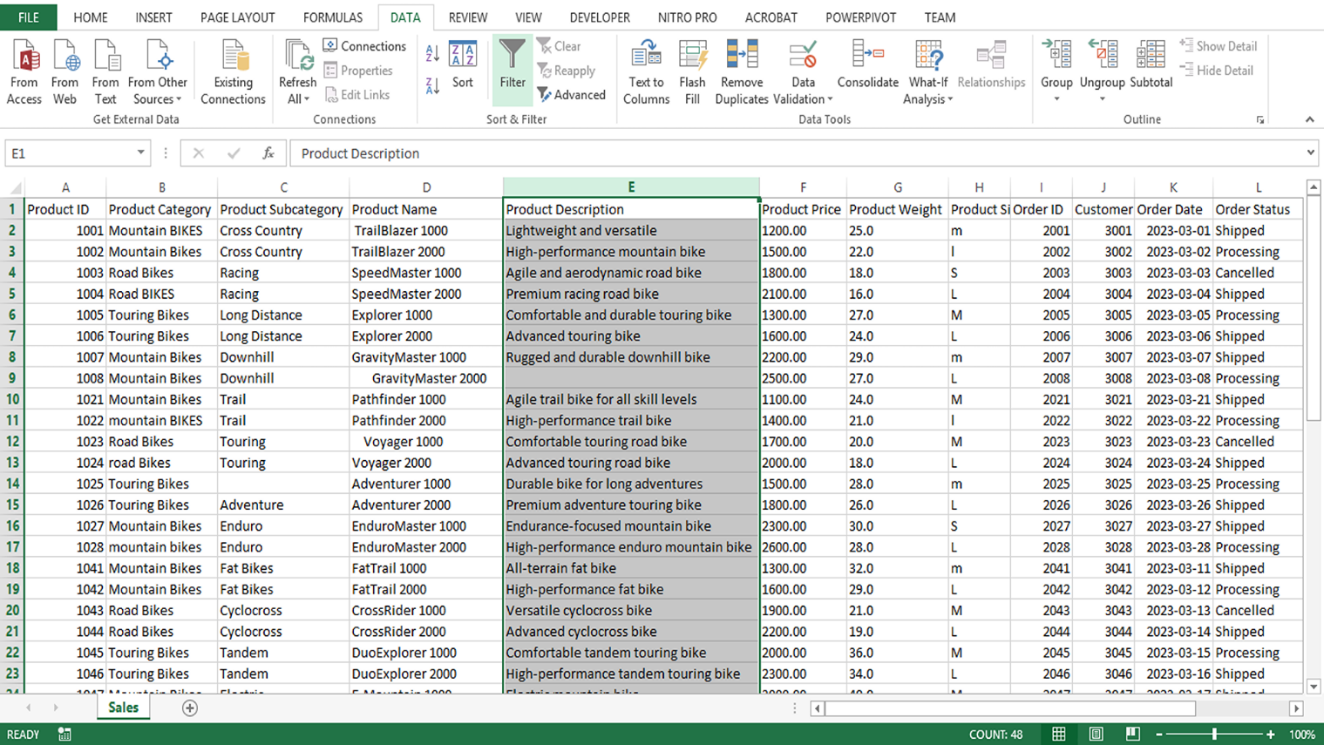

* In the text box at the bottom of the drop-down menu, type **(Blanks)** and then select **OK**. This will filter your data to only show rows where the product description is blank.

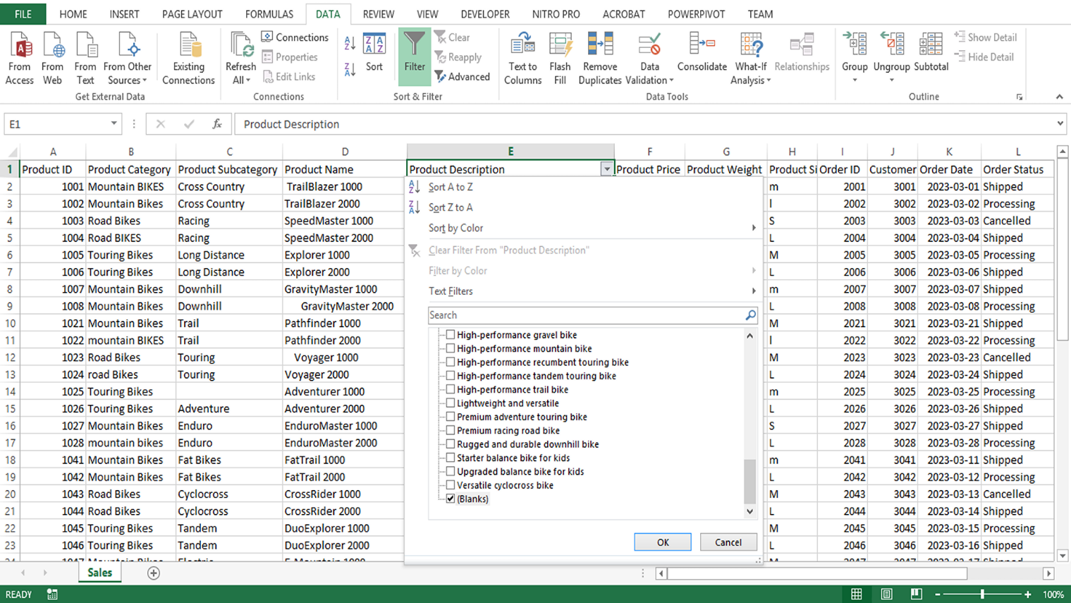

You can then use Excel’s filtering functionality to identify rows where the product description is missing. Instead of deleting them outright, consider alternative approaches such as:

* Filling in missing descriptions using existing data sources like product catalogs or databases.
* Using placeholders (e.g., "Description Not Available") to maintain data integrity while highlighting gaps.
* Analyzing whether missing descriptions are linked to specific product types or categories and addressing them accordingly.
* If the missing values significantly impact analysis accuracy, document the issue and assess the best course of action, such as excluding affected rows only in specific analyses where the description is essential.

**Conclusion**

Having completed the *Product launch analysis* exercise, you put some of your learning regarding the data analysis process into practice. You engaged with multiple tasks of a data analyst, including identifying stakeholders, identifying and exploring data sources, and evaluating and cleaning data. With each dataset you explore and every question you unravel, your data analysis skills will grow stronger.

Mark as completed

Like

Dislike

Report an issue

**Course Quiz: Harnessing the Power of Data in Power BI**

**1.**

Question 1

As a data analyst, what are some of the responsibilities you might have? **Select all that apply.**

To collect, organize, and analyze data to generate insights.

Correct

That's correct! A data analyst's primary responsibility is to collect, organize, and analyze data to generate insights that inform business decisions.

You didn't select all the correct answers

0.75 / 1 point

**2.**

Question 2

As a data analyst, you need to share your data insights with relevant stakeholders. What best practice can you implement to ensure the data used for your data analysis and reports is up-to-date and reliable?

Regularly consider data storage and refresh schedules for your data reports

Correct

That's correct! Considering storage and refresh schedules for a data report is important to ensure users always work with the most current and accurate information. Outdated data can lead to incorrect decisions and missed opportunities.

1 / 1 point

**3.**

Question 3

You are a data analyst hired by Adventure Works to gain insight into a decline in sales and customer satisfaction. Which phase of the data analysis process will involve exploring the data to identify patterns and trends that explain the decline?

Analyzing the data

Correct

That's correct! Once the data is clean and processed, you will explore the data and identify patterns and trends. For example, you may discover at this phase that the decline in sales is primarily due to a decrease in repeat customers and shipping and product quality issues.

1 / 1 point

**4.**

Question 4

What non-technical skills are essential for a data analyst to succeed in their role? **Select all that apply.**

Strategic thinking

Correct

That's correct! Strategic thinking helps data analysts prioritize tasks, allocate resources effectively, and make data-driven decisions contributing to long-term success.

Awareness of impact

Correct

That's correct! Awareness of the potential impact of their analyses is crucial for data analysts to communicate their findings responsibly and ethically. It can also help data analysts foster a data-driven culture within the organization.

Understanding of context

Correct

That's correct! With a deep understanding of the context in which they are working, such as the industry and the business' goals and strategy, data analysts can tailor their analyses to the needs of the business and ensure the insights they derive are useful and actionable.

1 / 1 point

**5.**

Question 5

In data analysis, what is Power Query primarily used for?

To connect to data sources, clean and transform data, and load it into Microsoft Power BI.

Correct

That's correct! Power Query's primary function is to connect to various data sources, clean and transform data, and load it into Power BI for analysis. It simplifies and automates data preparation tasks, making data analysis more efficient.

1 / 1 point

**6.**

Question 6

What is the primary responsibility of a Data Engineer in the data analysis process?

Building and maintaining the data infrastructure, which includes designing, constructing, and integrating data pipelines.

Correct

That's correct! Data Engineers are responsible for building and maintaining the data infrastructure, which includes designing, constructing, and integrating data pipelines. This ensures data is collected, stored, and processed efficiently and reliably.

1 / 1 point

**7.**

Question 7

What does diplomacy as a non-technical skill mean in the context of data analysis?

Navigating delicate situations related to the data analysis and maintaining positive relationships with stakeholders, even when disagreements arise.

Correct

That's correct! Diplomacy involves negotiating access to data, mediating stakeholder disagreements, and presenting results that challenge existing beliefs while maintaining trust and respect.

1 / 1 point

**8.**

Question 8

You are a data analyst at Adventure Works and are involved in a project to improve customer experience. The success of this project hinges on your ability to understand the needs of various stakeholders in the organization. What approach would help you achieve this goal?

Regularly engaging with end-users and empathizing with their perspectives.

Correct

That's correct! Understanding end-user needs involves empathizing with their perspectives, asking questions, and collaborating with stakeholders. Regular engagement and feedback are crucial to ensure the insights generated from data analysis are relevant and valuable.

1 / 1 point

**9.**

Question 9

What does being a successful 'translator' in the context of a Data Analyst mean?

The ability to translate complex concepts into easily understandable terms.

Correct

That's correct! Being a successful 'translator' involves explaining complex technical concepts in an accessible way to non-technical stakeholders, often using analogies or metaphors. This makes it easier for stakeholders to understand the insights derived from data analysis and use them to inform decisions.

1 / 1 point

**10.**

Question 10

Data preparation is crucial for the data analysis process. Which of the following are the objectives of data preparation? **Select all that apply.**

Gathering, cleaning, and pre-processing raw data to make it suitable for analysis.

Correct

That's correct! The primary objective of data preparation is to gather, clean, and pre-process raw data to ensure it's accurate, consistent, and in the right format for the analysis tools being used.

Identifying inconsistencies and errors in the data.

Correct

That's correct! Identifying inconsistencies and errors in the data is a crucial part of data preparation. This helps ensure the accuracy and reliability of the analysis.

1 / 1 point

**11.**

Question 11

As a data analyst at a retail store, you're asked to define the scope of your data. What could this involve? **Select all that apply.**

Determining the time frame for your analysis.

Correct

That's correct! Defining the scope of your data involves defining boundaries and parameters for the data you'll be using in your analysis, for example, deciding on the time frame. This helps focus the analysis and ensure it's relevant to business needs.

Deciding on the geographical regions you are interested in.

Correct

That's correct! When defining the scope of your data, it's important to decide on boundaries and parameters for the data you'll be using in your analysis, such as geographical regions of interest. This can help ensure the relevance and applicability of your analysis.

Selecting the product categories you want to include.

Correct

That's correct! Defining the scope of your data, which involves setting boundaries and parameters for the data you'll use in your analysis, could involve deciding on the product categories you want to examine. This can help target the analysis and make it more meaningful for decision-makers.

1 / 1 point

**12.**

Question 12

As a data analyst at Adventure Works, your manager assigns you a project to analyze sales data from the North American market. What should be your primary focus during the data preparation stage?

Ensuring the data is accurate, consistent, and ready for analysis.

Correct

That's correct! During the data preparation stage, your primary focus should be ensuring the data is accurate, consistent, and in a format suitable for analysis.

1 / 1 point

**13.**

Question 13

In the data analysis process, what is the primary purpose of the ETL (Extract, Transform, Load) process? **Select all that apply.**

Transforming raw data into a structured format suitable for analysis.

Correct

That's correct! One of the key stages in the ETL process is transforming data to make it consistent and suitable for analysis.

Loading the transformed data into a suitable storage space.

Correct

That's correct! The Load part of ETL refers to loading the transformed data into a database or other storage space ready for further analysis.

1 / 1 point

**14.**

Question 14

Why is data visualization important in the data analysis process?

It helps make complex data more accessible and easier to understand.

Correct

That's correct! Visualizations, such as charts and graphs, can help make complex data more accessible and easier to understand. They can also help uncover hidden patterns, trends, and relationships within the data that might not be apparent through calculations alone.

1 / 1 point

**15.**

Question 15

Why is understanding stakeholder experience critical in data visualization? **Select all that apply.**

It helps create effective visualizations that lead to better decision-making.

Correct

That's correct! Understanding stakeholder experience is vital. Visualizations informed by stakeholders' needs, preferences, and understanding of the data can improve the effectiveness and usability of visualizations, enhancing understanding and decision-making.

It can help by increasing collaboration and leading to improved business outcomes.

Correct

That's correct! Understanding stakeholder experience is critical as it helps create tailored visualizations that can enhance stakeholder collaboration, decision-making, and business outcomes.

1 / 1 point

**16.**

Question 16

As a data analyst, you work with the Microsoft Power Query Editor in Microsoft Power BI Desktop. What are some of the core functionalities provided by the Power Query Editor? **Select all that apply.**

It enables you to clean, transform, and reshape data.

Correct

That's correct! Power Query Editor in Power BI Desktop is an essential tool for cleaning, transforming, and reshaping data to ensure its accuracy and consistency for analysis.

It allows you to merge and append queries.

Correct

That's correct! The Power Query Editor provides capabilities to merge or append multiple queries, which is part of reshaping data.

1 / 1 point

**17.**

Question 17

You are creating calculations in Microsoft Power BI. Which languages are supported in Power BI to perform this task? **Select all that apply.**

Python

Correct

That's correct! While not the primary language, Power BI does have support for Python scripting in Power BI Desktop.

Data Analysis Expressions (DAX)

Correct

That's correct! DAX is the primary language used in Power BI to create calculations, allowing you to perform specific operations on data, manipulate it, and create new calculated measures, columns, and tables.

R

Correct

That's correct! Power BI provides support for R scripting, which you can use for complex data manipulations and calculations. However, it is not the primary language for calculations.

1 / 1 point

**18.**

Question 18

Which of the examples of data can you classify as semi-structured data?

Data collected from automatic door sensors.

Data stored in a software platform like an Enterprise Resource Planning (ERP) system.

Images and videos coming from social media.

Sales revenue figures

Incorrect

Not quite. Please review [*Identifying and evaluating required data*](https://www.coursera.org/learn/harnessing-the-power-of-data-with-power-bi/lecture/PI8Ju/identifying-and-evaluating-required-data)*.*

0 / 1 point

**19.**

Question 19

Adventure Works has a team of field sales representatives who are always on the move. As a data analyst, your manager asks you to give stakeholders real-time access to reports and dashboards on their mobile devices. Which component of Power BI is specifically designed for this purpose?

Power BI Apps

Correct

That's correct! Power BI Apps is the native mobile application of Power BI, available on iOS, Android, and Windows. It allows users to view and interact with reports and dashboards from mobile devices.

1 / 1 point

**20.**

Question 20

Which actions are part of a typical Microsoft Power BI workflow? **Select all that apply.**

Import data and create the report in Power BI Desktop.

Correct

That's correct. A typical workflow in Power BI often starts with importing data and creating a report in Power BI Desktop.

Share your reports and dashboards with relevant stakeholders and manage access.

Correct

That's correct. Once the report is created and published, the final step in a typical Microsoft Power BI workflow is to share the report to ensure proper distribution and manage access to the data by setting permission levels.

Use Power BI Mobile apps to view and interact with reports and dashboards.

Correct

That's correct! Part of the final step in the typical Power BI workflow, Share, is considering using Power BI Mobile apps to enable viewing and interaction with the published reports and dashboards on mobile devices.

Publish the report to the Power BI service.

Correct

That's correct! The Publish step of the typical Power BI workflow involves publishing your report to the Power BI service.

1 / 1 point

**21.**

Question 21

Why is it important to consider the technical expertise of stakeholders as a part of the data visualization process?

It influences the complexity and depth of the visualizations.

Correct

That's correct! Understanding the stakeholders' level of technical expertise is crucial in determining the complexity and depth of the visualizations.

1 / 1 point

**22.**

Question 22

As a data analyst, you explain the benefits of automating data ingestion processes to your team. What are the benefits of automating these processes? **Select all that apply.**

It can enhance operational efficiency and reduce manual labor.

Correct

That's correct! Automating data ingestion processes can save time, reduce manual labor, and minimize the risk of errors, thereby enhancing operational efficiency.

It allows for consistent and repeatable data ingestion.

Correct

That's correct! Automating data ingestion ensures consistency and repeatability, improving data quality and reliability.

1 / 1 point

**23.**

Question 23

You are a data analyst discussing the manual data entry method of data ingestion with your team. Which of the following are the limitations of this method? **Select all that apply.**

It is time-consuming and prone to errors.

Correct

That's correct! Manual data entry is straightforward and suitable for small amounts of data but can be time-consuming and prone to errors.

It is unsuitable for large-scale data ingestion.

Correct

That's correct! Manual data entry can be impractical and inefficient for large-scale data ingestion.

1 / 1 point

**24.**

Question 24

A colleague asks you about the Transform step in the Extract, Transform, Load (ETL) process. What are the critical elements to ensure during this step? **Select all that apply.**

Ensuring the transformed data is consistent, accurate, and complete.

Correct

That's correct! During the Transform step of the ETL process, it is important to ensure that the transformed data is consistent, accurate, and complete.

Cleaning the extracted data.

Correct

That's correct! Cleaning data is a crucial part of the Transform step, as it involves removing or correcting any errors in the data.

1 / 1 point

**25.**

Question 25

In the context of data storage planning, what does scalability refer to?

The ability to handle increased or decreased data volume as the organization grows.

Correct

That's correct! In the data storage context, scalability refers to the ability to handle an increase or decrease in data volume as the organization grows without compromising performance or requiring significant infrastructure changes.

1 / 1 point

**26.**

Question 26

During a team meeting at Adventure Works, you discuss an upcoming project involving a significant amount of data. Your co-worker brings up the subject of data cleaning. What can you say in favor of cleaning the data at the source? **Select all that apply.**

You can save time and effort in future analyses by cleaning and preparing data at the source.

Correct

That's correct. Addressing data quality issues at the source saves time and effort in future analyses, as the data will be clean and ready for use.

It addresses data quality issues without modifying the original data source.

This should not be selected

Not quite. Please review [*Transforming and cleaning data*](https://www.coursera.org/learn/harnessing-the-power-of-data-with-power-bi/lecture/PXVjB/transforming-and-cleaning-data).

0.5 / 1 point

**27.**

Question 27

You are reviewing a data set in Excel as part of your analysis project. How can data validation help you while cleaning this data? **Select all that apply.**

To set criteria for the allowable data in a cell or range of cells.

Correct

That's correct! Data validation allows you to set criteria for the allowable data in a cell or range of cells, helping prevent errors and inconsistencies in your data.

To prevent any unintentional entries that are not within the specified criteria.

Correct

That's correct! Data validation in Excel can prevent data entry that doesn't meet the specified criteria, ensuring higher data integrity.

1 / 1 point

**28.**

Question 28

You are using Microsoft Power Query for data transformation. What functionalities does the **Applied Steps** pane offer you? **Select all that apply.**

It records the transformation steps in data preparation.

Correct

That's correct! The **Applied Steps** pane in Power Query records your steps when transforming data. This creates a repeatable and editable process, ensuring consistency and accuracy in data preparation.

To show the history of actions performed on the dataset.

Correct

That's correct! The **Applied Steps** pane in Power Query displays the sequence of transformations applied to the dataset, which can be extremely useful for tracking changes.

1 / 1 point

**29.**

Question 29

You're working on a Microsoft Power BI project. What are the main objectives of data transformation? **Select all that apply.**

To convert raw data into a more meaningful and usable format

Correct

That's correct! Data transformation in Power BI involves converting raw data into a more usable and interpretable format, which can facilitate analysis and interpretation.

To improve data quality and consistency.

Correct

That's correct! A crucial aspect of data transformation in Power BI is improving the quality and consistency of data, which can enhance the accuracy of analysis and decision-making.

1 / 1 point

**30.**

Question 30

The marketing team at Adventure Works provides you with an Excel dataset containing sales data from branches worldwide. You need to classify this data before proceeding with the analysis, as different approaches and tools are required to analyze different types of data. What classification is most appropriate for the sales data in this scenario?

Structured data

Correct

That's correct! Structured data is organized and formatted in a predefined way, enabling efficient storage, retrieval, and analysis. Examples include Excel spreadsheets, SQL data, and tabular data.

**Next steps**

**Introduction**

Well done! You’ve completed another course in the *Power BI Analyst Professional Certificate* program and taken an additional step toward improving your data analysis knowledge, skills, and qualifications. As there's always more to learn in the growing field of data analysis, you will benefit from taking the next course in the program, *Extract, Transform, and Load Data in Microsoft Power BI,* which you’ll learn more about in this reading.

**Overview of the next course**

In the next course, you’ll learn how to perform the Extract, Transform, Load, or ETL, process in Microsoft Power BI. Passing the course will bring you closer to certification and help you further prepare for the *Microsoft PL-300* exam.

Upon completion of the *Extract, Transform, and Load Data in Microsoft Power BI* course, you’ll be able to:

* Identify, explain, and configure multiple data sources in Power BI.
* Clean and transform data using Microsoft Power Query.
* Inspect and analyze ingested data to ensure data integrity.

**Week 1**

In the first week, you'll learn how to describe and set up multiple data sources and explore the different data source capabilities in Power BI. This will include an exploration of storage modes in Power BI and using data to configure them.

**Week 2**

In the second week, you’ll be introduced to transforming data in Power BI. You’ll gain insight into and experience in cleaning and transforming data using Power Query, in preparation for data modeling later in the program. You’ll be introduced to advanced data transformations, with a focus on combining data.

**Week 3**

In the third week, you’ll delve into the Load step of the ETL process, exploring how you can use Power BI to load data. You’ll also learn how to evaluate data for data anomalies and overall integrity with data profiling and will be introduced to best practices and advanced query capabilities when working with Power Query.

**Week 4**

In the final week, you’ll synthesize the skills you gained by working through a data transformation exercise involving multiple data sources and completing a final course assessment in the form of a graded quiz.

**Conclusion**

By completing all the courses in the program, you’ll receive a Coursera certification. Plus, this course will provide you with additional knowledge and skills to enhance your preparation for the *PL-300* exam, through which you can gain a *Microsoft Power BI Data Analyst Associate* certification. So don't hesitate to take advantage of this valuable opportunity to further your learning and career in the world of data analysis!

Mark as completed

Like

Dislike

Report an issue